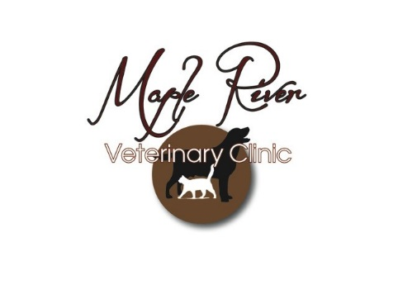

***Making Life Better for Pets and Their People!***

Phone: (989) 723-3458 5200 Colby Rd Owosso MI 48867 Fax: (989) 720-5253

**Pre-Operative Checklist**

_____ **I/D diet** – kick starts digestive tract, which stops moving during anesthesia; reduces the likelihood of nausea, vomiting and diarrhea post operatively.

_____ **Microchip –** a permanent form of identification in case your pet ever gets lost or stolen.

_____ **Elizabethan Collar –** If your patient requires the use of an e-collar, we may have one in your pet’s size. We prefer the inflatable donut shaped collars (Kong Cloud). If you prefer a different type, you are also welcome to purchase one elsewhere.

_____ **Pre-Operative Bloodwork –** this CBC/Chemistry with check your pet’s vital organs and make sure it is safe to put your pet under general anesthesia. If the results from this panel are abnormal, it may change the course of anesthesia or make extra precautions necessary. In young patients, this panel will provide a great baseline should your pet become sick.

_____ **FELV/FIV Test –** this test is ideal for any previously untested cat or kitten, or any cat who has previously been tested, but not kept current on vaccines. Both Feline leukemia and FIV are immunosuppressive diseases that are contagious to other cats.

_____ **Nail Trim -** if your pet hates having its toes trimmed, there is no better time to trim them!

_____ **Preventative Care**

Canine _____ DAPPL4 Feline _____ FDVFRTC

_____Lyme _____ Leukemia

_____ CIV _____ Rabies 1yr 3yr

_____ Bordetella

_____Rabies 1yr 3yr

_____ Heartworm Test

_____ **Any Other Procedure:**