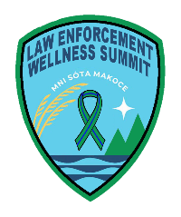
2026 Minnesota Law Enforcement Wellness Summit
Registration Form
Cost $250.00

Please type, and return either as a Word Document or PDF. Hand written registrations will not be accepted.

Attendees Names:

First Name | Last Name | Email | Lic Type

Agency Contact/Supervisor : please provide two supervisors to ensure contact

Title | First Name | Last Name | Email

Registration Process
- Complete the Registration and email to mnlawenforcementwellnesssummit@gmail.com
- In the subject line put TITLE of YOUR Agency and Conference Registration –
  - Therapy example : Minnesota Blue Line Therapy -Conference Registration –
  - Police/Corrections: XXXXX Police or Sheriff or Department of Corrections – Conference Registration

No Officers/attendees will be allowed into the conference without appearing on an invoice or the official roster.

Full Refunds will be offered no more than 45 days prior to the start of the conference: Conference Date Friday November 6th, 2026. If you use venmo, Venmo fees will be applied, and the full amount will not be returned.

For information on the conference – www.mnbluelintherapy.com

Payments
- Direct check
- Venmo

Mailing Address: in process of changing.

