CHILD HEALTH FORM
TO BE COMPLETED BY PARENT OR GUARDIAN:
_____________________________________ _________________________________ ______ _____/ _____ / ______
CHILD'S LAST NAME FIRST NAME M.I DOB: MO DAY YEAR

________________________________________________________________________________________________________
CHILD’S ADDRESS
WE/I ______________________________________________________ GIVE PERMISSION TO OBTAIN/RELEASE MEDICAL INFORMATION
SIGNATURE OF PARENT/GUARDIAN ON THE ABOVE CHILD.

PLEASE RETURN TO: ____________________________________________________________________________________
NAME OF CHILD CARE PROGRAM
HISTORY: TO BE COMPLETED BY PHYSICIAN
(THIS INFORMATION WILL BE HELD CONFIDENTIAL AND WILL BE USED ONLY FOR THE BENEFIT OF THIS CHILD).

A PRENATAL, PERINATAL AND POSTNATAL DEVELOPMENT: ANY SIGNIFICANT FINDINGS THAT COULD INFLUENCE THIS CHILD’S ADAPTATIONS TO A CHILD CARE SETTING (I.E., PHYSICAL HANDICAP, SENSORY LOSS, DEVELOPMENTAL IRREGULARITIES)?

- ANY CHRONIC ILLNESS THAT MAY REQUIRE MEDICATION, PARTICULARLY OBSERVATIONS OR PRECAUTIONS IN A CHILD CARE SETTING (E.G., RECURRENT EAR INFECTIONS, SEIZURE DISORDER, ALLERGIES)?

- ANY HOSPITALIZATIONS, OPERATIONS, OR SPECIAL TESTS OF WHICH A CHILD CARE PROVIDER SHOULD BE AWARE?

- PERTINENT FAMILY, SOCIAL OR HEALTH CHARACTERISTICS?

IMMUNIZATIONS FOR CHILD CARE AGENCY ATTENDANCE
PARENT MAY SUBSTITUTE A COPY OF CHILD'S IMMUNIZATION RECORD

VACCINE | DATE | DATE | DATE | DATE | DATE | DATE
DTP/DTAP
HIB
DTP-HIB
TD
OPV OR IPV
MMR
HEP-B
VARICELLA
OTHER

COMMUNICABLE DISEASE HISTORY RECOMMENDED SCREENING & TESTING OF ATTENDEES
DISEASE | DATE OF DIAGNOSIS | LABORATORY CONFIRMATION | PHYSICIAN |  | DATE | METHOD | RESULT:
CHICKENPOX |  | NOT  APPLICABLE |  | TB (FOR HIGH RISK CHILDREN ONLY)
OTHER: |  |  |  | VISION
 |  |  |  | HEARING
 |  |  |  | SPEECH
 |  |  |  | HIB/HCT |  | NOT  APPLICABLE
 |  |  |  | URINE |  | NOT  APPLICABLE
 |  |  |  | LEAD |  | NOT  APPLICABLE
(8)
HEALTH ASSESSMENT: (TO BE COMPLETED BY LICENSED HEALTH PRACTITIONER)

PHYSICAL EXAM:

LENGTH/HEIGHT  ______IN/CM %ILE______ | WEIGHT  ______LB/KG %ILE______ | HEAD CIRCUMFERENCE  ______IN/CM %ILE______ | BLOOD PRESSURE  ________/________

A. ESTIMATE OF LEVEL OF MATURATION:
A. INFANCY (0-2 YEARS) | EARLY: ____ |  | MID: ____ |  |  | LATE: ____
B. MID-PRESCHOOL (2-4 YEARS) | EARLY: ____ |  | MID: ____ |  |  | LATE: ____
C. PRESCHOOL (4 YEARS) | EARLY: ____ |  | MID: ____ |  |  | LATE: ____
D. SCHOOL-AGE (6-10 YEARS) | EARLY: ____ |  | MID: ____ |  |  | LATE: ____
E. ADOLESCENT (11-18 YEARS)  COMMENTS | EARLY: ____ |  | MID: ____ |  |  | LATE: ____
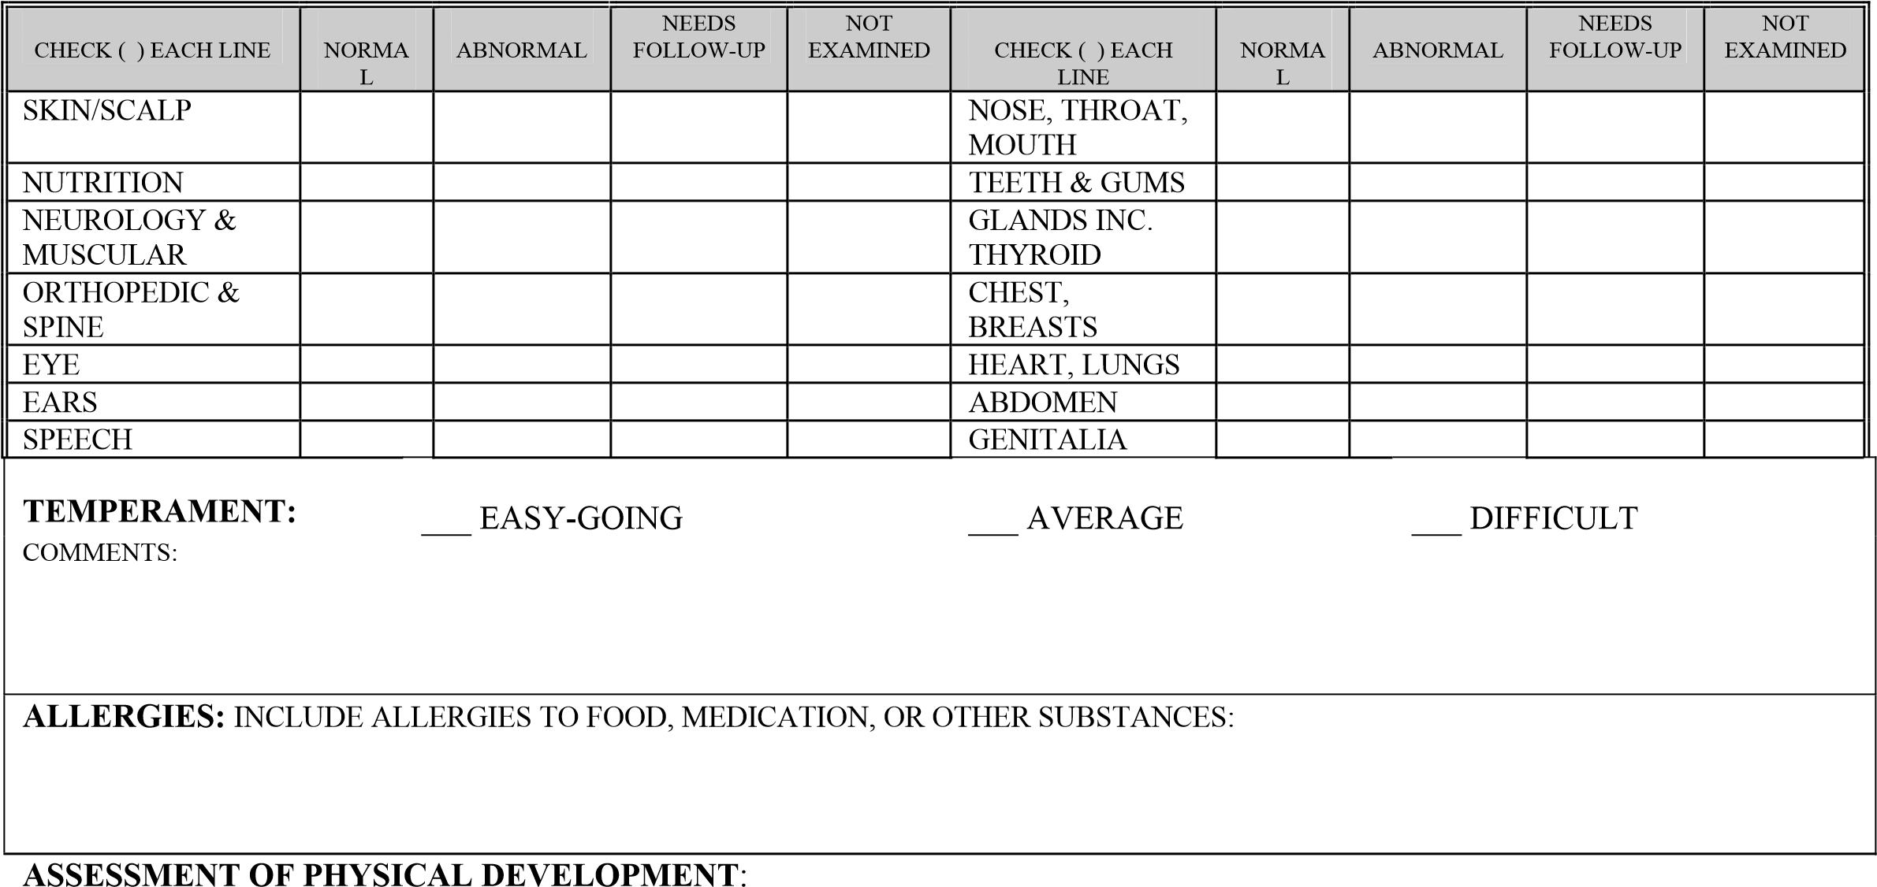
B. ESTIMATE OF FUNCTIONAL CAPACITY:
 | DELAYED FOR  DEVELOPMENT  PHASE | CONSISTENT WITH  DEVELOPMENT  PHASE | ADVANCED FOR  DEVELOPMENT  PHASE | COMMENTS:
GROSS MOTOR:
FINE MOTOR:
LANGUAGE SKILLS:
SOCIAL SKILLS:
EMOTIONAL:
_______________________________________________________________________ _______________
PHYSICIAN’S SIGNATURE: DATE OF EXAM:
_____________________________________________________________________ _____________________
PHYSICIAN'S NAME - TYPED OR PRINTED TELEPHONE NUMBER

DATE OF NEXT SCHEDULED EXAM: __________________________________

