In earlier newsletters, we talked about foods that the United States is known for. Even though the USA is one country, the variety of foods from north to south and east to west is monumental!

Let’s venture out now to other countries and talk about their foods.

And the next country is…..ITALY! Italia, Eat-a-lee!

What’s the first type of food that comes to your mind when you think of Italian food? Well, pasta of course! Although the Chinese claim to be the inventors of pasta, Italy gets the credit. (They claim it, too.)

Did you know there are over 350 types of pasta? Say your Ts. It’s spagheTTI not spagheddi

Salad is part of the main course, not before.

Southern Italy is where you’ll find an abundance of tomato sauce; whereas in northern Italy, they lean toward cream-based sauces. (Although you can certainly find either all over.) Fettucine is American and while you’ll find it in Italy, it will generally be at a tourist restaurant.

Another touristy thing is bread and oil to dip it in. This doesn’t happen in authentic Italian restaurants. Black pepper isn’t usually served in authentic Italian restaurants either.

Speaking of bread, almost immediately when you sit, the server will bring you a bread basket. Unless you want bread, don’t assume it’s free. Even if you leave it, it will appear on your bill. Just ask them to remove it and be sure they actually do (otherwise, when the bill comes, it is your word against theirs.) Yeah, this means sometimes you have to be assertive.

Cultural aspects of food in Italy:

If you’re a huge breakfast fan, complete with a buffet or a big IHOP-style menu, your best bet is to find a hotel. Breakfast restaurants, coffee shops and diners are difficult to come by. Most people eat a pastry or bread item with coffee, if they eat breakfast at all. Not to say you won’t find any full restaurants serving breakfast, but they are usually at hotels.

Gas stations serve yummy lunches. It’s true.

Dinner can last for hours.

Try to avoid restaurants that have menus with pictures or menus in several languages, if you want to eat authentic foods. The best places for authentic foods are going to be those that you would normally hesitate to venture in. Your “hole-in-the-wall” places. These are usually run by family and if you engage them in conversation, you’ll find they pull up a chair and join you.

Sitting in a café in the afternoon and having a glass of wine/beer is typical, except in the colder months when it might be difficult to find a café with a blanket or heaters.

There’s a whole culture surrounding coffee. If you want to experience coffee as most Italians do, go to a bar. This is what we call a café, not bar as in sports bar or alcohol bar. You can also go to large gas stations or visitor stations along the highway. The procedure is you place your order and get a receipt. Hold on to the receipt, then take it later to the cashier, who will need to see it before serving you.

You can’t stand patiently like at Starbucks. Approach the counter like it’s last call or they will run you over.

People stand and sip their coffee. It’s a quick beverage, not a sit and relax in the afternoon beverage.

It’s considered a major faux pas to drink cappuccino in the afternoon or evening. The reason is the milk and foam are considered a meal replacement and the dairy upsets the digestion.

Types of coffee:

Caffe- single espresso in small cup. Sugar and tiny spoon. Maybe a biscotti.

Espresso-not used by Italians. Stick to caffe. If you want double espresso, order 2 caffes.

Caffe lungo – served w/ a bit more water.

Caffe Ristretto – thick and dense espresso

Cappuccino – combo of espresso and whole milk steamed into a froth.

Caffe Latte has 2 versions – caffe macchiato. Mainly espresso w/ a shot of milk or latte macchiato – mostly milk w/ little espresso

Don’t ask for substitutions, like “sugar free” or “nonfat milk”

Don’t order cappuccino after 11a (milk digestion)

You pay more for coffee if you sit down.

If you ask for bottled water, be sure the cap is twisted in your presence or you do it yourself. Sometimes they replace with tap water, and while tap water is not dangerous, you don’t want to pay €3 for tap water, do you?

No trip to Italy would be complete without eating gelato. Don’t be dismayed if you see gelato that’s muted in color. That means it’s high quality! There’s no added food coloring. Pistachio is not green but brownish. Berry colors are deep muted reds, not a shockingly bright color.

Lemon gelato should be more white than yellow. Gelato should never look shiny. That means there are too many sugars or that it’s been oxidized, meaning it’s old.

The container it’s served in should be metal. No to plastic tubs. Lids are a good sign because it keeps the gelato at the right temperature.

Look at how it is served. Flat metal spades are better than curved ice cream scoops.

Let’s talk now about pizza, although frankly I’ve spent more time talking about coffee than I will pizza. Naples is known for the best pizza (but honestly, I don’t find Naples bringing enough to the itinerary to warrant staying.) And you can find good pizza elsewhere in Italy. Don’t expect to find deep-dish style pizza or paper thin. It will have thinner crust than “regular” pizza, though. Also, the pizza doesn’t come out already cut in slices. They bring a pizza cutter and you do it.

Here are some more typical Italian dishes:

Arancini: Fried rice balls. There are 2 types, Roman and Sicilian. Both have tomato sauce, cheese, and Arborio rice (which is a risotto rice). Sicilian arancini have beef and peas as well.

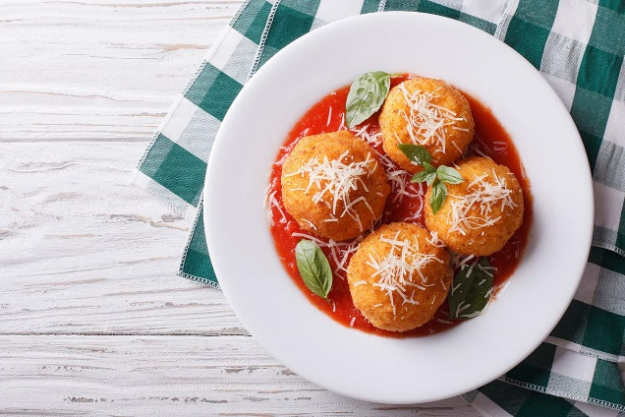

Focaccia: This is a bread baked in an oven with seasonings and tomatoes. This is usually served with olive oil, but is considered an appetizer.

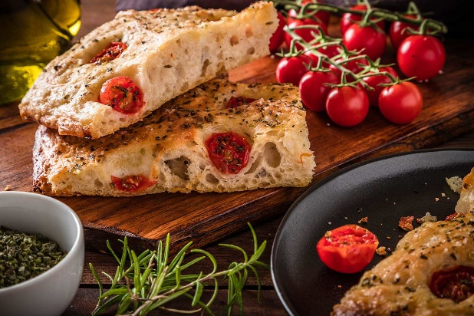

Ossobuco: This dish hails from Milan. It’s a slow-cooked meat made from veal shanks, cooked with a wine sauce, vegetables, garlic, and lemon. Ossobuco means “hollow bone” and the best part of Ossobuco is the part near the bone.

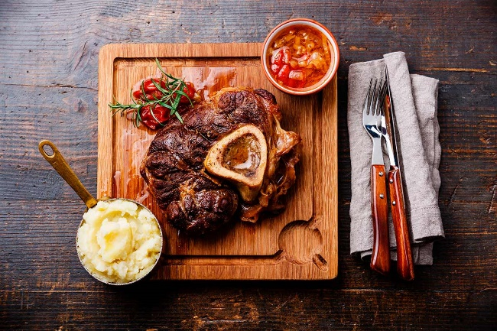

Popular Italian beverages:

Aperol Spritz- aka Spritz Veneziano or just Spritz. This is usually in Northeast Italy and is Prosecco, Aperol, and soda water. (Aperol tastes like orange popsicles.)

Grappa- 30-60% alcohol, also in north Italy. It’s made from skins, seeds, and stems from the grape and it tastes like bitter gasoline. It’s served in a shot glass; you dip your finger in the glass and rub it on your hand. Then you sip it, you don’t slam it back like a shot. It’s an after-dinner drink or it can be served in the morning with espresso.

Limoncello –this lemon-based drink is popular along the Amalfi coast, where lemons are bountiful.