O is for….Ontario, Canada

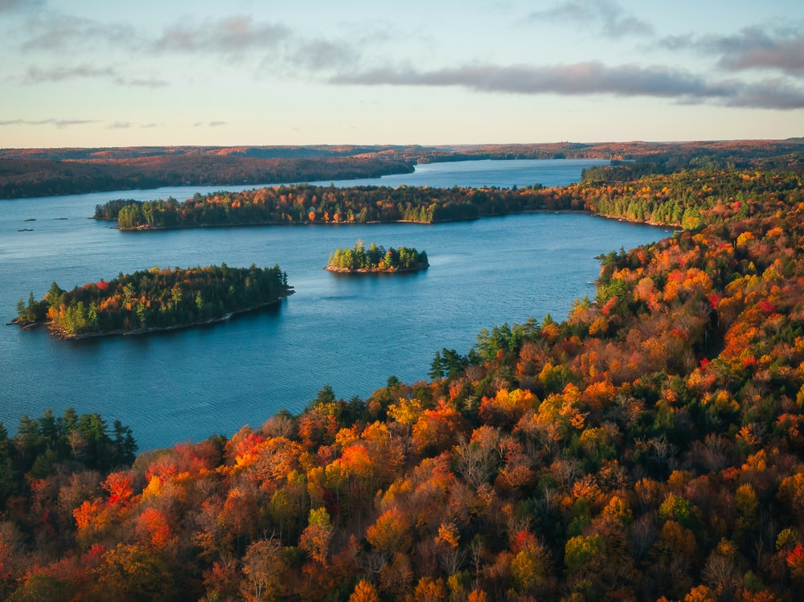

Canada is a winter wonderland beyond what words can convey. The beauty of the thick, stark-white snow makes you feel like you’re in another world, which in a manner of speaking, you are. There are so many things to do in Ontario in particular, so let’s hop right in, focusing first on winter activities:

- Cross-country skiing and downhill skiing-Must have strength in upper body, abs and legs. All kinds of levels.

- Snowboarding: You stand on a snowboard that’s attached to your feet. Featured in the Winter Olympics

- Snowshoeing: You wear snowshoes and hike. Sounds easy, but it’s not!

- Tubing: Children and toddlers can do this, as long as there’s an adult holding on tightly!

- Snowmobiling-not for children under 16 years of age, must have strength in your upper body

Packages can be bought that include ski-in resorts, lifts and lessons. Resorts offer these packages and I can help you find the right one for you.

Ontario has plenty of non-winter activities, too. Known for its natural diversity, outdoor activities are prominent:

- ATVing-for the more adventurous, I can provide you with a few places where you can rent an ATV and hit the trails.

- Animal parks and aquariums- one of the most unusual aquariums is Ripley’s Aquarium of Canada. There are animal sanctuaries and other typical zoos to visit.

- Opera, ballet, symphony

- Amusement parks-There are at least 10 amusement parks near Ottawa alone.

- Gardens-In the summer, you can visit lavender fields, and there are other gardens that put your photography talents to good use!

- Breweries & distilleries- beer, cider or Canadian whisky places that offer tours to see how they are made and yes, even tastings!

- Beaches- There are 250,000 freshwater lakes, and many of them offer rocky beaches, while others let you relax in the sand.

Now you can see there are TONS of things to do, whether you’re solo, with a family, with friends or with one other person. Contact me to book a trip to Ontario, for information on restaurants, hotels, or anything travel-related!

