P is for….Phoenix

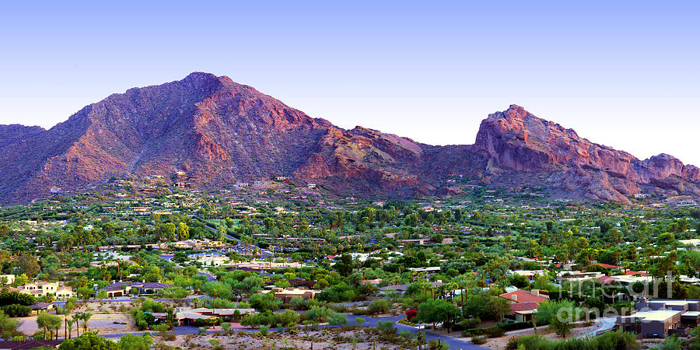

Phoenix, located in the northeast corner of the Sonoran Desert, is an anchor for visiting other areas of the state of Arizona. Because of her location in the desert, she’s known as the Valley of the Sun, and unless you love temperatures hovering in the 100s+, visiting this lovely town is best left for the fall and winter months.

The architecture and landscape are exactly what you picture when you imagine a desert: tons of cacti of all shapes and sizes, golden colored adobe sized buildings, sand, sand and more sand.

Let’s dive right into the sights and things to do in this urban town:

Desert Botanical Garden – This 91-year-old garden sits inside a park and offers events, displays and activities all year long. In the winter, there is a light and music display at night, along with concerts and intellectual talks about the wildflowers, cacti, flora and fauna. It will take you about 2 hours to walk through the garden, even without participating in the events. Who knows, you may see some lizards or other (scary!) crawling creatures!

Farmers’ Market – I love farmers’ markets, crafts markets, any kind of market! I rarely buy anything, but the vibe from the markets is energetic. This market is open on Wednesdays from 9a-1p and Saturdays from 8a-1p.

Boat riding/kayaking – Yes, just around the corner from all the desert, you will find Tempe Town Lake which has 2 miles of water perfect for paddling. There are dragon boats, rowing boats, kayaking, even stand-up paddleboards. Or you can take a quiet sail on the lake.

Wren House Brewing – I bet this caught your eye….brewery! Wren House is a favorite among locals for beer brewing and there are several different styles to choose from.

Roosevelt Row – located in downtown Phoenix, this street offers a showcase of local art. The state of Arizona is known for eclectic and down to earth artists and there are some unusual and beautiful pieces you’ll find here. On the first Friday of every month, you can take a self-guided art walk, and if you get tired of walking, you can hop on a free shuttle that goes to local galleries.

Chandler Museum – I know not a lot of people are fans of museums, but this is a cool one. There is a ranch on the property that teaches about agriculture in the desert, along with an old farmhouse, an old-style grocery store and old farm equipment.

Japanese Friendship Garden – Right in the center of town, you’ll find this 3.5 acres of land, and the garden of 1500 tons of hand-picked rock, more than 50 varieties of plants, a 12-foot waterfall, walking paths, and a Koi pond with over 300 Koi!

KOLI Equestrian Center – This center offers hay wagon rides, carriage rides, cattle drives, walking horses (for beginners) or rides for experienced riders. This center is located near downtown Phoenix, but you will ride the horses in the desert.

Golfing – anyone who knows anything about Arizona knows that the Phoenix area is known for outstanding golf courses. You can find almost 200 courses. I plan golf trips for people, too. Just let me know if you’re in need.

Piestewa Peak Summit Trail – I cannot imagine hiking this in the summer, but I have booked people who wanted to hike this trail in July. For those of us who are NOT die-hard hikers, this is still a great hike. The peak rises to 2,608 feet above the base of the valley. The views are so memorable. Start off at 5:00a and catch the sun rising.

Camelback Mountain – If you didn’t get exhausted after Piestewa Peak Summit, you can tackle Camelback Mountain. There are 2 trails. One is steep and rugged called Echo Canyon and the other is more my style, a trail called Cholla. Both are around a mile and are open from sunrise to sunset.

Food – You know I’ve got to talk about food. Guess what? I have a list of 46 different things you must eat while you’re in Phoenix. Give me a shout!

Not every place is open daily, so contact me to set up the perfect itinerary to incorporate everything you want to do. www.imaginationtvl.com or call me at 615-417-9859.

