Safeguarding Policy

Details of the place of worship
Name of Place of Worship – Wellspring Anglican Church
Meeting Place Address: St Twynnell’s Village Hall, St Twynnells
Contact address: Wellwood, Clay Lane, Hundleton SA71 5RA
Contact email: revjoshmaynard@gmail.com

Details of the leadership
Senior Leader / Vicar: Rev Josh Maynard
Address: Wellwood, Clay Lane, Hundleton SA71 5RA
Tel No: 07849991708
Email: revjoshmaynard@gmail.com
Designated Safeguarding Officer: Rachel Maynard
Tel No: 07849991708
Email: joshandrachelmaynard@gmail.com
Deputy Safeguarding Officer: Mary Young
Tel No: 07770771754
Email: eviemyo@icloud.com

Membership of Denomination:
The Anglican Convocation for Europe
Part of the Anglican Network in Europe

Charity Number: TBC

Insurance Company: Ecclesiastical Insurance Office plc
Type: Public Liability
Policy number: TBC
The following is a brief description of Wellspring Anglican Church and the type of work we undertake with children and adults who have care and support needs.

In line with our Statement of Belief and Practice, that we value all people as those created by God and bearing His image, and therefore of innate dignity; and those for whom Christ died and are therefore of infinite value and worth we seek to care for, support and share the gospel with all people, regardless of gender, ability, age, race or sexuality, and therefore including children and adults who have additional care and support needs.

The Trustees authorise the following activities which may involve work with children and/or adults who have additional care and support needs:
Lifts to/from church via car
Sunday family’s work (0-18s)
Midweek youth groups (11-17s)
Midweek adult home groups
Monthly women’s brunches and men’s breakfasts
Occasional trips and days/weekends away, including children and youth
Regular pastoral visits and 1-1 meetings, including children and youth

Our commitment

As Trustees of the Wellspring Anglican Church, we recognise the need to provide a safe and caring environment for children, young people and adults.

We acknowledge that children, young people and adults can be the victims of physical, sexual and emotional abuse, and neglect.

We accept the UN Universal Declaration of Human Rights and the International Covenant of Human Rights, which states that everyone is entitled to “all the rights and freedoms set forth therein, without distinction of any kind, such as race, colour, sex, language, religion, political or other opinion, national or social origin, property, birth or other status”.

We also concur with the Convention on the Rights of the Child which states that children should be able to develop their full potential, free from hunger and want, neglect and abuse. They have a right to be protected from “all forms of physical or mental violence, injury or abuse, neglect or negligent treatment or exploitation, including sexual abuse, while in the care of parent(s), legal guardian(s), or any other person who has care of the child.”

As a Leadership we have therefore adopted the procedures set out in this safeguarding policy in accordance with statutory guidance. We are committed to build constructive links with statutory and voluntary agencies involved in safeguarding.

The policy and any attached practice guidelines are based on the ten Safe and Secure safeguarding standards published by thirtyone:eight

The Trustees undertake to:
- have a robust and regularly assessed and monitored safeguarding policy and to ensure that this policy is actively implemented across all church activities.
- endorse and follow all national and local safeguarding legislation and procedures, in addition to the international conventions outlined above - particularly, ‘Working together to safeguard children’, 2018, and The Care Act 2014. This may also include guidance from the Equality Act 2010, as well as duties arising from the Counter Terrorism and Security Act 2015 and the Prevent duty guidance.
- provide on-going safeguarding training for all its workers and will regularly review the operational guidelines attached.
- ensure that the premises meet the requirements of the Equality Act 2010 and all other relevant legislation, and that it is welcoming and inclusive.
- support the Safeguarding Officers in their work and in any action they may need to take in order to protect children and adults with care and support needs.

Section 2
Prevention

Understanding abuse and neglect

Defining child abuse or abuse against an adult is a difficult and complex issue. A person may abuse by inflicting harm or failing to prevent harm. Children and adults in need of protection may be abused within a family, an institution or a community setting. Very often the abuser is known or in a trusted relationship with the child or adult.

In order to safeguard those in our place of worship we adhere to the UN Convention on the Rights of the Child and have as our starting point as a definition of abuse, Article 19:

1. States Parties shall take all appropriate legislative, administrative, social and educational measures to protect the child from all forms of physical or mental violence, injury or abuse, neglect or negligent treatment, maltreatment or exploitation, including sexual abuse, while in the care of parent(s), legal guardian(s) or any other person who has the care of the child.
2. Such protective measures should, as appropriate, include effective procedures for the establishment of social programmes to provide necessary support for the child and for those who have the care of the child, as well as for other forms of prevention and for identification, reporting, referral, investigation, treatment and follow-up of instances of child maltreatment described heretofore, and, as appropriate, for judicial involvement.

Also for adults the UN Universal Declaration of Human Rights with particular reference to Article 5:
No one shall be subjected to torture or to cruel, inhuman or degrading treatment or punishment.
Detailed definitions, and signs and indicators of abuse are included as Appendices 1-4 of this policy.

Details of how to respond to a concern or a disclosure of abuse can be found in Section 4 of this policy and in Appendices 6-8.

Safer recruitment

The Leadership will ensure all workers will be appointed, trained, supported and supervised in accordance with government guidance on safe recruitment. This includes ensuring that:

- There is a written job description / person specification for the post
- Those applying have completed an application form and, where applicable, a self-declaration form for a disclosure and barring check
- Those short listed have been interviewed (formally or informally)
- Safeguarding has been discussed prior to taking up the post; the applicant has been given a copy of the organisation’s safeguarding policy and knows how to report concerns
- Written references have been obtained, and followed up where appropriate
- Where applicable, a disclosure and barring check has been completed (we will comply with Code of Practice requirements concerning the fair treatment of applicants and the handling of information)
- Where applicable, qualifications have been verified
- Where applicable, suitable training is provided and/or a probationary period is undertaken

Safeguarding training
The Trustees are committed to on-going safeguarding training and development opportunities for all workers, developing a culture of awareness of safeguarding issues to help protect everyone.

All our workers will undertake recognised safeguarding training on a regular basis.

The Trustees will also ensure that children and adults with additional care and support needs are provided with information on where to get help and advice in relation to abuse, discrimination, bullying or any other matter where they have a concern.

The church’s safeguarding policy statement and “who’s who” poster will be displayed prominently.

Management of Workers – Codes of Conduct

As a Leadership we are committed to supporting all workers and ensuring they receive support and supervision. All workers have been issued with a code of conduct (see Appendix 5) towards children, young people and adults with additional care and support needs.

This code includes the requirement to treat everyone with dignity, respect and fairness, and to comply with our safety and safeguarding policies at all times, including our policy on online safety and social media.

Section 3
Practice Guidelines

As a place of worship working with children, young people and adults with additional care and support needs we wish to operate with and promote good working practice. This will enable workers to run activities safely, develop good relationships and minimise the risk of false or unfounded accusation.

We aim to align with the guidance provided in the Ofsted report “Inspecting safeguarding in early years, education and skills”, September 2019.

As well as a general code of conduct for workers we also have specific good practice guidelines and risk assessments for every activity we are involved in. These are held by the safeguarding officer - by their very nature they are continually being reviewed and updated.

Working in Partnership

The diversity of organisations and settings means there can be great variation in practice when it comes to safeguarding children, young people and adults. This can be because of cultural tradition, belief and religious practice or understanding, for example, of what constitutes abuse.

We therefore have clear guidelines in regards to our expectations of those with whom we work in partnership, whether in the UK or not. We will discuss with all partners our safeguarding expectations and request a copy of their policy prior to working with them.

We believe good communication is essential in promoting safeguarding, both to those we wish to protect, to everyone involved in working with children and adults and to all those with whom we work in partnership. This safeguarding policy is just one means of promoting safeguarding.
Section 4
Responding to allegations of abuse

Under no circumstances should a volunteer or worker carry out their own investigation into an allegation or suspicion of abuse. They should follow the procedures set out below, and explained more fully in Appendix 6.

The person in receipt of allegations or suspicions of abuse should report concerns as soon as possible to:
Name: Rachel Maynard (hereafter the “Designated Safeguarding Officer")
Tel: 07849991708
Email: joshandrachelmaynard@gmail.com

The above is nominated by the Trustees to act on their behalf in dealing with the allegation or suspicion of neglect or abuse, including referring the matter on to the statutory authorities.

In the absence of the Designated Safeguarding Officer or, if the suspicions in any way involve the Designated Safeguarding Officer, then the report should be made to:
Name: Evelyn Mary Young (hereafter the "Deputy")
Tel: 07770771754
Email: eviemyo@icloud.com

If the suspicions implicate both the Designated Safeguarding Officer and the Deputy, then the report should be made in the first instance to:
thirtyone:eight PO Box 133, Swanley, Kent, BR8 7UQ.
Tel: 0303 003 1111.

In an emergency, the report should be made to the Police (tel: 101) or to the Multi Agency Referral Unit (tel: 03001231116).

The Designated Safeguarding Officer should contact the appropriate agency or they may first ring the thirtyone:eight helpline for advice. They should then contact social services in the area the child or adult lives.

Name of local authority: Pembrokeshire County Council

Child Care Assessment Team: 01437 776444
Adult Safeguarding Team: 01437 776056
Social Services out of Hours: 0300 333 2222

Children’s Social Services
Tel: 01437776444

Adult Social Services
Tel: 01437776056

Out of Hours: 03003332222

Website Address: Safeguarding - Pembrokeshire County Council

The Designated Safeguarding Officer may need to inform others depending on the circumstances and/or nature of the concern:
- The trustee responsible for safeguarding who may need to liaise with the insurance company or the charity commission to report a serious incident.
- the Local Authority Designated Officer (LADO) - if the allegation concerns someone under 18.

Suspicions must not be discussed with anyone other than those nominated above. A written record of the concerns should be made in accordance with these procedures and kept in a secure place.

Whilst allegations or suspicions of abuse will normally be reported to the Safeguarding Officer(s), the absence of the Safeguarding Officer(s) should not delay referral to Social Services, the Police or taking advice from thirtyone:eight.

The Trustees will support the Safeguarding Officer(s) in their role and accept that any information they may have in their possession will be shared in a strictly limited way on a need to know basis.

It is of course the right of any individual as a citizen to make a direct referral to the safeguarding agencies or seek advice from thirtyone:eight, although the Trustees hope that members of the organisation will use this procedure.

If, however, the individual with the concern feels that the Safeguarding Officer(s) has not responded appropriately, or where they have a disagreement with the Safeguarding Officer(s) as to the appropriateness of a referral they are free to contact an outside agency direct. We hope by making this statement that the Trustees demonstrate their commitment to effective safeguarding and the protection of all those who are vulnerable.

The role of the Designated Safeguarding Officer or Deputy is to collate and clarify the precise details of the allegation or suspicion and pass this information on to statutory agencies who have a legal duty to investigate.

Detailed procedures where there is a concern about a child
(see Appendix 7):

Allegations of physical injury, neglect or emotional abuse

If a child has a physical injury, a symptom of neglect or where there are concerns about emotional abuse, the Designated Safeguarding Officer will:

- Contact Children’s Social Services (or thirtyone:eight) for advice in cases of deliberate injury, if concerned about a child's safety or if a child is afraid to return home.
- Not tell the parents or carers unless advised to do so, having contacted Children’s Social Services.
- Seek medical help if needed urgently, informing the doctor of any suspicions.
- For lesser concerns, (e.g. poor parenting), encourage parent/carer to seek help, but not if this places the child at risk of significant harm.
- Where the parent/carer is unwilling to seek help, offer to accompany them. In cases of real concern, if they still fail to act, contact Children’s Social Services direct for advice.
- Seek and follow advice given by thirtyone:eight (who will confirm their advice in writing) if unsure whether or not to refer a case to Children’s Social Services.

Allegations of sexual abuse

In the event of allegations or suspicions of sexual abuse, the Designated Safeguarding Officer will:

- Contact the Children’s Social Services Department Duty Social Worker for children and families or Police Child Protection Team direct. They will NOT speak to the parent/carer or anyone else.
- Seek and follow the advice given by thirtyone:eight if for any reason they are unsure whether or not to contact Children’s Social Services/Police. Thirtyone:eight will confirm its advice in writing for future reference.

Detailed procedures where there is a concern that an adult needs protection
(see Appendix 8):
Suspicions or allegations of abuse or harm including; physical, sexual, organisational, financial, discriminatory, neglect, self-neglect, forced marriage, modern slavery, domestic abuse

If there is concern about any of the above, the Designated Safeguarding Officer will:

- Contact the Adult Social Care Team who have responsibility under the Care Act 2014 to investigate allegations of abuse. Alternatively thirtyone:eight can be contacted for advice.
- If the adult is in immediate danger or has sustained a serious injury contact the Emergency Services, informing them of any suspicions.

If there is a concern regarding spiritual abuse, the Designated Safeguarding Officer will:
- Identify support services for the victim i.e. counselling or other pastoral support
- Contact thirtyone:eight and in discussion with them will consider appropriate action with regards to the scale of the concern.

Allegations of abuse against a person who works with children/young people
If an accusation is made against a worker (whether a volunteer or paid member of staff) whilst following the procedure outlined above, the Designated Safeguarding Officer, in accordance with Local Safeguarding Children Board (LSCB) procedures will:
- Liaise with Children’s Social Services in regards to the suspension of the worker
- Make a referral to a designated officer formerly called a Local Authority Designated Officer (LADO) whose function is to handle all allegations against adults who work with children and young people whether in a paid or voluntary capacity.
- Make a referral to Disclosure and Barring Service for consideration of the person being placed on the barred list for working with children or adults with additional care and support needs. This decision should be informed by the LADO if they are involved.

Allegations of abuse against a person who works with adults with care and support needs

The Designated Safeguarding Officer will:

- Liaise with Adult Social Services in regards the suspension of the worker
- Make a referral to the DBS following the advice of Adult Social Services

The Care Act places the duty upon Adult Services to investigate situations of harm to adults with care and support needs. This may result in a range of options including action against the person or organisation causing the harm, increasing the support for the carers or no further action if the ‘victim’ chooses for no further action and they have the capacity to communicate their decision. However, this is a decision for Adult Services to decide not the church.

Section 5
Pastoral Care

Supporting those affected by abuse

The Leadership is committed to offering pastoral care, working with statutory agencies as appropriate, and support to all those who have been affected by abuse who have contact with or are part of the place of worship/organisation.

Working with offenders and those who may pose a risk

When someone attending the place of worship / organisation is known to have abused children, is under investigation, or is known to be a risk to adults with care and support needs; the Leadership will supervise the individual concerned and offer pastoral care, but in its safeguarding commitment to the protection of children and adults with care and support needs, set boundaries for that person, which they will be expected to keep. These boundaries will be based on an appropriate risk assessment and through consultation with appropriate parties.

This policy was approved by the Trustees on 13th December 2021
Safeguarding Appendix 1:
Statutory Definitions of Abuse (Children)

Abuse and neglect are forms of maltreatment of a child. Somebody may abuse or neglect a child by inflicting harm, or by failing to act to prevent harm.

Children may be abused in a family or in an institutional or community setting; by those known to them or, more rarely, by a stranger. They may be abused by an adult or adults or another child or children. Child protection legislation throughout the UK is based on the United Nations Convention on the Rights of the Child. Each nation within the UK has incorporated the convention within its legislation and guidance.

England & Wales

The four definitions (and a few additional categories) of abuse below operate in England & Wales based on the government guidance ‘Working Together to Safeguard Children (2018)’.

What is abuse and neglect?

Abuse and neglect are forms of maltreatment of a child. Somebody may abuse or neglect a child by inflicting harm, or by failing to act to prevent harm. Children may be abused in a family or in an institutional or community setting, by those known to them or, more rarely, by a stranger for example, via the internet. They may be abused by an adult or adults, or another child or children.

Physical abuse may involve hitting, shaking, throwing, poisoning, burning or scalding, drowning, suffocating, or otherwise causing physical harm to a child. Physical harm may also be caused when a parent or carer fabricates the symptoms of, or deliberately induces, illness in a child.

Emotional abuse is the persistent emotional maltreatment of a child such as to cause severe and persistent adverse effects on the child’s emotional development. It may involve conveying to children that they are worthless or unloved, inadequate, or valued only insofar as they meet the needs of another person. It may include not giving the child opportunities to express their views, deliberately silencing them or ‘making fun’ of what they say or how they communicate. It may feature age or developmentally inappropriate expectations being imposed on children. These may include interactions that are beyond the child’s developmental capability, as well as overprotection and limitation of exploration and learning, or preventing the child participating in normal social interaction. It may involve seeing or hearing the ill-treatment of another. It may involve serious bullying (including cyberbullying), causing children frequently to feel frightened or in danger, or the exploitation or corruption of children. Some level of emotional abuse is involved in all types of maltreatment of a child, though it may occur alone.

Sexual abuse involves forcing or enticing a child or young person to take part in sexual activities, not necessarily involving a high level of violence, whether or not the child is aware of what is happening. The activities may involve physical contact, including assault by penetration (for example, rape or oral sex) or non-penetrative acts such as masturbation, kissing, rubbing and touching outside of clothing. They may also include non-contact activities, such as involving children in looking at, or in the production of, sexual images, watching sexual activities, encouraging children to behave in sexually inappropriate ways, or grooming a child in preparation for abuse (including via the internet). Sexual abuse is not solely perpetrated by adult males. Women can also commit acts of sexual abuse, as can other children.

Neglect is the persistent failure to meet a child’s basic physical and/or psychological needs, likely to result in the serious impairment of the child’s health or development. Neglect may occur during pregnancy as a result of maternal substance abuse. Once a child is born, neglect may involve a parent or carer failing to:
- provide adequate food, clothing and shelter (including exclusion from home or abandonment);
- protect a child from physical and emotional harm or danger;
- ensure adequate supervision (including the use of inadequate care-givers); or
- ensure access to appropriate medical care or treatment.
It may also include neglect of, or unresponsiveness to, a child’s basic emotional needs.

Child sexual exploitation is a form of child sexual abuse. It occurs where an individual or group takes advantage of an imbalance of power to coerce, manipulate or deceive a child or young person under the age of 18 into sexual activity (a) in exchange for something the victim needs or wants, and/or (b) for the financial advantage or increased status of the perpetrator or facilitator. The victim may have been sexually exploited even if the sexual activity appears consensual. Child sexual exploitation does not always involve physical contact; it can also occur through the use of technology

Extremism goes beyond terrorism and includes people who target the vulnerable – including the young – by seeking to sow division between communities on the basis of race, faith or denomination; justify discrimination towards women and girls; persuade others that minorities are inferior; or argue against the primacy of democracy and the rule of law in our society.

© Thirtyone:eight. UK’s only Independent Christian Safeguarding Charity. No part of this publication may be shared or distributed to any party outside of the member organisation, without the prior written permission of the publisher.

Safeguarding Appendix 2:
Signs of Abuse (Children)

The following signs could be indicators that abuse has taken place but should be considered in context of the child’s whole life.

Physical
- Injuries not consistent with the explanation given for them
- Injuries that occur in places not normally exposed to falls, rough games, etc
- Injuries that have not received medical attention
- Reluctance to change for, or participate in, games or swimming
- Repeated urinary infections or unexplained tummy pains
- Bruises on babies, bites, burns, fractures etc which do not have an accidental explanation*
- Cuts/scratches/substance abuse*

Sexual
- Any allegations made concerning sexual abuse
- Excessive preoccupation with sexual matters and detailed knowledge of adult sexual behaviour
- Age-inappropriate sexual activity through words, play or drawing
- Child who is sexually provocative or seductive with adults
- Inappropriate bed-sharing arrangements at home
- Severe sleep disturbances with fears, phobias, vivid dreams or nightmares, sometimes with overt or veiled sexual connotations
- Eating disorders - anorexia, bulimia*

Emotional
- Changes or regression in mood or behaviour, particularly where a child withdraws or becomes clinging.
- Depression, aggression, extreme anxiety.
- Nervousness, frozen watchfulness
- Obsessions or phobias
- Sudden under-achievement or lack of concentration
- Inappropriate relationships with peers and/or adults
- Attention-seeking behaviour
- Persistent tiredness
- Running away/stealing/lying

Neglect

- Under nourishment, failure to grow, constant hunger, stealing or gorging food, untreated illnesses, inadequate care, etc

*These indicate the possibility that a child or young person is self-harming. Approximately 20,000 are treated in accident and emergency departments in the UK each year.

© Thirtyone:eight. UK’s only Independent Christian Safeguarding Charity. No part of this publication may be shared or distributed to any party outside of the member organisation, without the prior written permission of the publisher.

Safeguarding Appendix 3:
Statutory Definitions of Abuse (Adult)
The following information relates to the Safeguarding of Adults as defined in the Care Act 2014, Chapter 14. Safeguarding - this replaces the previous guidelines produced in ‘No Secrets’ (Department of Health 2000)

The legislation is relevant across England and Wales but on occasions applies only to local authorities in England.

The Safeguarding duties apply to an adult who;
- has need for care and support (whether or not the local authority is meeting any of those needs) and;
- is experiencing, or at risk of, abuse or neglect; and
- as a result of those care and support needs is unable to protect themselves from either the risk of, or the experience of abuse or neglect.

Organisations should always promote the adult’s wellbeing in their safeguarding arrangements. People have complex lives and being safe is only one of the things they want for themselves. Professionals should work with the adult to establish what being safe means to them and how that can be best achieved. Professional and other staff should not be advocating ‘safety’ measures that do not take account of individual well-being, as defined in Section 1 of the Care Act.

This section considers the different types and patterns of abuse and neglect and the different circumstances in which they may take place. This is not intended to be an exhaustive list but an illustrative guide as to the sort of behaviour which could give rise to a safeguarding concern.

Physical abuse – including assault, hitting, slapping, pushing, misuse of medication, restraint or inappropriate physical sanctions.

Domestic violence – including psychological, physical, sexual, financial, emotional abuse; so called ‘honour’ based violence.

Sexual abuse – including rape, indecent exposure, sexual harassment, inappropriate looking or touching, sexual teasing or innuendo, sexual photography, subjection to pornography or witnessing sexual acts, indecent exposure and sexual assault or sexual acts to which the adult has not consented or was pressured into consenting.

Psychological abuse – including emotional abuse, threats of harm or abandonment, deprivation of contact, humiliation, blaming, controlling, intimidation, coercion, harassment, verbal abuse, cyber bullying, isolation or unreasonable and unjustified withdrawal of services or supportive networks.

Financial or material abuse – including theft, fraud, internet scamming, coercion in relation to an adult’s financial affairs or arrangements, including in connection with wills, property, inheritance or financial transactions, or the misuse or misappropriation of property, possessions or benefits.

Modern slavery – encompasses slavery, human trafficking, forced labour and domestic servitude. Traffickers and slave masters use whatever means they have at their disposal to coerce, deceive and force individuals into a life of abuse, servitude and inhumane treatment.

Discriminatory abuse – including forms of harassment, slurs or similar treatment; because of race, gender and gender identity, age, disability, sexual orientation or religion.

Organisational abuse – including neglect and poor care practice within an Institution or specific care setting such as a hospital or care home, for example, or in relation to care provided in one’s own home. This may range from one off incidents to on-going ill-treatment. It can be through neglect or poor professional practice as a result of the structure, policies, processes and practices within an organisation.

Neglect and acts of omission – including ignoring medical, emotional or physical care needs, failure to provide access to appropriate health, care and support or educational services, the withholding of the necessities of life, such as medication, adequate nutrition and heating.

Self-neglect – this covers a wide range of behaviour neglecting to care for one’s personal hygiene, health or surroundings and includes behaviour such as hoarding. Incidents of abuse may be one-off or multiple, and affect one person or more.

© Thirtyone:eight. UK’s only Independent Christian Safeguarding Charity. No part of this publication may be shared or distributed to any party outside of the member organisation, without the prior written permission of the publisher.

Safeguarding Appendix 4:
Signs of Abuse (Adults)

Physical abuse
- History of unexplained falls, fractures, bruises, burns, minor injuries.
- Signs of under or over use of medication and/or medical problems left unattended.
- Any injuries not consistent with the explanation given for them
- Bruising and discolouration - particularly if there is a lot of bruising of different ages and in places not normally exposed to falls, rough games etc.
- Recurring injuries without plausible explanation
- Loss of hair, loss of weight and change of appetite
- Person flinches at physical contact &/or keeps fully covered, even in hot weather;
- Person appears frightened or subdued in the presence of a particular person or people

Domestic violence
- Unexplained injuries or ‘excuses’ for marks or scars
- Controlling and/or threatening relationship including psychological, physical, sexual, financial, emotional abuse; so called ‘honour’ based violence and Female Genital Mutilation
- Age range extended to 16 years

Sexual abuse
- Pregnancy in a woman who lacks mental capacity or is unable to consent to sexual intercourse
- Unexplained change in behaviour or sexually explicit behaviour
- Torn, stained or bloody underwear and/or unusual difficulty in walking or sitting
- Infections or sexually transmitted diseases
- Full or partial disclosures or hints of sexual abuse
- Self-harming
- Emotional distress
- Mood changes
- Disturbed sleep patterns
- Psychological abuse
- Alteration in psychological state e.g. withdrawn, agitated, anxious, tearful
- Intimidated or subdued in the presence of a carer
- Fearful, flinching or frightened of making choices or expressing wishes
- Unexplained paranoia
- Changes in mood, attitude and behaviour, excessive fear or anxiety
- Changes in sleep pattern or persistent tiredness
- Loss of appetite
- Helplessness or passivity
- Confusion or disorientation
- Implausible stories and attention seeking behaviour
- Low self-esteem

Financial or material abuse
- Disparity between assets and living conditions
- Unexplained withdrawals from accounts or disappearance of financial documents or loss of money
- Sudden inability to pay bills, getting into debt
- Carers or professionals fail to account for expenses incurred on a person’s behalf
- Recent changes of deeds or title to property
- Missing personal belongings
- Inappropriate granting and / or use of Power of Attorney

Modern slavery
- Physical appearance; unkempt, inappropriate clothing, malnourished
- Movement monitored, rarely alone, travel early or late at night to facilitate working hours.
- Few personal possessions or ID documents.
- Fear of seeking help or trusting people.

Discriminatory abuse
- Inappropriate remarks, comments or lack of respect
- Poor quality or avoidance care
- Low self-esteem
- Withdrawn
- Anger
- Person puts themselves down in terms of their gender or sexuality
- Abuse may be observed in conversations or reports by the person of how they perceive themselves

Institutional Abuse
- Low self-esteem
- Withdrawn
- Anger
- Person puts themselves down in terms of their gender or sexuality
- Abuse may be observed in conversations or reports by the person of how they perceive themselves
- No confidence in complaints procedures for staff or service users.
- Neglectful or poor professional practice.

Neglect and acts of omission
- Deteriorating despite apparent care
- Poor home conditions, clothing or care and support.
- Lack of medication or medical intervention

Self-neglect
- Hoarding inside or outside a property
- Neglecting personal hygiene or medical needs
- Person looking unkempt or dirty and has poor personal hygiene
- Person is malnourished, has sudden or continuous weight loss and is dehydrated – constant hunger, stealing or gorging on food
- Person is dressed inappropriately for the weather conditions
- Dirt, urine or faecal smells in a person’s environment
- Home environment does not meet basic needs (for example not heating or lighting)
- Depression

© Thirtyone:eight. UK’s only Independent Christian Safeguarding Charity. No part of this publication may be shared or distributed to any party outside of the member organisation, without the prior written permission of the publisher.

Safeguarding Appendix 5:
Code of Conduct for working with children, young people and adults at risk of harm

Purpose

This behaviour code outlines the conduct expected of all workers (staff and volunteers).
The code of conduct aims to help protect adults at risk of harm, children and young people from abuse and inappropriate behaviour from those in positions of trust, and to reduce the risk of unfounded allegations of abuse being made.

The role of workers (staff and volunteers)

When working with children and young people or adults at risk of harm, you are acting in a position of trust for Wellspring Anglican Church. You will be seen as a role model and must act appropriately.

Good practice
- Treat everyone with dignity, respect and fairness, and have proper regard for individuals’ interests, rights, safety and welfare
- Work in a responsible, transparent and accountable way
- Be prepared to challenge unacceptable behaviour or to be challenged
- Listen carefully to those you are supporting
- Avoid any behaviour that could be perceived as bullying, emotional abuse, harassment, physical abuse, spiritual abuse or sexual abuse (including inappropriate physical contact such as rough play and inappropriate language or gestures)
- Seek advice from someone with greater experience when necessary
- Work in an open environment – avoid private or unobserved situations
- Follow policies, procedures and guidelines and report all disclosures, concerns, allegations, and suspicions to the safeguarding co-ordinator
- Don’t make inappropriate promises particularly in relation to confidentiality
- Do explain to the individual what you intend to do and don’t delay taking action

Unacceptable behaviour
- Not reporting concerns or delaying reporting concerns
- Taking unnecessary risks
- Any behaviour that is or may be perceived as threatening or abusive in any way
- Passing on your personal and/or social media contact details and any contact that breaches our social media policy
- Developing inappropriate relationships
- Smoking and consuming alcohol or illegal substances
- Favouritism/exclusion – all people should be equally supported and encouraged

Breaching the Code of Conduct
If you have behaved inappropriately you will be subject to disciplinary procedures (particularly in the case of paid staff where the line manager will consult the safeguarding officer as appropriate). Depending on the seriousness of the situation, you may be asked to stop working with Wellspring Anglican Church. We may also make a referral to statutory agencies such as the police and/or the local authority children’s or adult’s social care departments or the Disclosure & Barring Service. If you become aware of a breach of this code, you should escalate your concerns to the safeguarding officer or line manager (in the case of a paid staff member).

Declaration
I agree to abide by the expectations outlined in this document and confirm that I have read the relevant policies that assist my work with vulnerable groups.

Name:

Signature:

Date:

© Thirtyone:eight. UK’s only Independent Christian Safeguarding Charity. No part of this publication may be shared or distributed to any party outside of the member organisation, without the prior written permission of the publisher.

Safeguarding Appendix 6:
Responding to Abuse:
Procedure for workers and volunteers

How you may become aware of actual or possible abuse:

- A child or vulnerable adult may make a disclosure to you (see below)
- A third party (child or adult) may make a disclosure to you
- You may notice signs of abuse (physical, emotional, sexual or neglect)
- You may notice concerning behaviour by one of the other workers or volunteers

If you have concerns of abuse, or you receive a disclosure or allegation of abuse, the one thing you must NOT do is NOTHING.

Dos and Don’ts if a child or adult makes a disclosure of abuse to you:

✓ | ✗
Remain calm | Do not panic
Listen without interrupting | Do not promise confidentiality, only discretion
Give them time and space to talk | Do not asking leading questions
Reassure them that they were right to tell you | Do not question their story
If they decide not to disclose, reassure them that you are always easy to listen | Do not investigate the allegations or contact any of the people involved

Following up on a concern or disclosure:

If you have a concern that a child, young person or vulnerable adult may have been abused, or a direct disclosure or allegation of abuse has been made to you, it is essential that you do the following:

- Make notes as soon as possible (preferably within one hour of the event)
- Write down exactly what was said, when it was said, what was said in reply and what was happening immediately beforehand (e.g. a description of an activity).
- If there were physical signs or injuries, describe them, including drawings if necessary.
- Write down dates and times of these events and when the record was made.
- Write down any action taken and keep all handwritten notes even if subsequently typed up.

These notes should be passed on to the Designated Safeguarding Officer (details below) to assist them should the matter need to be referred to the statutory agencies such as Adult or Children’s Social Services or the police.

If the Safeguarding Officer is unavailable, or if they are in any way involved in the concern or disclosure, you should contact the Deputy Safeguarding Officer (details below).

If both the Safeguarding Officer and the Deputy are either unavailable or involved, or if you want independent advice, you should contact thirty one:eight (details below).

If it is an emergency (i.e. you fear for their immediate safety), contact the Police or the Multi Agency Referral Unit or MARU (details below).

Concerns and ‘gut feelings’:

Workers and volunteers need to pass on concerns, even minor ones, as well as clear allegations of abuse. Sharing ‘gut feelings’ at an early stage may assist in helping those who need it.

Someone exhibiting signs of abuse does not automatically mean that they are being abused. But by sharing your concern about them with your Safeguarding Officer, it will enable you to discuss the best way forward.

If you do suspect abuse, under no circumstances should you investigate the matter yourself.

Unfounded Allegations and ‘Whistleblowing’:

It needs to be remembered that in relative terms very few allegations are fabricated (less than 10% in many research studies). Others may not lead to prosecutions because of the inability to prove or disprove. Following the workers’ and volunteers’ code of conduct is essential to minimise situations where abuse can take place or actions can be misinterpreted. And remember – it is not our job to decide what is true or untrue but to report what is alleged.

Contact Information

Designated Safeguarding Officer: Polly Skinner

07528 220756

ps10lms@gmail.com

Deputy Safeguarding Officer: Ben Ireland

07943 880006

ben.ireland5@gmail.com

Thirty:one eight:

0303 003 11 11

Police:

101

Multi Agency Referral Unit:

0300 123 1116

Safeguarding Appendix 7:
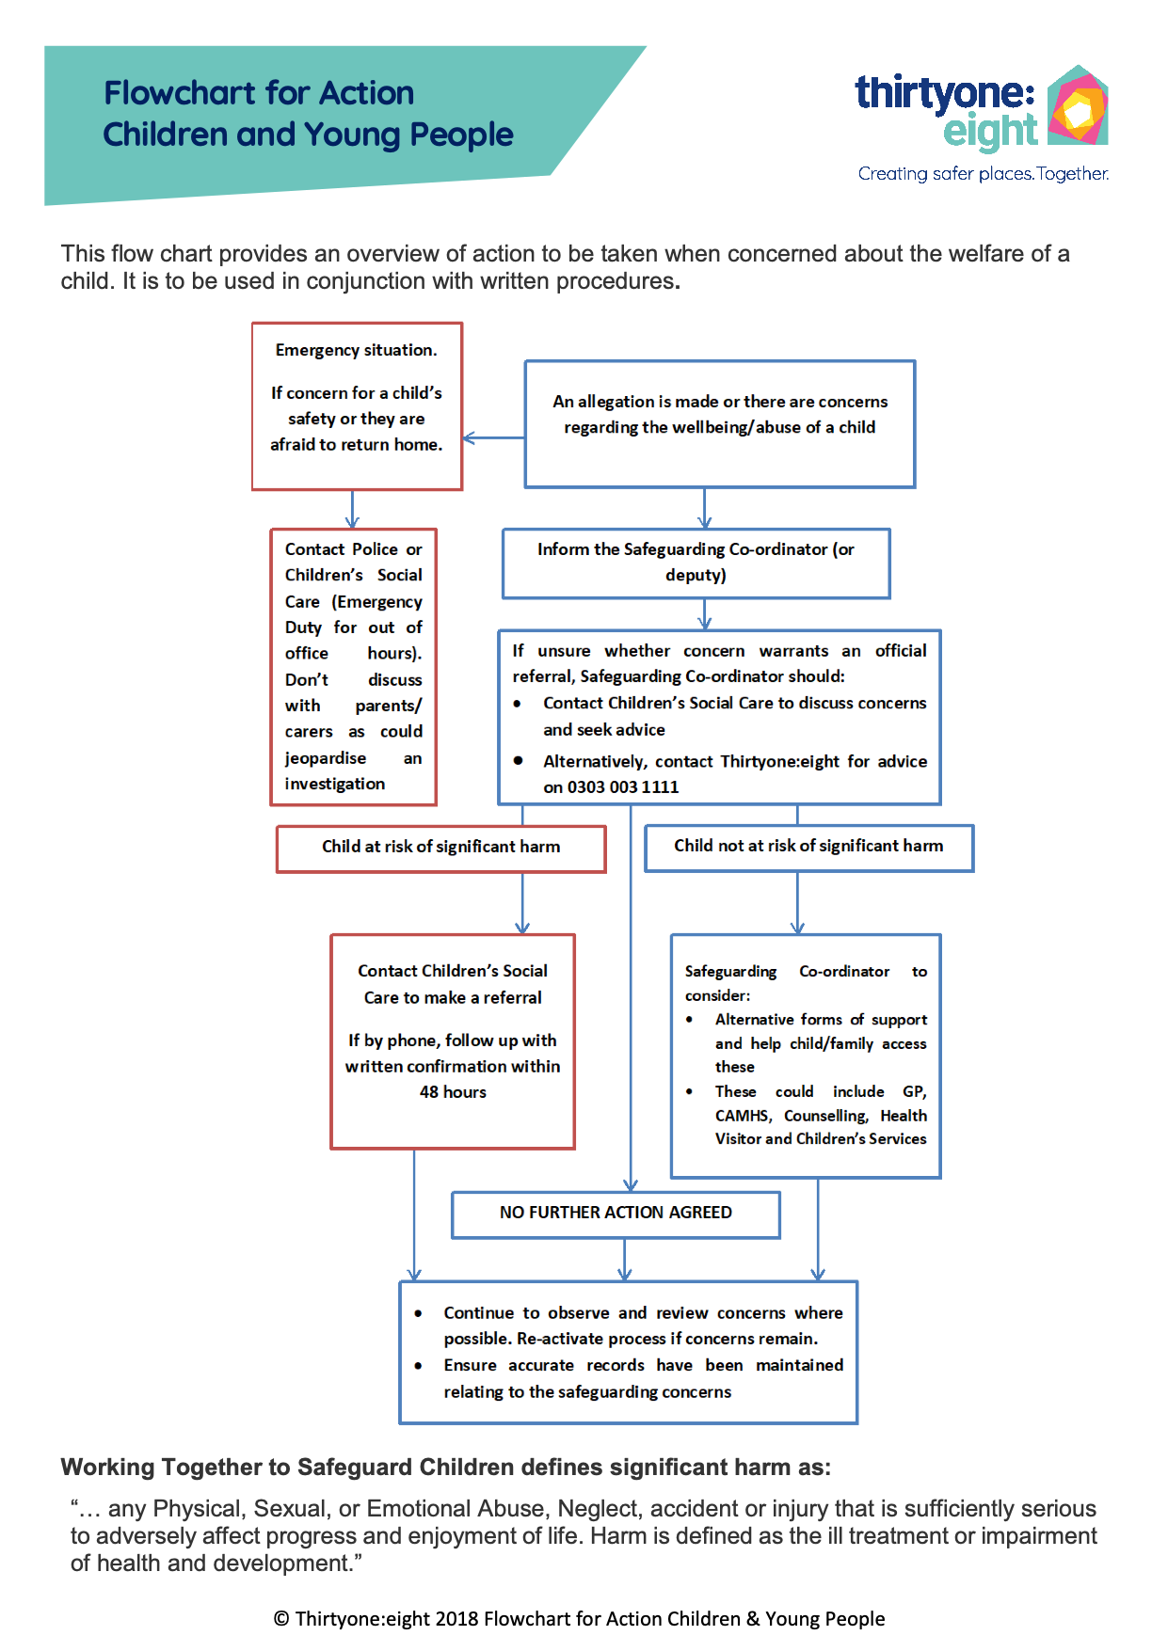
Flow chart for action (children)
Safeguarding Appendix 8:
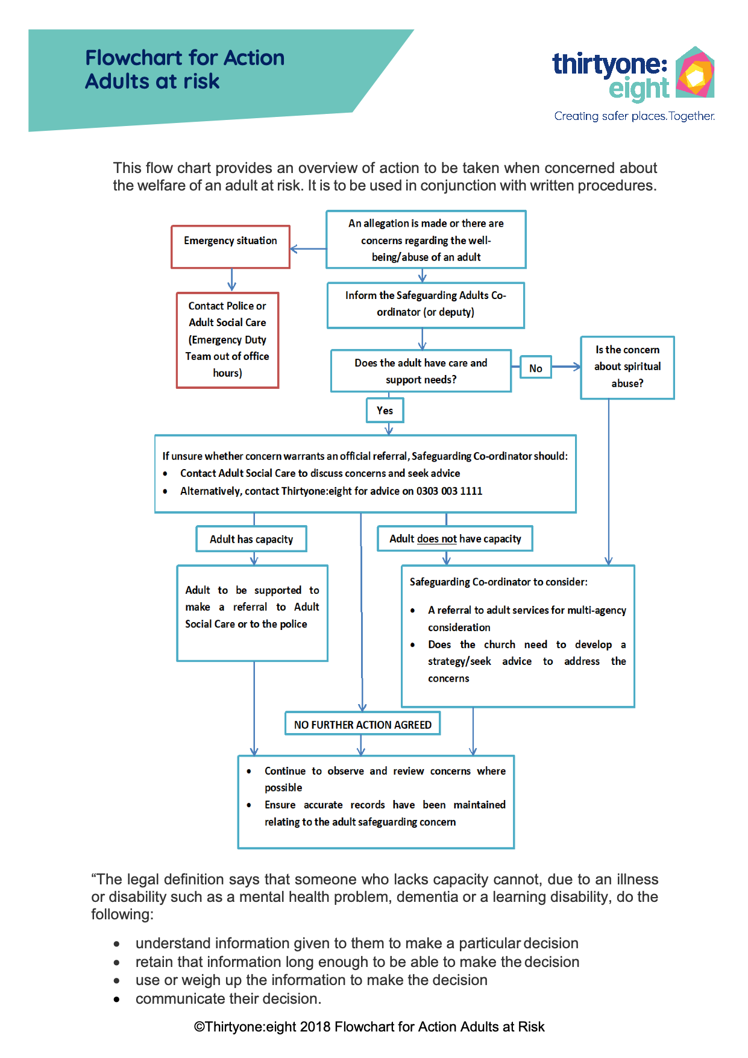
Flow chart for for action (adults)

