Cocktails

3rd & Ferry Classics
Red Rover Bloody Mary- 10.
vodka, our secret mash recipe, old bay rim
The Crabby Mary- 16.
our Red Rover Bloody topped off with shrimp cocktail, jumbo lump crab meat, and a crab cake slider.
Cucumber Collins- 10.
house infused cucumber vodka, house sour, club
3rd & Ferry Fresh Margarita- 12.
El Jimador Silver, Cointreau, simple, muddled citrus, club
Nor’easter- 12.
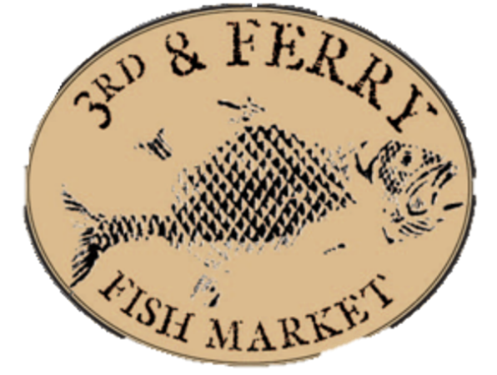
Don Q spiced rum, pomegranate, house sour, orange juice, pineapple juice, passionfruit syrup, demerara sugar rim
Freddy’s Haunting- 10.
Old Forester 86, orange bitters, honey thyme simple syrup, pineapple juice
Bubble Trouble-. 12.
rosemary infused vodka, St. Germain, Cointreau, raspberries, fresh lemon juice, prosecco top
Warmth for your Soul
The Hot Doddy- 10.
Don Q limon, barrow’s ginger liqueur, brown sugar rosemary simple, muddled citrus, chamomile citrus
Autumn Warmth- 11.
Kinsey Honey, Apple cider, ginger, cinnamon
Mike’s Smoked Barrel Old Fashioned- 14.
3rd & Ferry’s Jack Daniels Single Barrel, maple syrup, muddled orange, smoked glass, caramelized apple

Martinis
The Local Business- 13.
Stateside Vodka, blueberry raw honey simple syrup, fresh lime juice
Filthy Viking- 11.
Reyka Icelandic vodka, olive juice, blue cheese stuffed olives
Barrel Aged Manhattan- 15.
Woodford Reserve, sweet and dry vermouth
Golden Elixir- 14.
Barr Hill gin, Bitter Truth Golden Falernum, Barrow’s Intense ginger liqueur, mint, cucumber, prosecco
Pomegranate Tini- 10.
house infused raspberry vodka, house made sour, pomegranate
Pip’s Pumpkin- 12.
Vanilla Vodka, RumChata, pumpkin puree, graham cracker crust
Lipkin’s Espresso Tini-12.
Vanilla vodka, espresso liquor, hazelnut espresso infused vodka
Mules
Light and Stormy- 10.
Tito’s vodka, fresh lime juice, ginger beer
London Mule- 11.
Fords Gin, fresh lime juice, ginger beer
Seasonal Maryland Mule- 12.
Sagamore Spirit Rye, pomegranate, fresh lime juice, thyme, ginger beer
Dark and Stormier- 11.
Purchase a round of beer for the kitchen! 7.
Don Q Spiced Rum, fresh lime juice, Barrow’s Intense Ginger liqueur, club soda

Beers

Craft Drafts
Founder’s Mas Agave Lime Selzer- Grand Rapids, MI 4.5%
Cloudy & Cumbersome NEIPA- Westchester, PA 5.9%
Saugatuck Peanut Butter Porter (Nitro)- Douglas, MI 5.7%
Downeast Original Blend Cider- Boston, MA 5.1%
Spatan Oktoberfest- Germany 5.9%
Logyard Shandy Le Bleu- Kane, PA 3.2%
Roy Pitz Mason Dixon Vixen Imp. Stout- Chambersburg, PA 10%
Leinenkugel Toasted Bock- Chippewa Falls, WI 5.1%
Mahou Pilsner- Madrid, Spain 5.5%
Victory Easy Ringer IPA- Downingtown, PA 4.3%
Hermit Thrush Party Jam Apricot Sour- Battleboro, VT 5.9%
River Horse Raspberry Triple Horse- Ewing, NJ 10%
Miller Lite- Milwaukee, WI 4.2%
Yuengling Lager- Pottsville, PA 4.4%
Guinness- Dublin, Ireland 4.2%
Founder’s All Day IPA-Grand Rapids, MI 4.7%

Craft Draft Flight
4 beers. 4 ounces each. All your choice.

Bottled and Canned Brews
Budweiser
Bud Lite
Blue Moon
Michelob Ultra
Coors Light
Heineken
Peroni
Corona
Stella Artois
Fat Tire
Dogfish Head 60 Minute IPA
New Ground Café Latte
McKenzie’s Winter Crisp Cider
Yuengling Flight
Non-Alcoholic
Heineken 0.0
Bucklers

