Cocktails

3rd & Ferry Classics
Red Rover Bloody Mary- 10.
vodka, house made mash recipe, old bay rim
The Crabby Mary- 16.
our Red Rover Bloody topped off with two shrimp cocktail, and a crab cake slider.
3rd & Ferry Fresh Margarita- 12.
El Jimador Silver, Cointreau, simple syrup, muddled citrus, club
Light and Stormy- 10.
Tito’s vodka, fresh lime, ginger beer
Nor’easter- 12.
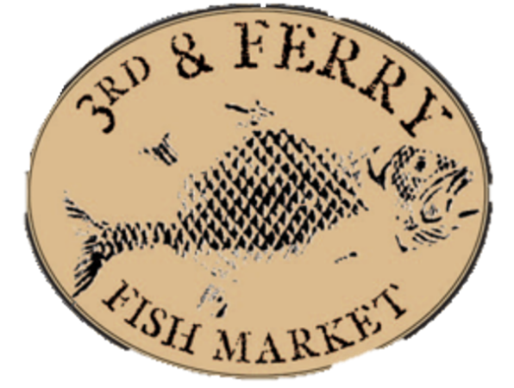
Don Q Spiced rum, pomegranate, orange, pineapple, passionfruit syrup, demerara sugar rim
Cucumber Collins – 11.
cucumber infused vodka, house made sour, club
Summer Spirit- 12.
Sagamore Spirit Rye, Montenegro amaro, strawberry puree, lemon, simple, ginger beer
Spring Fairy Sangria- 13.
white wine, chambord, lavender simple, pear puree, prosecco
Mike’s Smoked Barrel Old Fashioned- 14.
Jack Daniel’s #7, maple syrup, muddled orange, smoked glass
Becoming Royalty- 12.
Ford’s Gin, lemon, simple, butterfly pea flower tea
Sour Cherry Mojito- 14.
Christmas City Spirits Rum, Christmas City Spirits Cherry Bounce, lime, mint, club
Touch of Destiny- 14.
21 Seeds grapefruit & hibiscus tequila, guava nectar, lime, hibiscus tea, Peychaud’s bitters, El Miracle Rose Cava
Twisted Boulevard-15.
Don Q Grand Anejo, Dolin Sweet Vermouth, Montenegro amaro, Contratto Aperitif, Barrel Aged
Martinis
The Local Business- 13.
Stateside Vodka, blueberry raw honey syrup, fresh lime
High Hopes-13
strawberry infused Old Forester 86, fra-go la strawberry liqueur, elderflower liqueur, lemon, prosecco
Filthy Viking- 12.
Reyka Icelandic vodka, olive juice, blue cheese stuffed olives
Barrel Aged Perfect Manhattan- 15.
Woodford Reserve, sweet and dry vermouth
Pomegranate Tini- 12.
house infused raspberry vodka, house made sour, pomegranate
Lipkin’s Espresso Tini-12.
Powderhorn vanilla bean infused vodka, Borghetti espresso liqueur, hazelnut espresso infused vodka
Pip’s Peartini- 12.
Pear vodka, elderflower liqueur, lemon, simple, pear puree, sparkling wine
Sinful Orange Cosmo- 13.
Hanson Organic Clementine & Habanero vodka, cointreau orange & serrano shrub, lime, cranberry, candied serrano raw sugar rim
Adult Teas & Lemonades
Glass - $12 Carafe- $40
Choose your Spirit: Choose your Puree or Tea:
Raspberry vodka Strawberry
Cucumber vodka Blueberry honey
Strawberry Old Forester Raspberry puree
Blueberry vodka Guava Hibiscus tea
Choose your:
Lemonade or unsweetened iced tea
Craft Drafts
Beers
Cape May Tan Limes- Cape May, NJ 4.5%
Modelo Especial- Mexico 4.4%
Downeast Pineapple Cider- Boston, MA 5.1%
Victory Hop Devil IPA (Nitro)- Downington, PA 5.2%
Levante Cloudy and Cumbersome- West Chester, PA 5.9%
Founder’s Rubaeus Ale- Grand Rapids, MI 4%
Lagunita’s IPA- Petauma, CA 6.2%
Atwater Dirty Blonde- Detroit, MI 5.7%
Founder’s Solid Gold Lager Grand Rapids, MI 4.4%
Sloop Citrus Bomb- Fishkill, NY 6.5%
Mahou Pilsner- Spain 5.5 %
Victory Summer Love - Downingtown, PA 5.2%
Miller Lite- Milwaukee, WI 4.2%
Yuengling Lager- Pottsville, PA 4.4%
Guinness- Dublin, Ireland 4.2%
Founder’s All Day IPA-Grand Rapids, MI 4.7%

Craft Draft Flight
4 beers. 4 ounces each. All your choice.

Bottled and Canned Brews
Budweiser
Bud Lite
Blue Moon
Michelob Ultra
Coors Light
Heineken
Peroni
Corona
Stella Artois
Fat Tire
Cape May Always Ready Pale Ale
Dogfish Head 60 Minute IPA
McKenzie’s Black Cherry Cider
McKenzie’s Peach Tea
Atwater Java Porter
Founder’s Breakfast Stout
High Noon Seltzer
*ask server for selection
Non-Alcoholic
Heineken 0.0
Oyster Shooters
add oyster a la carte
Red Rover
Vodka, Bloody Mary mash
Cucumber Cooler
Cucumber vodka, serrano ginger, mash
Garden Shooter
Horseradish vodka, garden mash
Purchase a round of beer for the kitchen! 7.

