- 3rd & Ferry Classics
Red Rover Bloody Mary- 10.
vodka, our secret mash recipe, old bay rim
The Crabby Mary- 16.
our Red Rover Bloody topped off with shrimp cocktail, jumbo lump crab meat, and a crab cake slider.
Cucumber Collins- 10.
house infused cucumber vodka, house sour, club
3rd & Ferry Fresh Margarita- 12.
El Jimador Silver, Cointreau, simple, muddled citrus, club
Blueberry Lemonade- 10.
house infused blueberry vodka, simple syrup, fresh lemon juice
Freddy’s Haunting 10.
Old Forester 86, orange bitters, honey thyme simple syrup, pineapple juice
La Paloma Señorita 12.
Dulce Vida Grapefruit Tequila, lime, grapefruit, simple syrup, chile salt rim
Bubble Trouble 12.
rosemary infused vodka, St. Germain, Cointreau, raspberries, fresh lemon juice, prosecco top

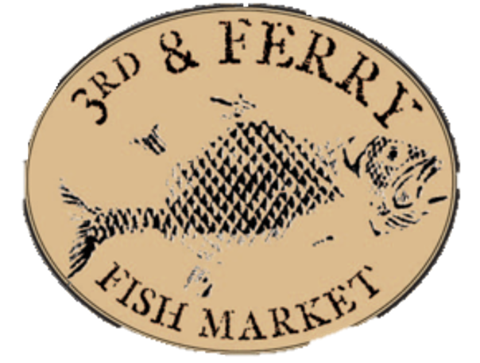
- Martinis
The Local Business- 13.
Social Still Vodka, blueberry raw honey simple syrup, lime juice
Filthy Viking- 10.
Reyka Icelandic vodka, olive juice, blue cheese stuffed olives
Barrel Aged Manhattan- 15.
Woodford Reserve, sweet and dry vermouth
3rd Street Vesper- 15.
Hendricks, Ketel One, Lillet
Lipkin’s Espresso Tini-12.
Vanilla vodka, espresso liquor,
hazelnut espresso infused vodka

- Mules
Light and Stormy- 10.
Tito’s vodka, lime juice, ginger beer
London Mule- 11.
Fords Gin, lime juice, ginger beer
Maryland Mule- 12.
Sagamore Spirit Rye, lime juice
Dark and Stormier- 11.
Don Q Spiced Rum, lime juice, Borrow’s Intense Ginger liqueur, club soda

- Craft Drafts
Epic Son of a Baptist Coffee Stout- Salt Lake City, UT 8%
Sloop Sabro Bomb NEIPA- East Fishkill, NY 6.5%
Saugatuck Peanut Butter Porter (Nitro)- Douglas, MI 5.7%
Downeast Original Blend Cider- Boston, MA 5.1%
Connecticut Valley Spiked Lemonade Smoothie- S. Windsor, CT 5%
Logyard Shandy Le Bleu- Kane, PA 3.2%
Roy Pitz Mason Dixon Vixen Imp. Stout- Chambersburg, PA 10%
Leinenkugel Toasted Bock- Chippewa Falls, WI 5.1%
Mahou Pilsner- Madrid, Spain 5.5%
New Belgium Accumulation IPA- Fort Collins, CO 6.2%
Hermit Thrush Party Jam Apricot Sour- Battleboro, VT 5.9%
River Horse Raspberry Triple Horse- Ewing, NJ 10%
Miller Lite- Milwaukee, WI 4.2%
Yuengling Lager- Pottsville, PA 4.4%
Guinness- Dublin, Ireland 4.2%
Founder’s All Day IPA-Grand Rapids, MI 4.7%

- Bottled and Canned Brews
Budweiser
Bud Lite
Michelob Ultra
Coors Light
Heineken
Peroni
Corona
Stella Artois
Cape May Tan Limes
Fat Tire
Dogfish Head 60 Minute IPA
New Ground Café Latte

- White Wines
Sparkling
Cavaliere d’Oro. Prosecco, Veneto, Italy ‘17
Freixenet, Cava, Blanc De Blancs, NV
Pinot Grigio
House Pinot Grigio
Pio, Delle Venezie, Italy ‘18
Chardonnay
House Chardonnay
William Hill, Central Coast, CA ‘15
Folie à Deux, Russian River Valley, CA ’17
Sauvignon Blanc
House Sauvignon Blanc
Echo Bay, Marlborough, NZ ‘18
Riesling
House Riesling
Bex, Nahe Qualitatswein, Germany ‘17
White Varietals
Sol Real, Vinho Verde, Escudo Real, Portugal ‘16
Chateau Pilet Bordeaux, France ‘17
Chenin Blanc, MAN, South Africa ‘16
Rose
Rosehaven, Modesto, CA ‘17
Sol Real, Vinho Verde Rose, Escudo Real, Portugal ‘19

- Red Wines
Pinot Noir
House Pinot Noir
Evolution, Willamette Valley, CA '17
Merlot/Malbec
Dark Horse, Merlot, CA ‘15
Alamos, Malbec. Mendoza ‘18
Cabernet
House Cabernet Sauvignon
Storypoint, Cabernet Sauvignon, CA '17
Red Blend
Sterling Vineyards, Napa, CA

