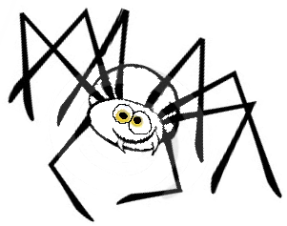
A Spider’s Spite
- Write the tale.
- Illustrate your tale.
- Publish your story on the wall.

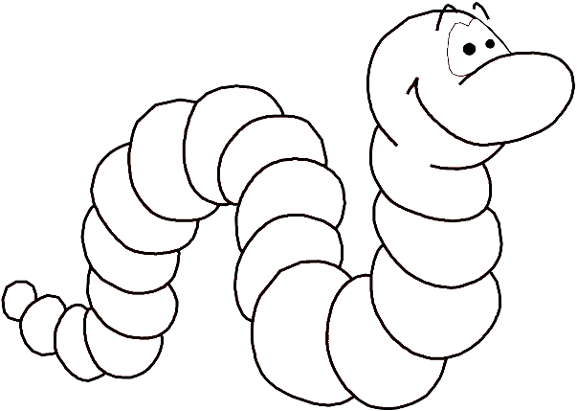
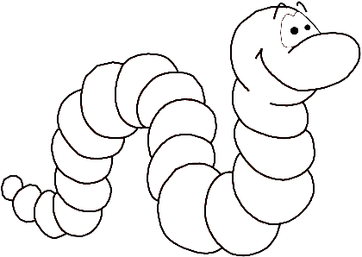
Once upon a time, there was a _______________ spider. It lived in a _____________ and had _______________ __________________. Her name was ______________ the Spider, and she was very ___________________. One day two worms _____________ up to her and said, “We want your _________________! Give it to us now.” ________________ the Spider became really _________________ and __________________ them.
adjective
verb
noun (name)
noun
verb
adjective
proper noun (name)
noun
adjective
noun
adjective
A Spider’s Spite
Prewriting
Give examples each of these parts of speech by filling in the chart.
Adjective
- _______________
- _______________
- _______________
- _______________
Proper Noun:
- _______________
Noun:
- _______________
- _______________
- _______________
Verb (infinitive):
- _______________
- _______________
Parts of Speech
- A NOUN is a person, place, thing or idea. (Examples: boy, kitchen, cup, freedom)
- A PROPER NOUN is a name. It can be a person, a place, or a thing. (Examples: Benjamin Franklin, Tennessee, Legos)
- A VERB gives action to the sentence. Verbs in the INFINITIVE form have not been changed to make sense in the sentence. (Examples: to run: I ran to the park.)
- An ADJECTIVE describes a noun. (Examples: pretty, red, two)

Parts of Speech
- A NOUN is a person, place, thing or idea. (Examples: boy, kitchen, cup, freedom)
- A PROPER NOUN is a name. It can be a person, a place, or a thing. (Examples: Benjamin Franklin, Tennessee, Legos)
- A VERB gives action to the sentence. Verbs in the INFINITIVE form have not been changed to make sense in the sentence. (Examples: to run: I ran to the park.)
- An ADJECTIVE describes a noun. (Examples: pretty, red, two)

