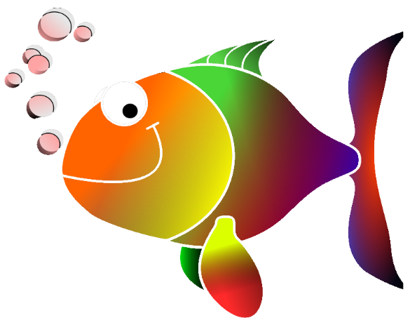
Go Fish!
(open/closed syllable)

Rules:
- Use the fishing pole to hook a card.
- Decide whether the first syllable is open or closed.
- Read the card out loud.
- Using the game mat, place the card on the spot for either “open syllable” or “closed syllable.”
- Write the words in the correct column on your sheet.
- Use the self-check sheet to see how you did.

Materials:
- Pond
- Fishing pole with magnet
- Word cards with magnets

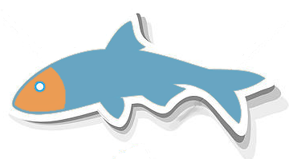
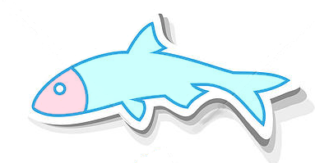

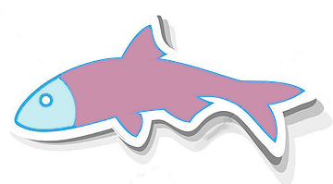
OPEN SYLLABLES | CLOSED SYLLABLES

Go Fish!
Self-Check

OPEN SYLLABLE | CLOSED SYLLABLE
noble | gobble
open | stoppable
global | inner
see | flat
token | apple
frozen | bigger
the | dust
toe | cat

YOUR NAME: ____________________________________________
Go Fish!
Write the words in the correct column.
OPEN SYLLABLE | CLOSED SYLLABLE

Open & Closed Syllables
OPEN SYLLABLES | CLOSED SYLLABLES
- End in a vowel | - End in a consonant
- Have a long vowel sound | - Have a short vowel sound
- Vowel falls off the cliff and screams its name | - Vowel is held on the cliff by a consonant
I’m safe up here! Thank you, consonant p!
No consonant to keep me safe on the cliff! Ooooo!
“go” “stop”
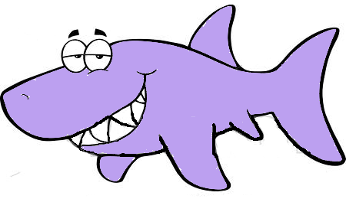
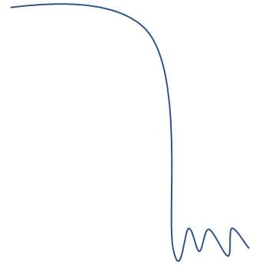
o
g
stop

