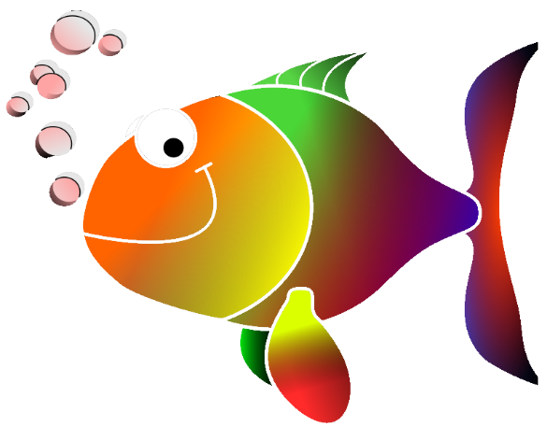
Go Fish!
(2 vowels go walking)

Rules:
- Use the fishing pole to hook a card.
- Read the card out loud.
- If you read the word correctly you get to keep the card.
- If you read the word incorrectly your teammates will help you read it correctly and it goes back into the pond.

Materials:
- Pond
- Fishing pole with magnet
- Word cards with magnets

Teacher Option:
- Students write the words on the worksheet.
- Students turn in exit ticket with graph of student wins.

Go Fish!
Self-Check

oa | ea | ai
shoal | seat | chain
foal | peat | aim
boat | each | tail
moat | meat | sail
goal | wheat | mail
soap | cheap | pain
loan | peach | main

Go Fish!
Write the words in the correct column.

oa | ea | ai

Go Fish!

- Write the players’ names in the graph.
- Color a square for each game each player wins.

