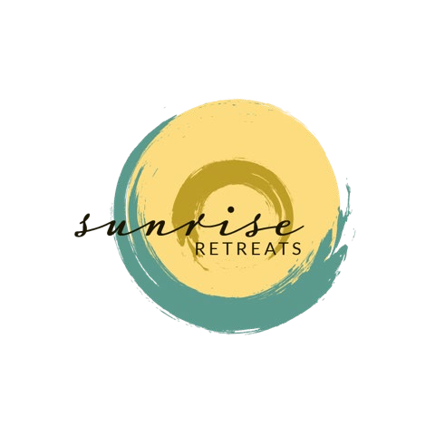
Board Member Recruitment
Applications accepted until positions are filled
Sunrise Retreats, Inc. is an Idaho nonprofit with a mission to create, fund and offer healing opportunities with trained professionals that directly support individuals (and their children) who are navigating the death of their partner. We create experiential education opportunities to enhance the health and wellbeing of individuals navigating life after the death of a partner by fostering connections, education, deep understanding, inspiration, and most of all, hope.

Sunrise Retreats positively affects the health of our community through experiences that engage the whole being through nature, art, movement, wellness tools, education, body work, adventure, good food and self-inquiry. Together we share in our common humanity: finding compassion, strength, wisdom, courage and inspiration to keep living through the fullness of grief and reimagine life after loss.

We believe that grief a preciously intimate and sacred journey and affects the whole being in body, mind and spirit. However, something magical happens when we come together in our healing. Spending time in nature, creative expression, movement, body work, adventure, good food, practical tools and self-inquiry offer powerful moments of healing. Our retreats provide a safe space to connect, support and inspire each other while reimagining new life. Together we share in our common humanity by honoring the past, being aware of the present and creating a hope filled future.
Why be a Sunrise Retreats Board Member?

- Inform and influence 2 annual retreats serving 24 women from Idaho and across the county
- Facilitate our long-term goals of being a resource for grief and life after loss
- Positively impact the health and wellbeing of Idaho’s grief and bereavement community
- Gain professional development experience in the nonprofit sector
- Use your expertise and experience to create positive change and improve lives
- Work with a passionate and committed group of experienced colleagues
Board Member Roles/Responsibilities: Our board members provide mission-based leadership and strategic governance. The Board has responsibilities associated with guiding the organization and has the ultimate legal and fiduciary responsibility for Sunrise Retreats, Inc. In general, a Board member will add value, make a difference, guide the organization, and have fun in the process.
Responsibilities:
- Serve as a trusted advisor to the Executive Director.
- Review and approve budget, audit and financial reports and statements.
- Assess program outcomes and impact.
- Contribute to annually evaluating the performance of the volunteer Executive Director.
- Represent Sunrise Retreats, Inc. to stakeholders by clearly articulating its mission and accomplishments and garnering support from the community.
- Ensure adequate resources to fulfill the Sunrise Retreats’ mission.
- Actively participate in strategic planning to establish organization goals and objectives.
- Participate on board committees.
- Review and approve relevant administrative policies
- Provide annual financial contribution to the organization, commensurate with a gift you consider to be generous.
- Serve an initial 1-year term that may be extended if Sunrise Retreats is a good fit for your talents.
- Participate fully in monthly meetings (1 hour), yearly strategic planning session (3-4 hours).
Interested in serving on the Sunrise Retreats Board?
If you would like to learn more or want to apply for an open board position, contact:
Marni Henderson | Executive Director | 208.440.1230 | marni@sunriseretreat.org
Amber Mausling | President | 208-866-5236 | ambermauslingrealty@gmail.com
Amber Dresslar | Vice President | 208-345-5145 | amber.dresslar@arkoosh.com
Katie Rhodenbaugh | Secretary | 208.870.3418 | katierhodenbaugh@yahoo.com
Jamie McCormick | Treasurer| 208-342-3676 | jmccormick@thesolvgroup.com

