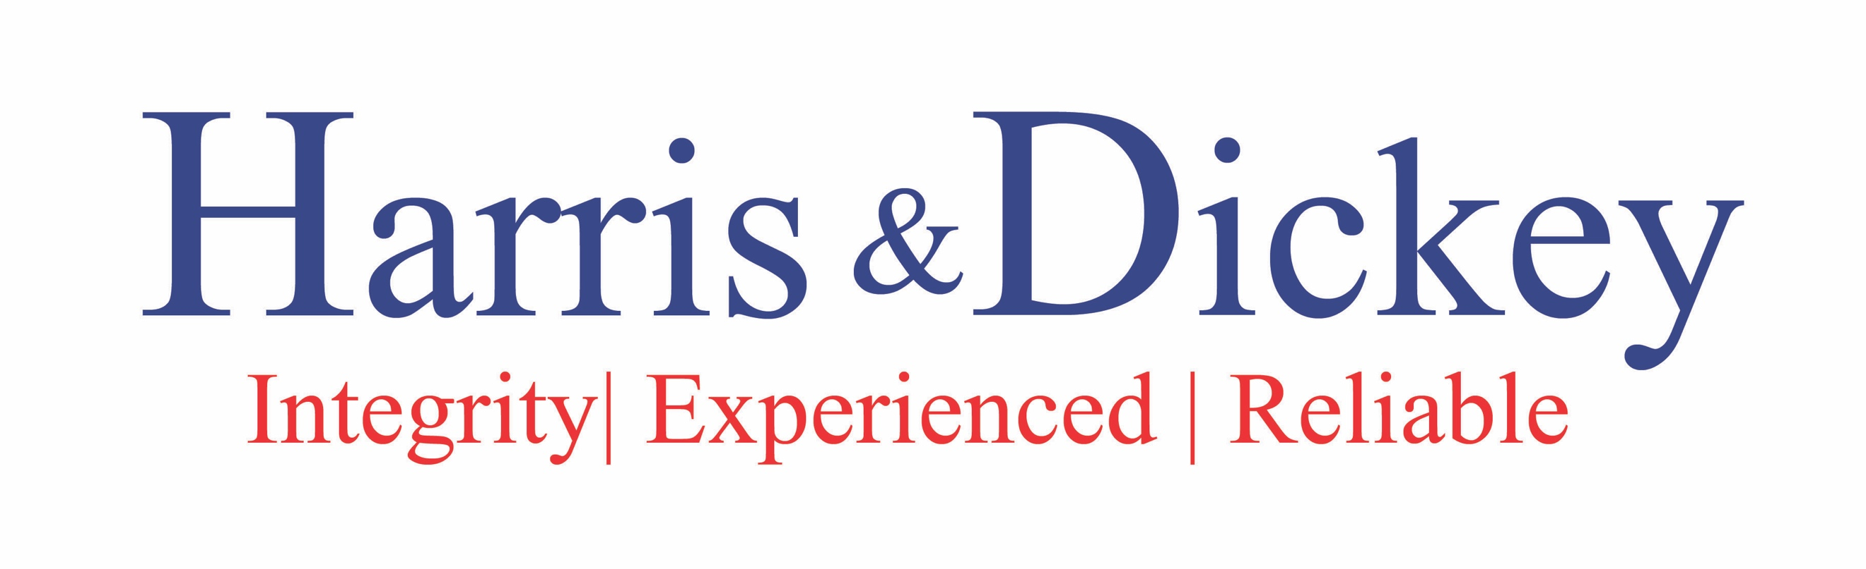
COMPANY TESTIMONIAL QUESTIONS

- What is your company name? Describe what your company does.
Kimberly Clark Corp. 140 year old company
Part of the global IT org.
Chief information Security Officer (CISO)
- How did you hear about Harris & Dickey?
Worked for Helen at Jefferson Wells. Helen was managing director and he was the director of Technoclogy management. 2 years.

Left JW before Helen.

- What was the nature of the engagement you hired Harris & Dickey to do? What problem/issue did Harris & Dickey help you solve?
KC resp. for all global It secirty complicane.
CSA – needed to be have Security Assessment. Auditing would address the issues. Needed rescources who were knowledgeable of global environments. See video

Affordable rates with the experience, trust

Driving results and have experience to provide caliture of results and develoverables.

- How did Harris & Dickey deliver on their promise?
KC new to areana, working from ground zero. Resouces were experienced and ready to assist. Integrated team members, ready to deliever.
- Why did you choose to work with Harris & Dickey? Were their other providers you were considering?

- Would you recommend Harris & Dickey to your colleagues? What comments would you say about Harris & Dickey?

Yes. Dependable, dedication and personal relationship. Reliablbilty & dependable for timeframes. Commitment, dedication and .

- Would you choose to work with Harris & Dickey again? Why?

- Are there any additional comments you would like to add?

Partner at the table with you. Bring quality resources that can work well in the teams.

