**Rose with a Stem Instructions**

1. Take a piece of origami paper and fold it diagonally. Unfold.
2. Hold the paper so that it is in the position of a diamond (rather than a square).
3. Fold the bottom two sides of the paper to the center line. Notice that the folds create two right triangles, with a side on top and a side on the left/right.

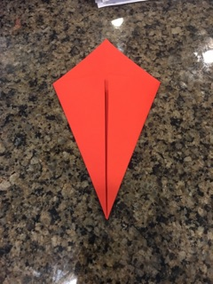

1. Fold down the top lines of the triangles to their relative hypotenuses.

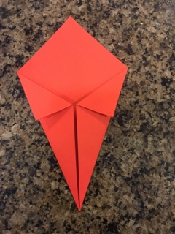

1. Flip the paper over and fold the bottom tip to the top tip.

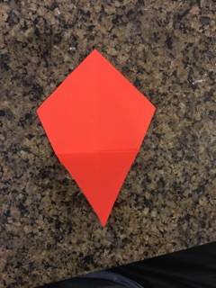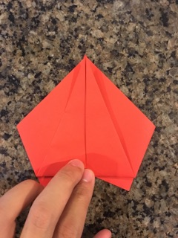

1. Fold the top tip down past the bottom line so that the ratio of the height of the newly formed upside down triangle to the height of the original triangle is ~4:5.

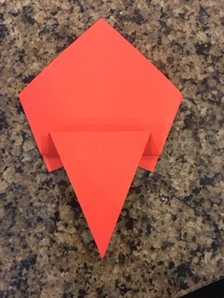

1. Fold down the two top corners so that they touch the bottom line.

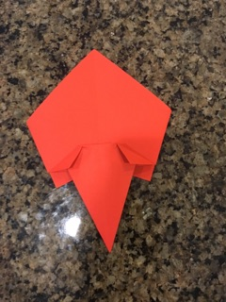

1. Open the folds you made in step 7 and flatten.

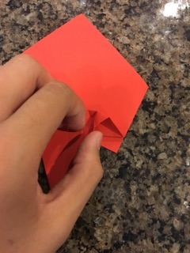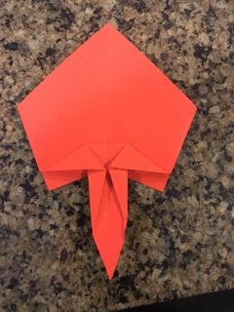

1. Fold down the very top tip of the paper.

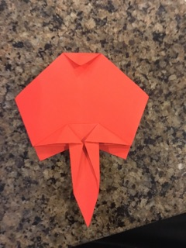

1. Flip the paper over. You finished the rose part!

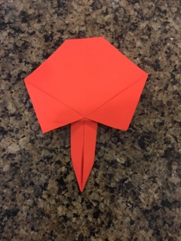

1. Take another piece of paper of a different color and repeat steps 1 to 3.

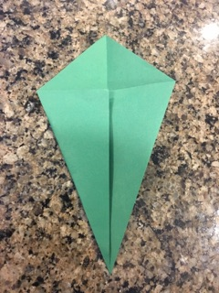

1. Notice that the shape you made is a kite. Take the two shorter sides of the kite and fold them to the center line.

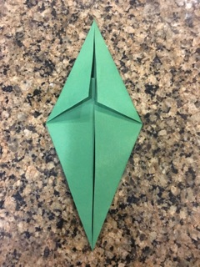

1. Fold the paper in half.

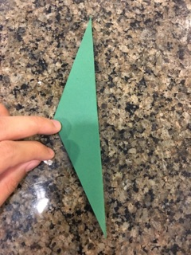

1. Fold the paper in half again. Unfold.

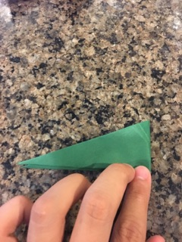

1. Fold the paper so that one half of the paper is on top of the other half, but not completely covering it (it doesn’t matter what direction you fold the paper). You finished the stem part!

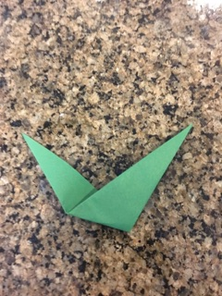

1. Connect the first of origami paper with the second piece and stick them together. You have created a rose with a stem!

