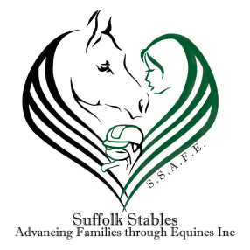

**S.S.A.F.E FINANCIAL ASSISTANCE INFORMATION.**

Financial Assistance is based upon household size and the total amount of household income for a family applying for dependents or total income of a young adult if they are applying for themselves. To be able to help as many people as possible, we adhere to the following guidelines:

* Applicants can apply up to and including the age of 25 years.
* Applicants that are not approved at first can reapply in 30 days.
* Financial assistance is limited to lessons, Leases, Shows and day trips.
* Please keep in mind that we are trying to make our program available and possible to as many people as we can. Please don’t let a lack of riding gear or equipment stop you from applying. We do have spare items and will do our ‘BEST’ to ensure you have what you need. If you need items please contact Deborah Lyons Greer at (609) 346-7093.

**HOW TO APPLY FOR FINANCIAL ASSISTANCE**

* Complete a manual application for each rider you wish to apply for.
* Submit the completed application and any supporting documents required. (2018 tax returns with dependent listed on return if applicable, current financial information including three consecutive pay stubs, any support or alimony documentation, disability or unemployment.
* Allow at least forty five days for processing of your Financial Assistance Application. Financial Assistance is NOT guaranteed and is awarded on a first come first serve basis.
* Upon notice of your qualification you will have seven days from the notice to accept or refuse the assistance.
* Scholarship recipients are required to volunteer five hours a month to help at the Suffolk Stables.
* S.S.A.F.E Reserves the right to cancel at any time.

Mail the completed application and required support to:

S,S,A,F,E

1418 Old Indian Mills Rd

Shamong NJ 08088

Please call Deborah Lyons-Greer at (609) 346-7093 with any questions.