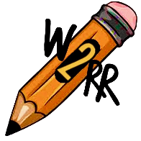
Write 2 Read Right
Media Consent Form for
Children and Young Adults

I, ___________________________________, am the parent/guardian of
____________________________________________ (child’s name).
I hereby consent to my child’s participation in interviews, the use of quotes and the taking of photographs and/or videos of him/her on behalf of Write 2 Read Right and the Nova 2020 Book Series.
I also grant the right to use, and reuse said products for print, online, social media, and all other forms of media.
I consent to the use of my child’s name and association with Write 2 Read Right and Nova 2020 Book Series for the foregoing purposes.
I give authorization without expectations of compensation.
This consent will not expire until it has been revoked in writing by me.

Signature: ________________________________________ Date: ___________________________

Write 2 Read Right and Nova 2020 Book Series are presented by Michol Whitney.
Sign up for emails and notification on write2readright.com.
Follow @nova2020series on social media platforms. YouTube @w2rr

