94-04 MUSTANG TUBULAR FRONT END INSTALL INSTRUCTIONS
**Disclaimer- For Off-road Use Only**

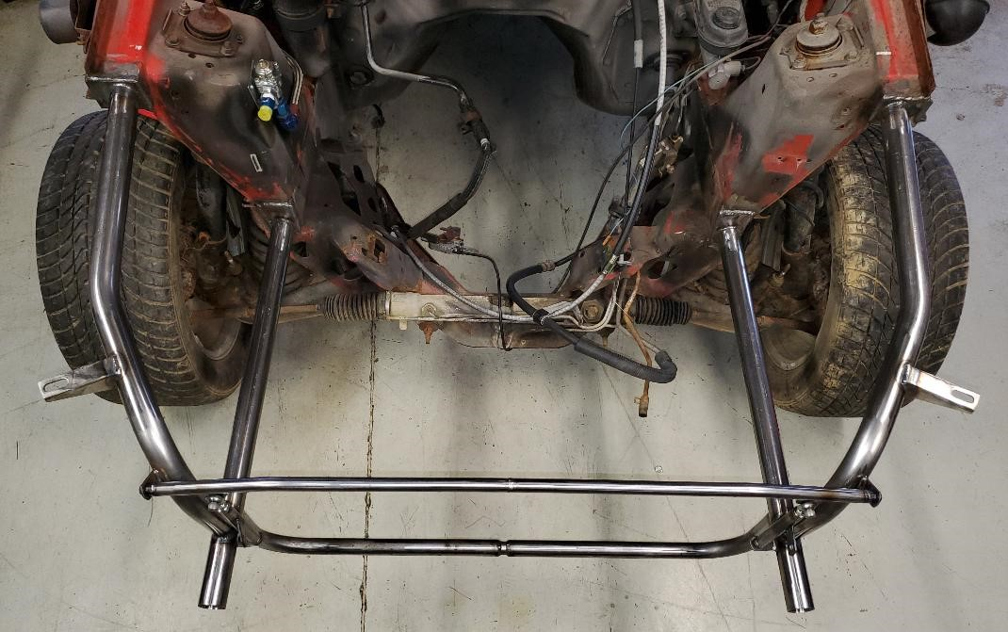
Reference picture of how the general final assembly will look, pending on the final position of the upper and lower core support bars on your particular setup
-----Please note, several of the pictures in reference to leveling and a few measurements show a foxbody mustang, but the images are updated for 94-04 measurements and accurate-----

- Start by removing the front bumper cover, fenders, and anything in front of the strut towers. This includes the front swaybar and all wiring, brake lines, etc

- Get the car level. Use the frame rail at the bottom of the strut tower to level the car front to rear, as this allows the factory angle of the frame rail to be followed by your new bottom rail

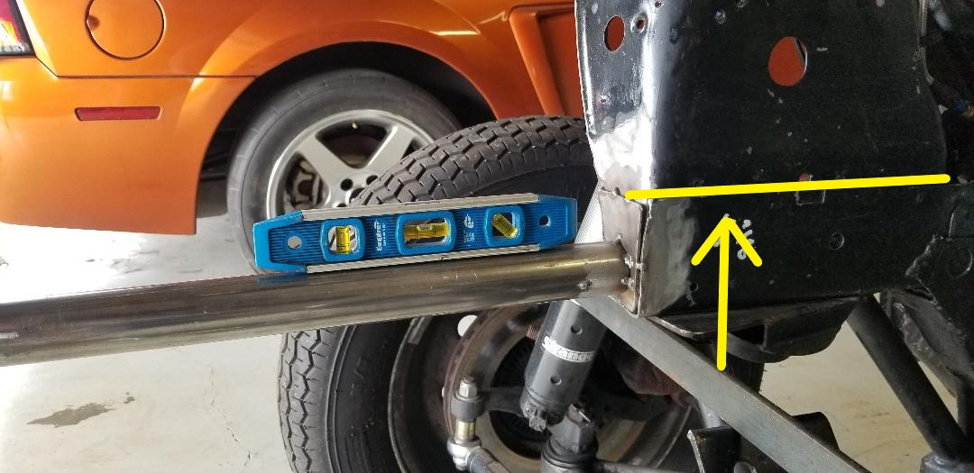

-There are several points you can use for side to side leveling. It is preferred to use a bar/level along the bottom of the frame rails across the engine bay. Of course, if you are attempting this with the drivetrain in the car, a 4 ft level across the top of the frame rails above the strut towers works OK as well, just be aware that the rails slope down towards the front of the car

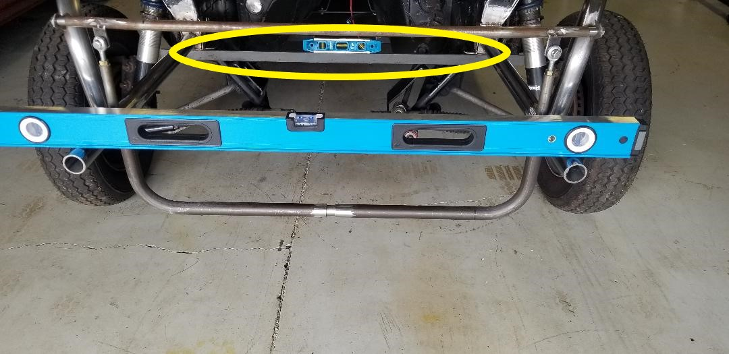

- The following pictures are a visual reference for where to make your cuts. This particular car has had several different tube front ends installed, so the factory lower rails are cut back further towards the strut tower than typically would be at first.

- For the upper cut, pull your measurement from the front edge of the square area on the rear area of the upper rail. Your final cut should be 12 1/8” from that point. It is recommended to cut it a little long, so you have extra material to touch it up and keep it as square as possible, for welding and aesthetic purposes.
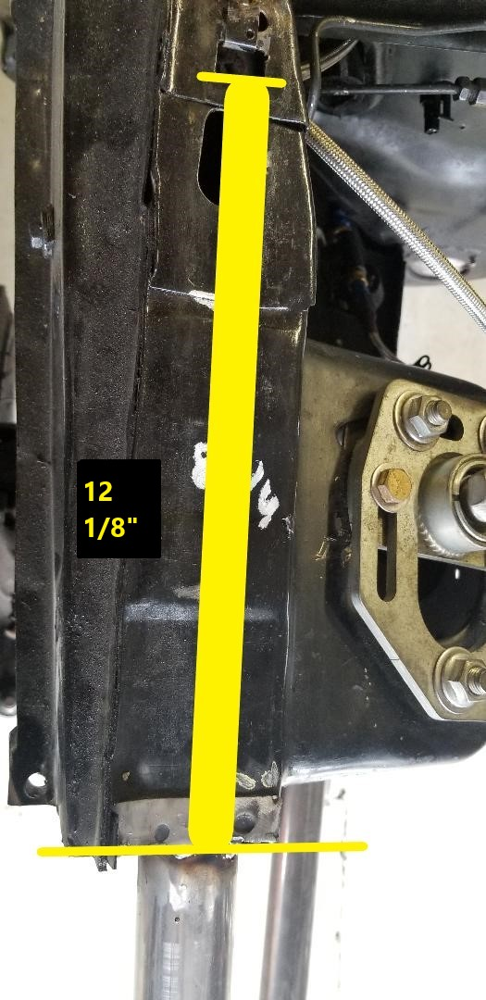
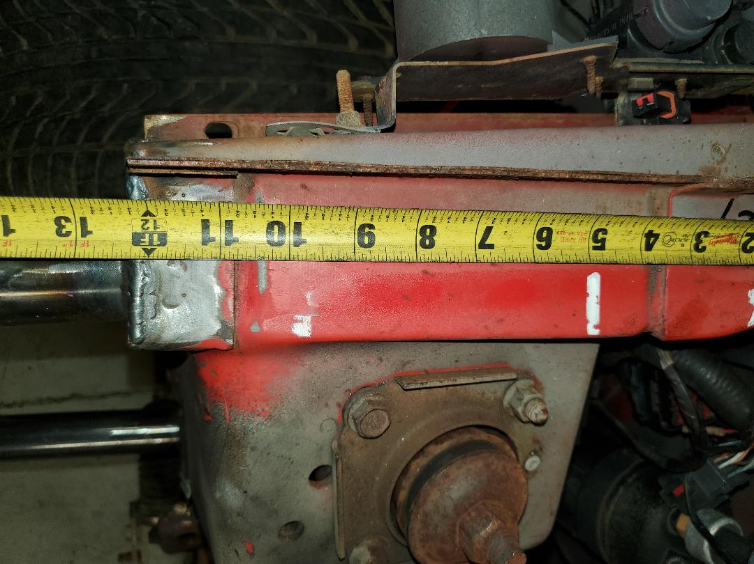

- For the lower cut, disregard the measurements on the following picture, as the notch location in the lower rail varies slightly between the 94-95, 96-98, and 99-04 cars.

- Instead, use it as a visual reference, as you generally want a straight cut from the upper mount to the lower rail area. I do like to leave the lower frame rail roughly 1/2” long from the strut tower face, so I can slowly trim back for final fitup and appearance
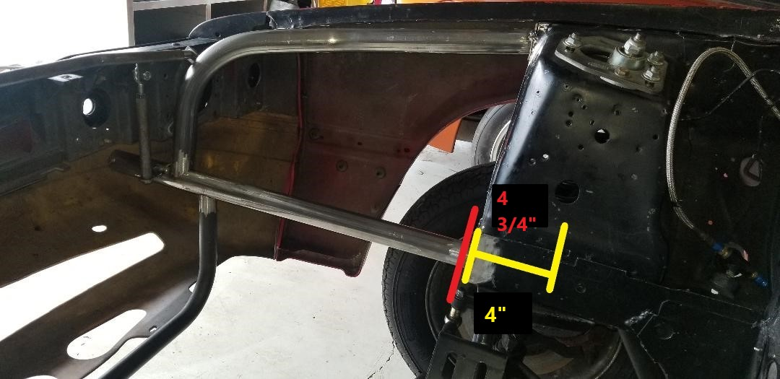
****An important note that may not be required for all installs, as it depends on how much work you want to put into the lower factory rail fit-up.

It may be required to touch up this bottom corner and grind a curve into it to fit flush and look good for final welding. Refer to the following pictures.

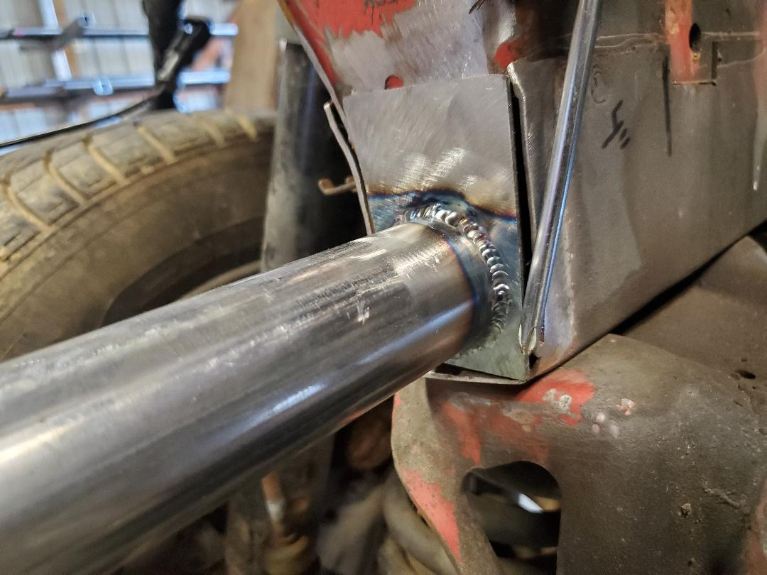

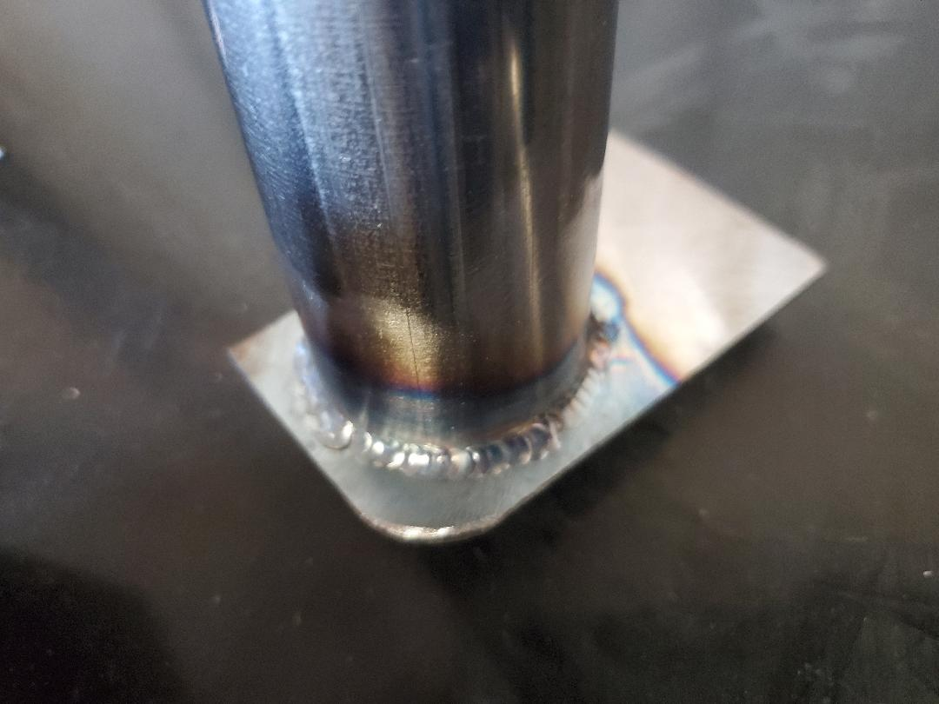

- At this point, once you are satisfied with your fit-up and dimensions in front of the strut towers, you are ready to install the lower tubular rails. Of course, you should have all paint removed and clean metal to weld to

- Start with small tacks so you can still manipulate the bar slightly if need be. It is best to set up both bars at the same time, so you can verify they are level with each other, and can make changes as needed. Keep in mind, looking from the top, the bars come out at an angle, matching the factory path, and NOT 100% parallel with each other.

**(It may be necessary to move lower bars up or down + - 1/8 on the strut tower to get final fit of the upper bars located exactly where you want them)**

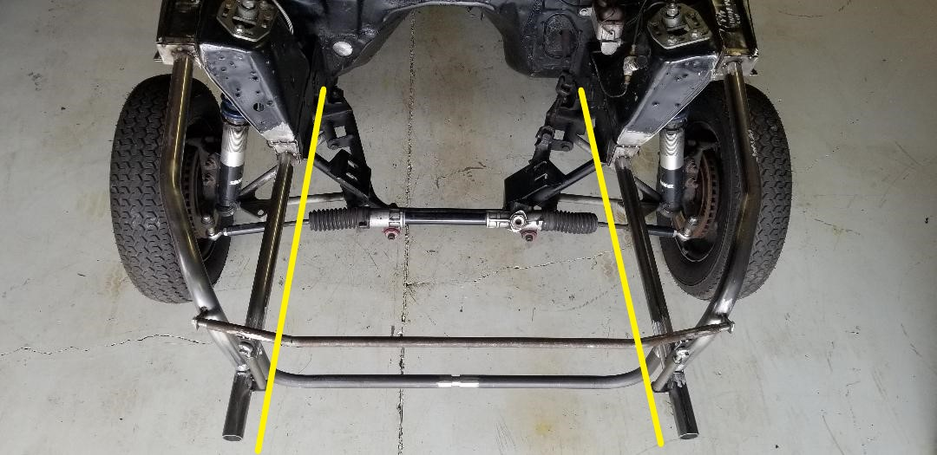

- The notches in the upper bars will get your outward angle on the lower bars correct, but the following pictures will show where to pull measurements in an “X” pattern to verify the assembly is square, and to account for minor differences from install to install. Dimensions noted in the pictures as well

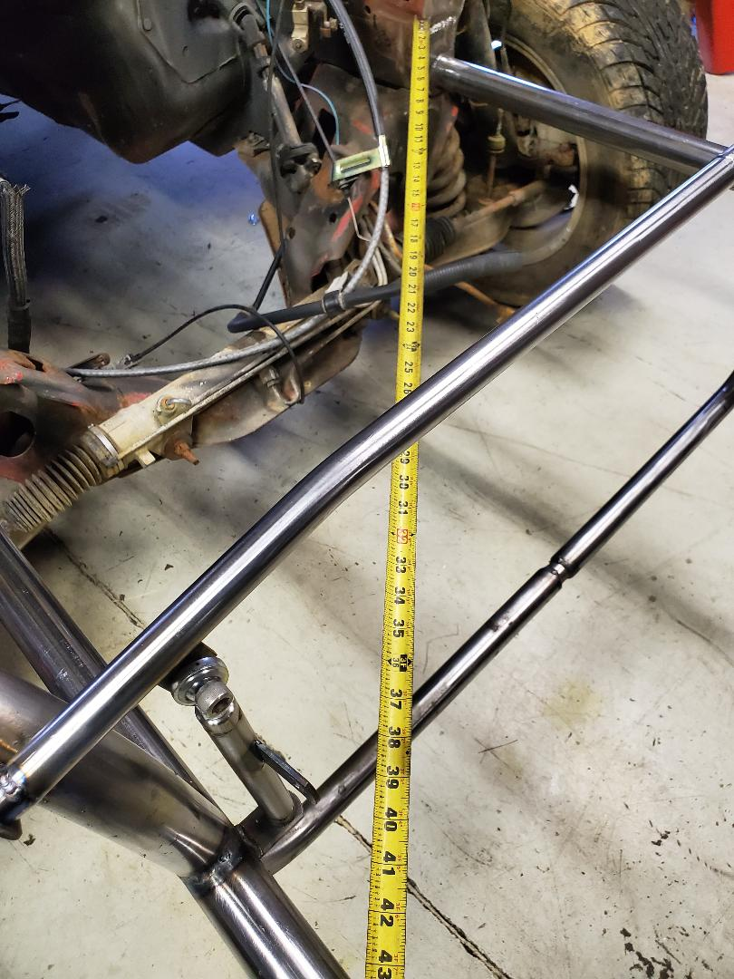

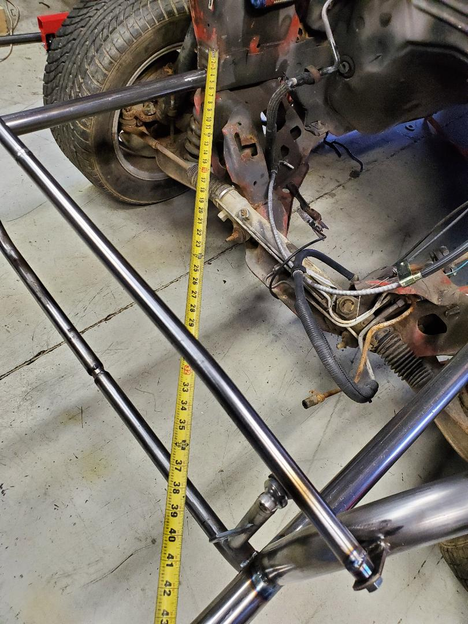

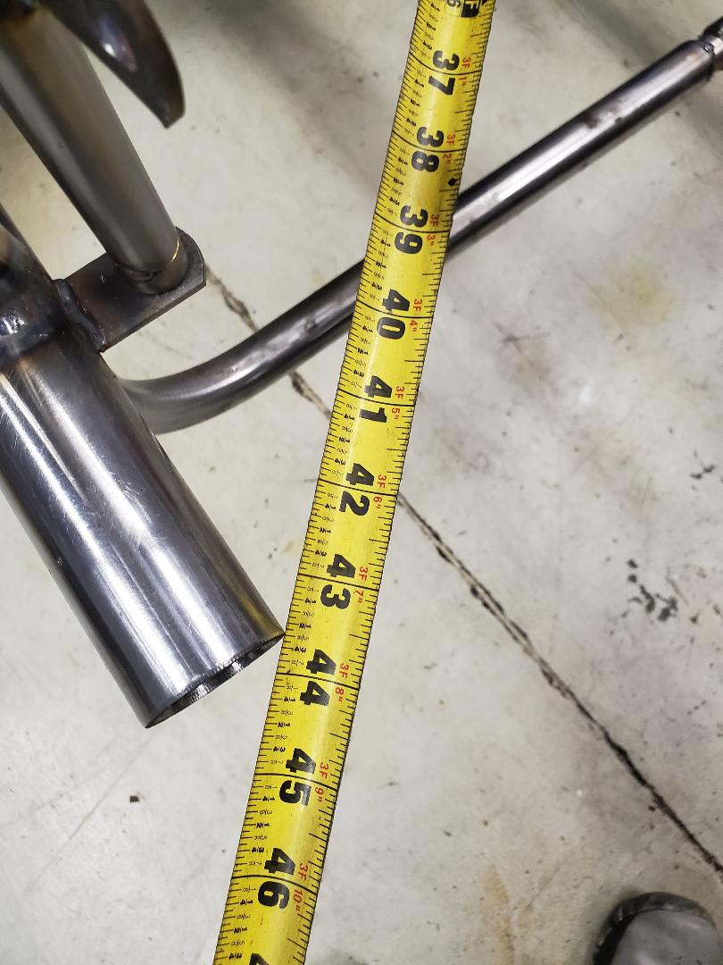

- On to the upper bars, a digital angle gauge was used to set these up as accurate as possible, but a simple analog needle type angle gauge will work well too. Attached are pictures to note the angles the upper bars should be at.

- Looking from the front of the car, the angle of the forward down bar should be angled out at 85 degrees. The other angles are not very important in the general setup, they are just used to verify a mirror image on both sides
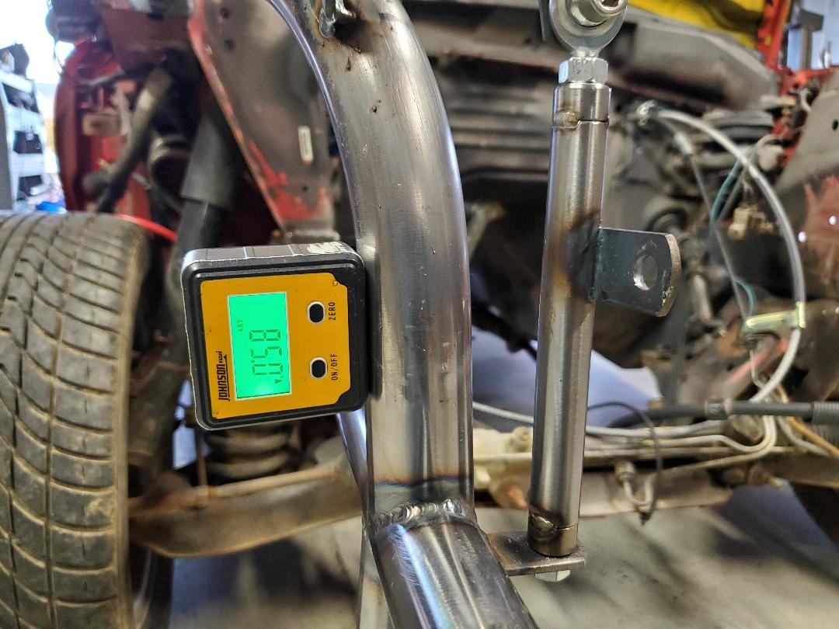

- From the very front of the lower bar, to the front edge of your upper bar where the 2 bars tie together, should be very close to 4”, preferred to keep it + or – within 1/8
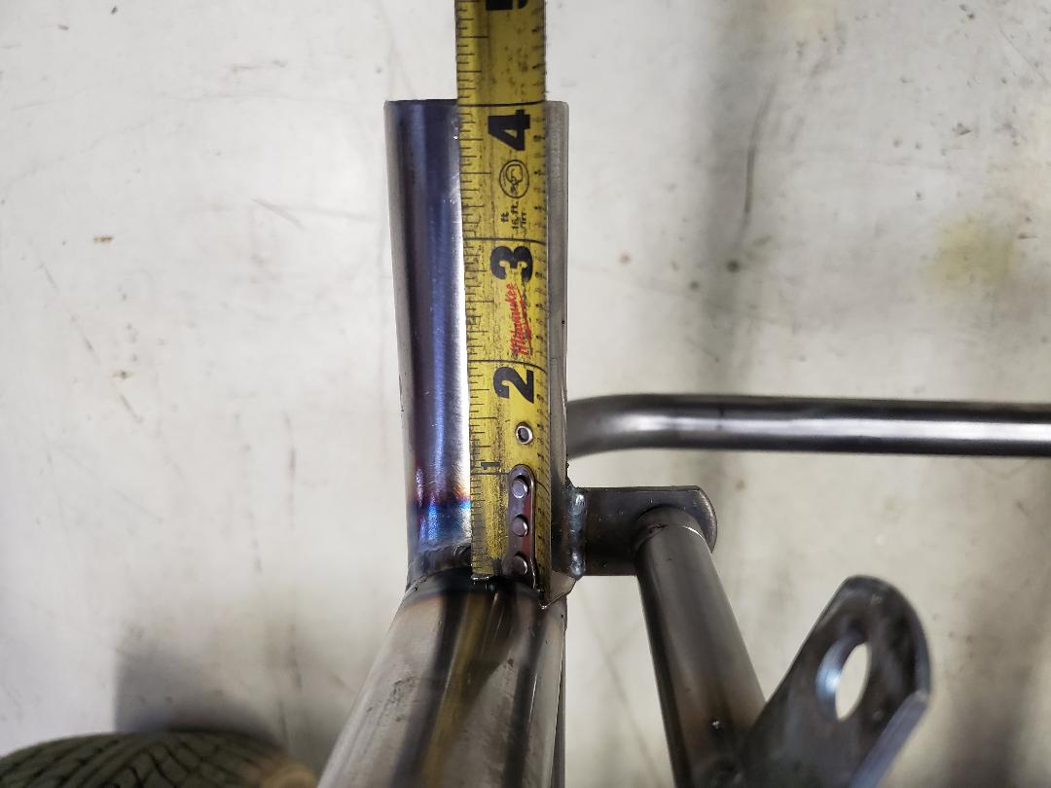

- Strut tower face to the end of the lower bar is setup at 28 3/8”

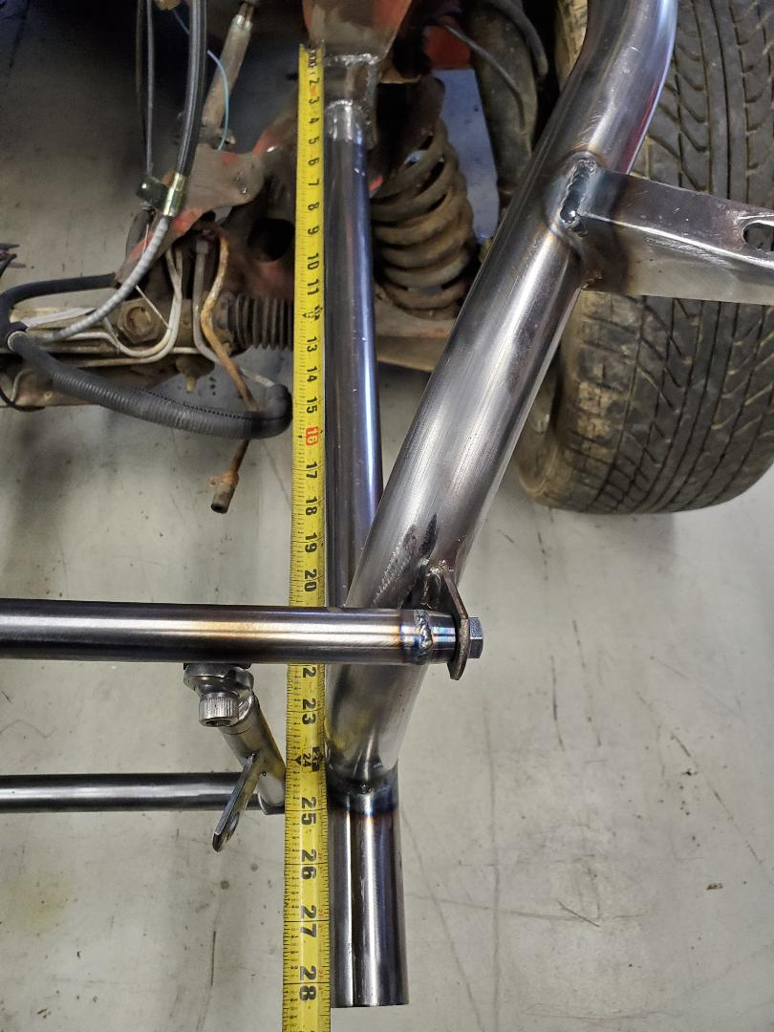

- The lower heim joint mounting tab, I like to set back 3 ¾” from the front edge of the lower bar. Again, this is just a general reference point, as it could be different between setups. The goal here is to make sure it clears your headlight panel.

- The (2) 2 3/8 tabs included are designed to attach and weld to your adjusters once the final setup is done, to provide a solid mounting point for the header panel. Refer to the following pictures
***( Note the body shim on the passenger side, just to demonstrate and easy way to have the header panel sit 100% perfect and tight if needed) ***

EDIT: THE FOLLOWING PICTURE IS OF THE UPDATED HEADER PANEL TABS THAT REPLACE THE SINGLE 2 3/8” TAB ON EACH SIDE

THE TOP “L” SHAPED BRACKETS BELONG TO THE 99-04 CARS

THE LOWER FLAT BRACKETS BELONG TO THE 94-98 CARS
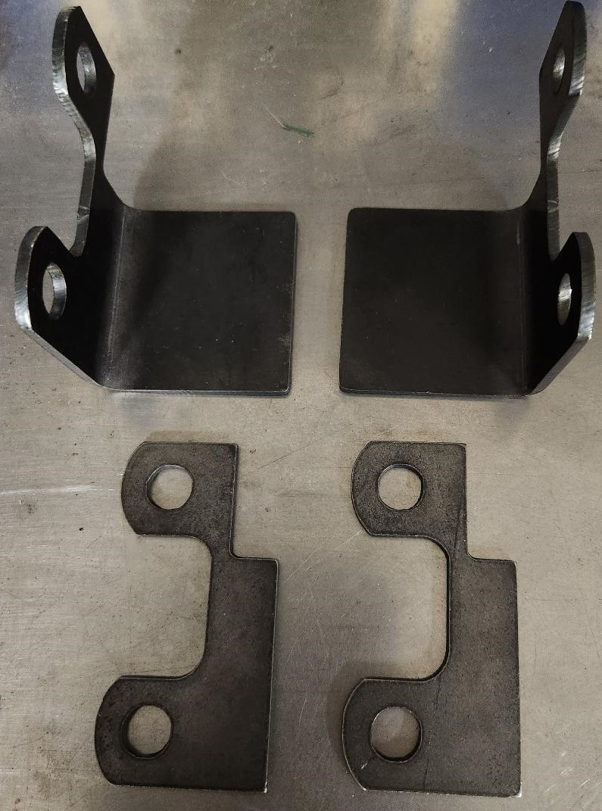

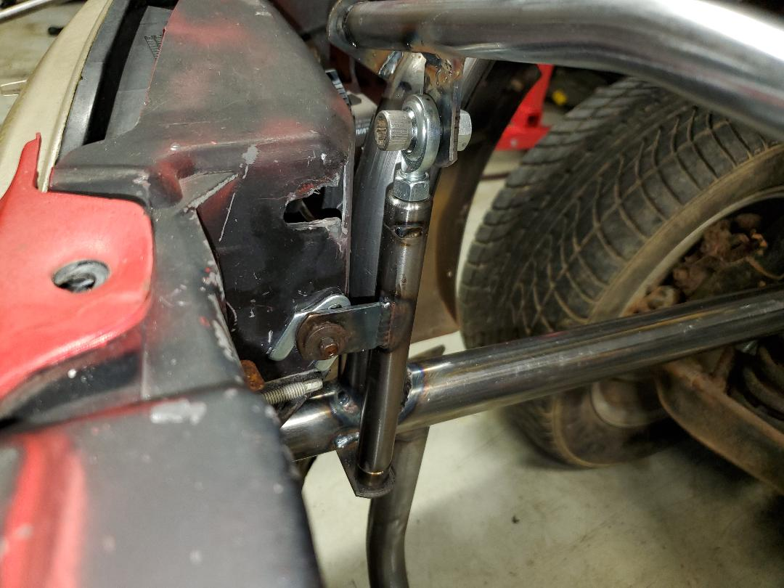

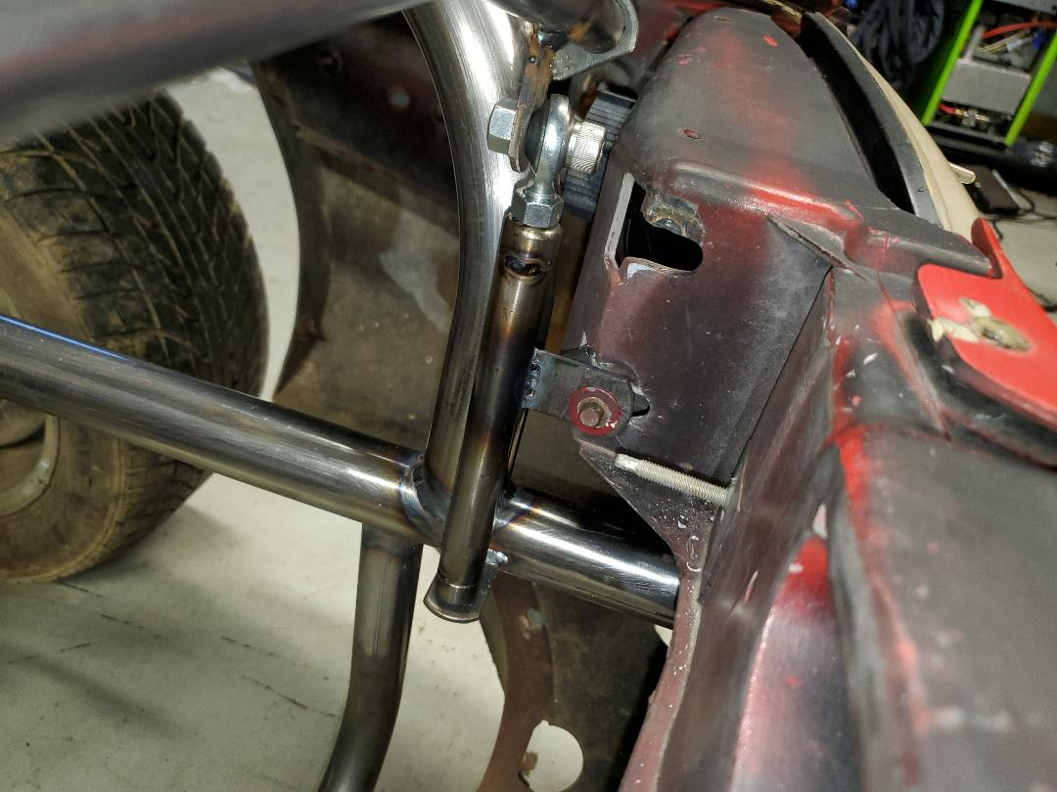

- Fender mounting tabs are included, and must be welded up by the installer. It is not necessary, but I like to weld and grind the bead down for aesthetic reasons. Refer to the following pictures
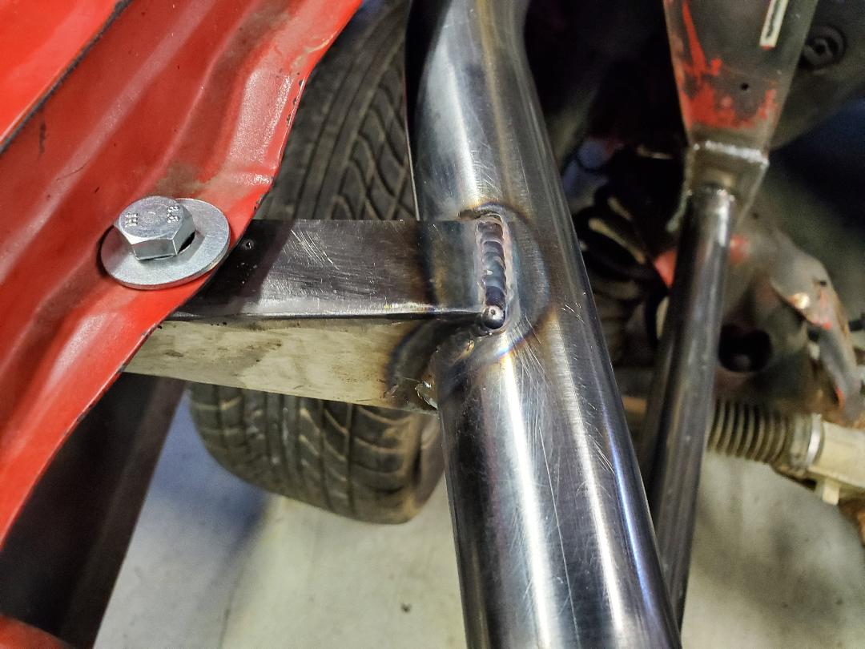

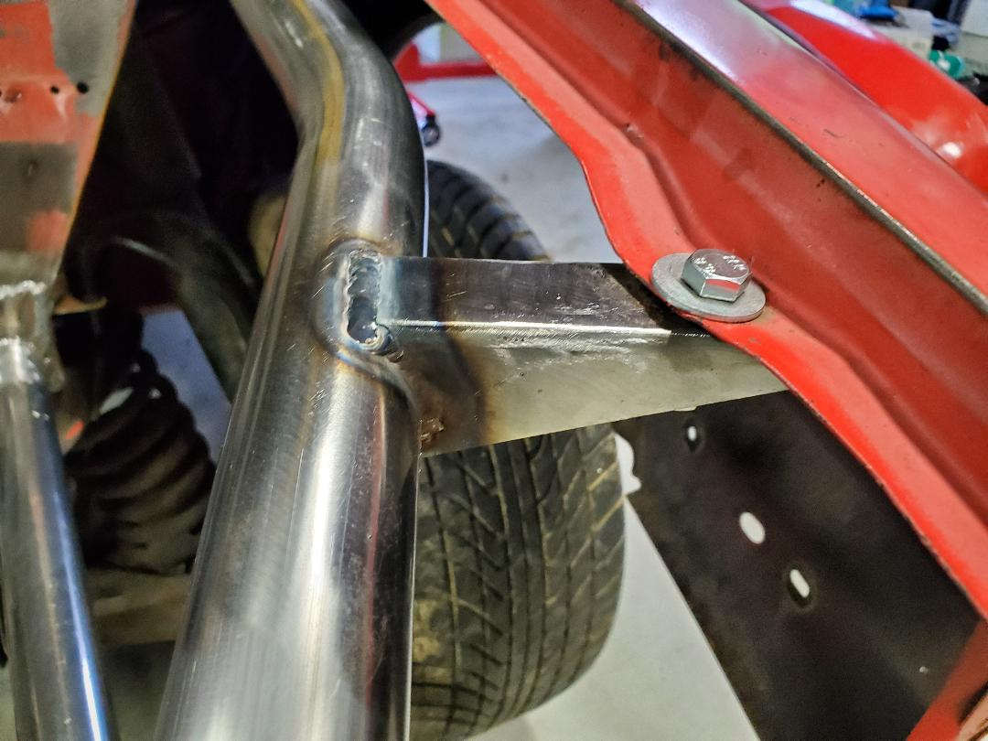

- There is not a whole lot to cover in reference to mounting the radiator support and upper core support bar, as they are designed with quite a bit of adjustability, and likely will not be the same between setups. Just be sure to mount the two lower support halves on its correct side, as the notches follow the angle of the lower frame bars, and are not at a true 90 degree angle.

Mount them to where they work best for your setup, but generally speaking, roughly 19” from where the radiator sits in its lower support bar, to the upper core support will get you close.

- At this point, before any final welding is done, it is typical to double check all measurements, and make sure everything is still square and level. Verify the upper core support placement doesn’t interfere with hood closure, etc

- Double check your clearance between your upper bars and headlight bulbs and insert. This is a rather tight fit in this area, so verify clearance before final welding
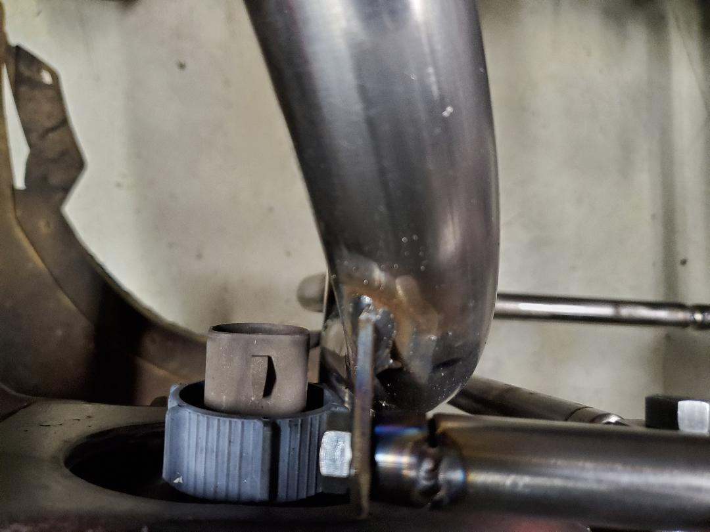
***In closing, a few final pictures will follow for reference to how it should look all finished up and done. Take your time, and enjoy your new setup!

