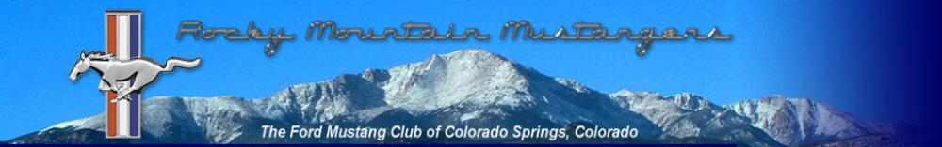
–
VOLUME 15 ISSUE 1 JANUARY, 2015
September, 2026
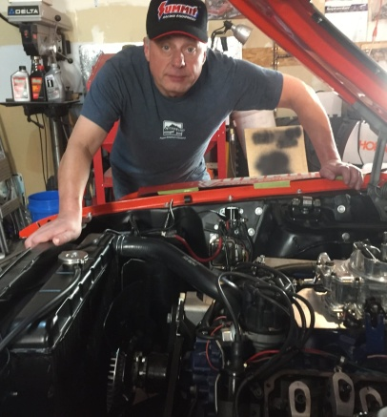
From the Editor…
As our planet is nearing the end of yet another trip around the Sun, fall is here. Please keep an eye out for Reed’s announcement about the annual Fall Colors Tour. This event is dependent on when the leaves turn and that can be tough to call in the Rockies. After a very dry year, weather guessers are predicting the leaves will turn early, but one never knows. The Fall Colors Tour is a signature event for the Rocky Mountain Mustang Club and it’s a lot of fun. Not sure if I can make it this year as my Mustang is still awaiting a new engine, but I hope you can. Mark your calendars for the day Reed chooses and get your Pony into the Mountains!
The club is changing up venues for our monthly meetings. The IHOP restaurant at Powers and Stetson Hills is new. Well, it’s new again. The club had met there years ago and we are trying again. Check the club web site for details so you know where to be and when.
The club board had some discussions about the “Door Prizes” we feature at our monthly meetings. Seems participation is waning. Janie puts a lot of work into the Door Prizes. Please tell her how much you appreciate that work and speak up at the meeting if you want the Door Prizes to continue. Also let us know if you have any suggestions for the Door Prizes.
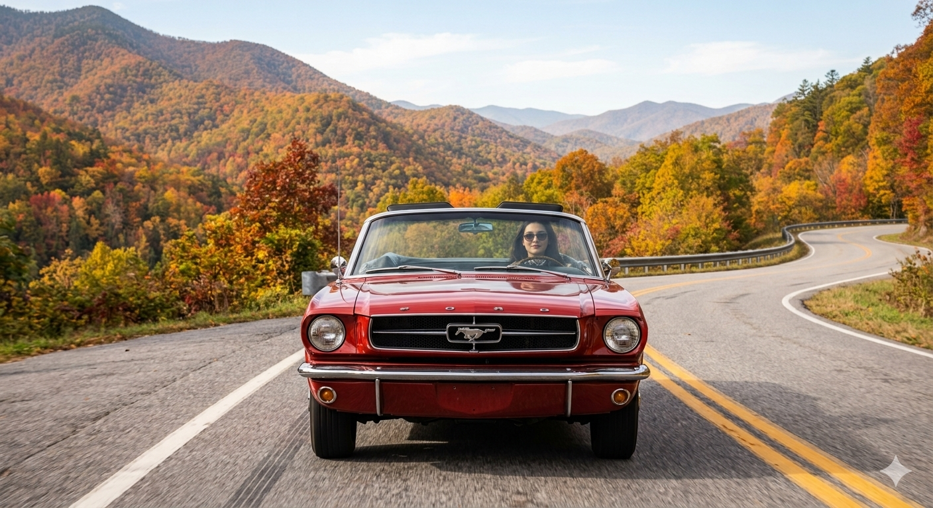
As for suggestions, don’t forget the Rocky Mountain Mustang Club is your club. If you have ideas or suggestions, please bring them up at the monthly meetings. You can also shoot me a message at newsletter@mustangers.com
Ford Mustang News

Time to wave your “BLASPHEMY!” flags. Ford is once again planning a four-door Mustang coupe.
https://www.motortrend.com/news/2029-ford-mustang-mach-4-sedan-future-cars
2027 Dark Horse Convertible
https://themustangsource.com/how-tos/slideshows/2027-ford-mustang-dark-horse-sc-convertible-795-hp-with-the-top-down-1009967#the-most-powerful-drop-top-mustang

New Ford Mustang GTD Spirit Of America Debuts As Europe Reopens Applications

https://fordauthority.com/2026/09/new-ford-mustang-gtd-spirit-of-america-debuts-as-europe-reopens-applications/
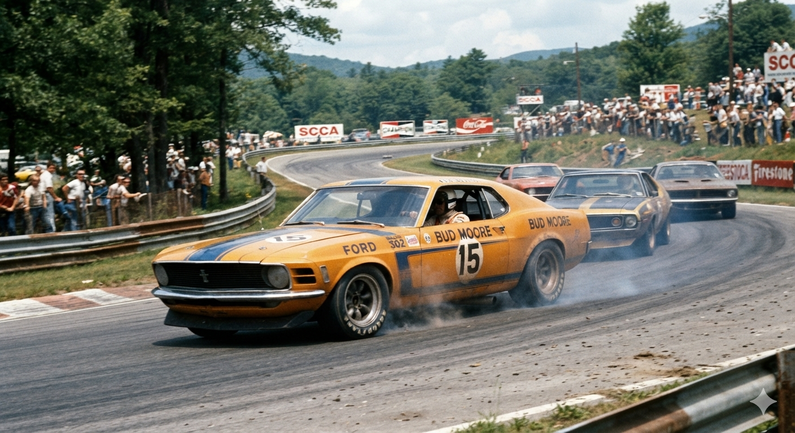
2026 Garage Tour
We started out at Curt's house where 11 mustangs showed up and gooey cinnamon rolls were served. Then, we drove over to Mike’s house where we added 2 more mustangs and min-donuts were available. Finally, we drove over to my house where we had a total of 15 mustangs and 20 people. During the meeting, subway sandwiches and wraps were served.

- George
20202620
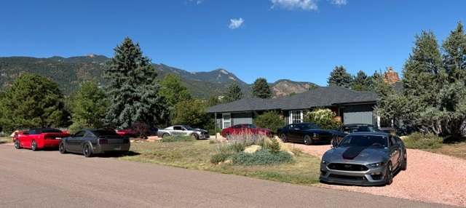
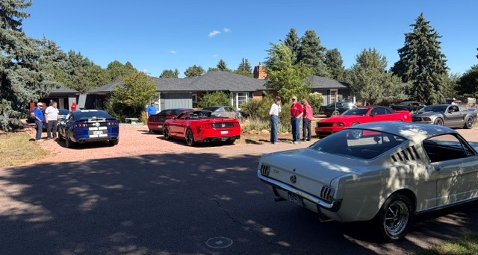
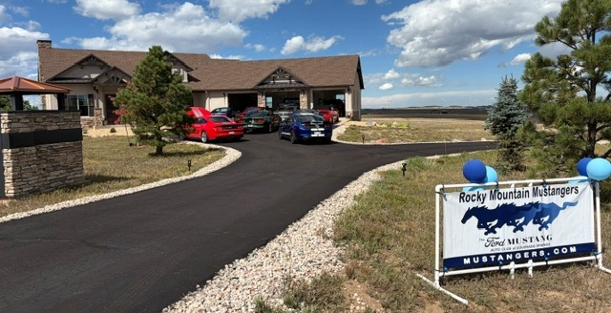

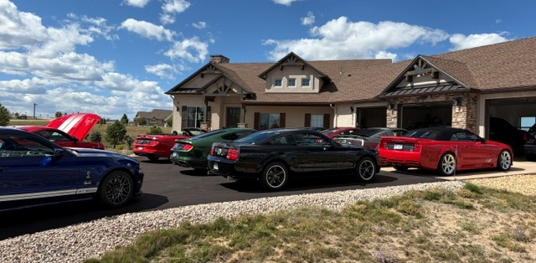

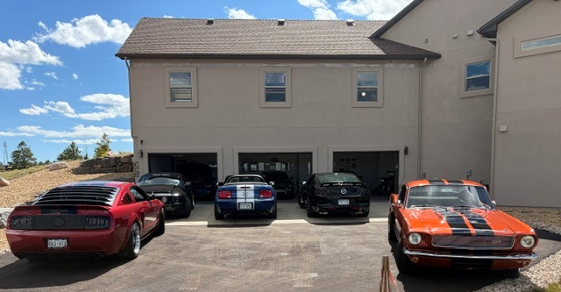

Upping the Ponies
And Other Mods for Your Early Street Mustang
By Patrick Germain
Introduction
Some people consider the Mustang to be a sports car while others will argue it’s not. Either way, when thinking of a Mustang, the word “sporty” should come to mind. And sporty is associated with performance. So it makes sense that many proud owners of the Ford Mustang want to make their cars more powerful and handle better. Increasing power, or upping the ponies, makes a classic car not only more fun, but also significantly increases the cool factor. And if you’re not interested in being cool, why are you driving a Mustang?
The reality is a basic, low-horsepower Mustang can still be a lot of fun when cruising to Dairy Queen. If that’s all you need, good on you. For those who want some grunt when they push the pedal which is narrow, read on.
In this multi-part series, I will cover some basics for modifying early Mustangs. For the proud owners of later model Mustangs, well, you have the benefit of having more power and handling from the factory than all but a tiny few early cars. If you want to see an article about modifying late model Mustangs, by all means let me know.
Part 4: Heavy Breathing

Since an internal combustion is basically an air pump and moving more air through that pump makes more power, nothing contributes more to moving that air than cylinder heads. These are the critical components that separate the ho-hum economy motors from the fire breathing terrors of the street or race track.

There is likely no greater contrast when comparing Ford cylinder heads than the standard 302 next to the Boss 302. You may recall my friend Mark from my high school days who owned a mint 1970 Boss 302. During one of my many visits to the speed shop where Mark worked, he was explaining why the factory, iron cylinder heads on my Mustang’s 302 didn’t have much power potential. To illustrate, he pulled a set of 302 intake manifold gaskets from the shelf. Then he pulled a set of Boss 302 intake manifold gaskets and set them side by side. The difference was astounding.

While most car enthusiasts have heard of the Boss 302 engine, many don’t realize that engine is basically a 302 with 351 Cleveland cylinder heads. Sure, the heads were actually a separate casting with intake manifold coolant ports where the Cleveland heads had none. But that casting was from 351 Cleveland 4V heads.

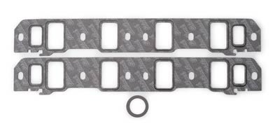

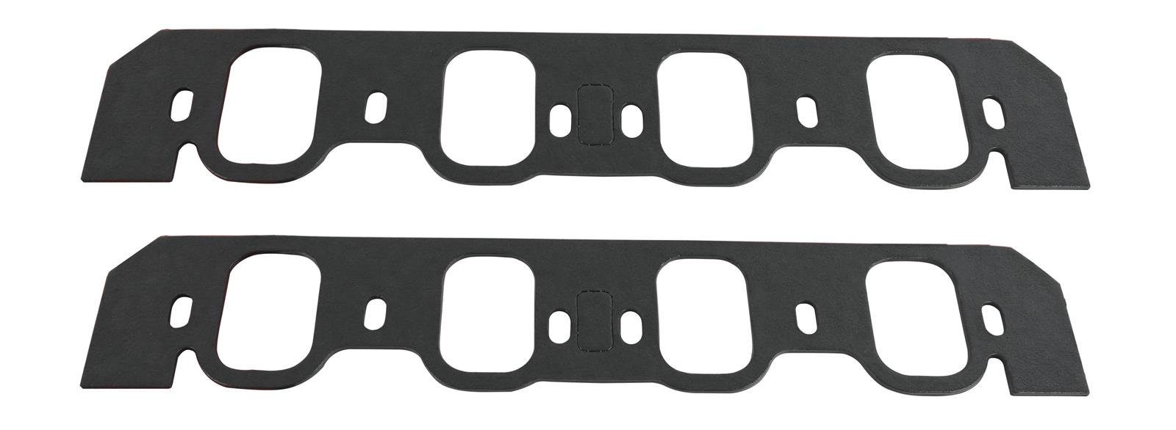

302 (Top) and 351 Cleveland 4V (Bottom) Intake Manifold Gaskets

The pictures above may not be to the exact same scale, but they are very close. The gist is how much larger the Cleveland ports are compared to the standard 302 ports. Those huge Cleveland ports are the primary reason why that engine makes so much power and why it dominated and won the 1970 Trans Am racing series. (Cleveland combustion chambers also have canted valves which is another advantage.)

It’s a sad, but unfortunate truth that the vast majority of Ford V8 cylinder heads were downright puny. And it’s a primary reason why over the decades most hot-rodders have preferred Chevrolet engines. The Bowtie guys simply had more options for bigger cylinder heads.

Throughout racing history, hot rodders would spend countless hours grinding out the intake and exhaust ports on cast iron cylinder heads to make them breathe better and thus make more power. This procedure is called “Porting”. Porting heads evolved into an art of science using a flow bench and a bit of secret Voodoo. Many racers had their own formulas for squeezing the most power from factory, iron heads.
Here in the 21st century, we have many choices of aftermarket, aluminum heads with computer designed ports than can run circles around factory iron heads. While not cheap, by the time you pay someone for some serious porting and machining iron heads for screw-in, adjustable rocker studs, you’re getting into the price territory for aluminum heads.
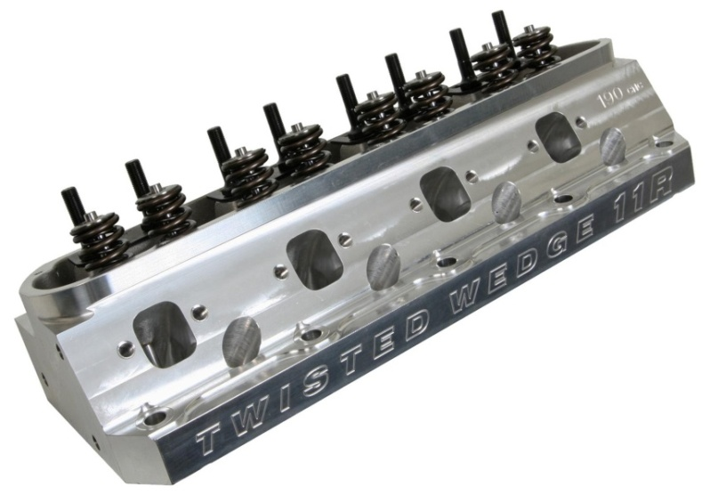
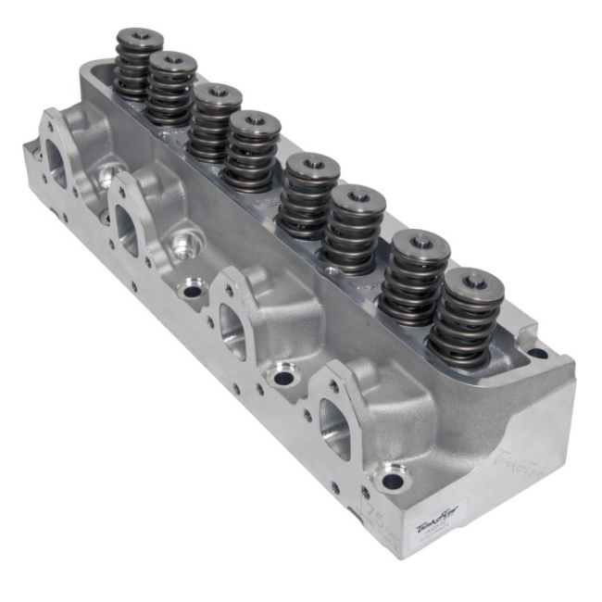

Small Block Ford and FE Aluminum Cylinder Head from Trick Flow

Before you peruse the online performance web sites and click the “Buy Now” button, be aware aluminum cylinder heads are priced each. So yeah. The price you see is double for both cylinder heads. Also be aware you will need new rocker arms and push rods to go with your new heads.

Another key consideration when buying cylinder heads is the size of the combustion chambers. You must factor in the type of piston (dished, flattop, popup), how high it sits in the bore and the combustion chamber size to determine static compression. All too often just grabbing any set of aluminum heads results in low compression from large combustion chambers. Choose wisely!

A significant option with aluminum cylinder heads is CNC porting. This means the intake and exhaust ports are finished by a computerized porting machine for improved flow characteristics. Yes, this will cost extra.

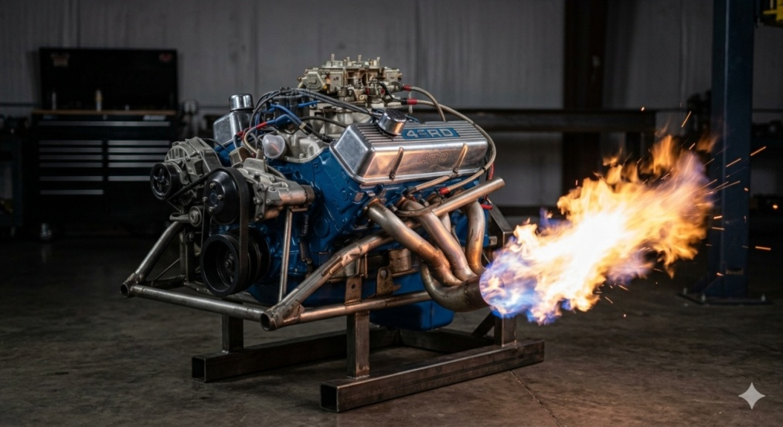
Another advantage of aluminum cylinder heads are the thermal characteristics. Since aluminum transfers heat much more efficiently than iron, you can run higher compression ratios because the combustion chambers stay cooler.

Club code of Conduct
The Rocky Mountain Must angers take pride in our Club being an organized club with monthly meetings and events. We enjoy having members of all ages participate and show their love for the Mustang, from a new car to a classic car, a show car and a race car, and up and coming cars. We have had numerous members come and go from the Club for various reasons. The Board of Directors does not want to see any of our members treat other members, or potential members inappropriately, with comments or actions. In accordance with our By-Laws, the Board of Directors will ask anyone found causing embarrassment to the Club to resign.

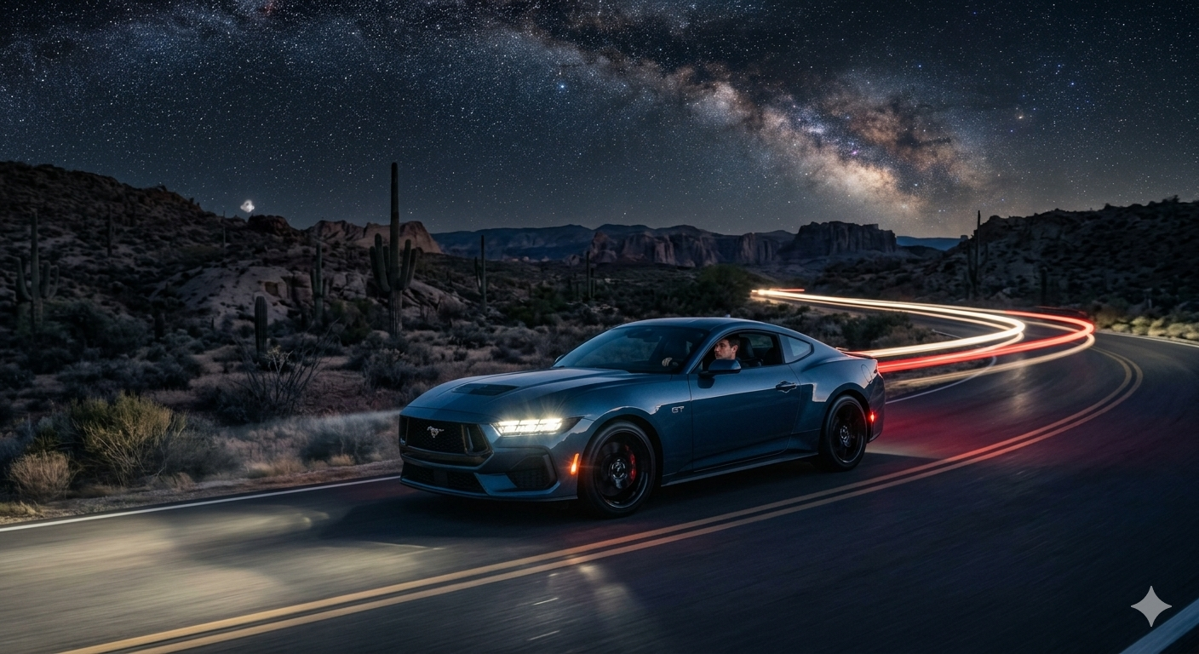

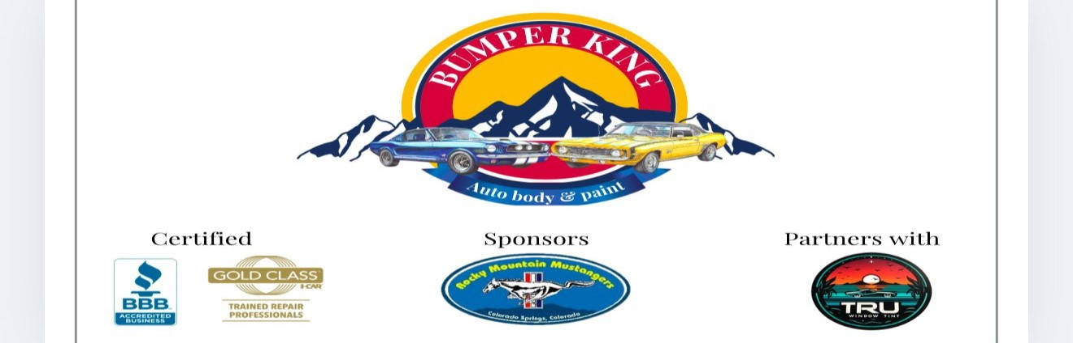
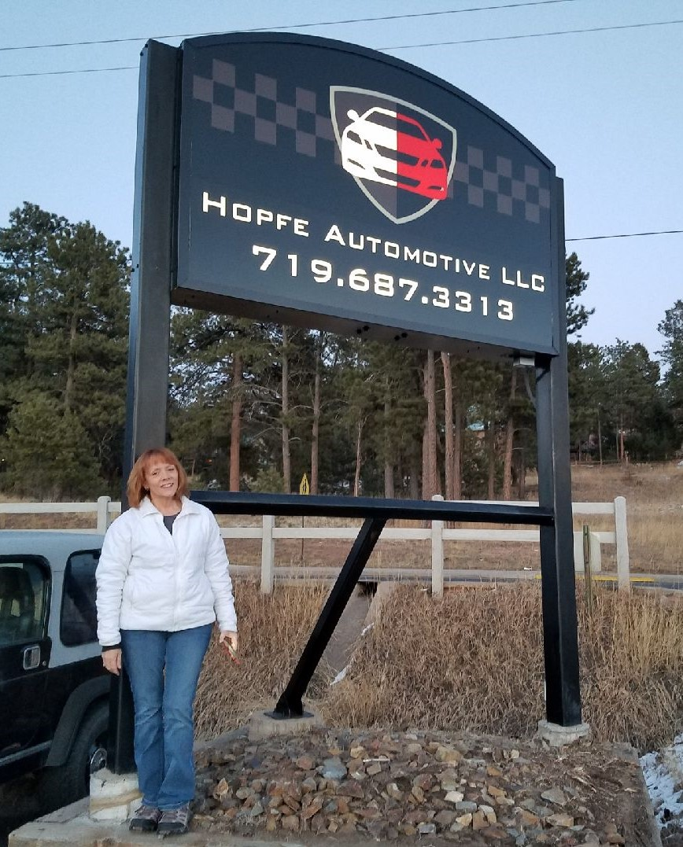
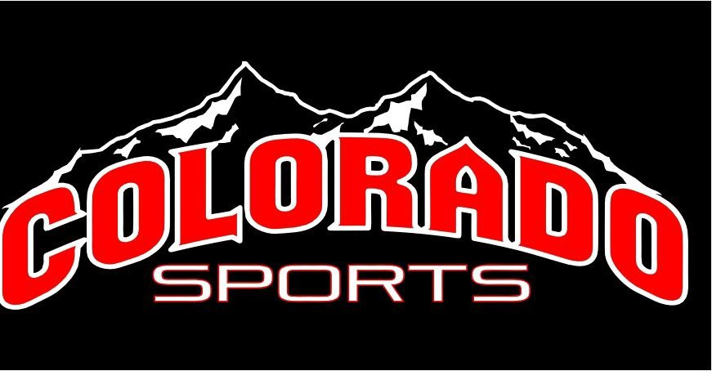
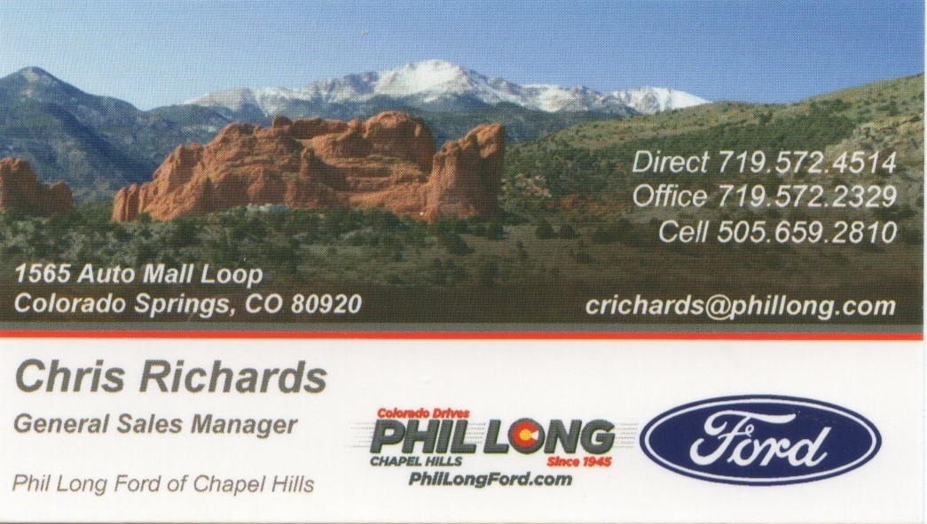
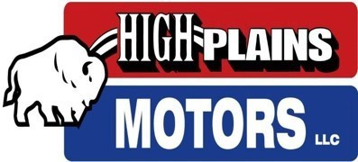
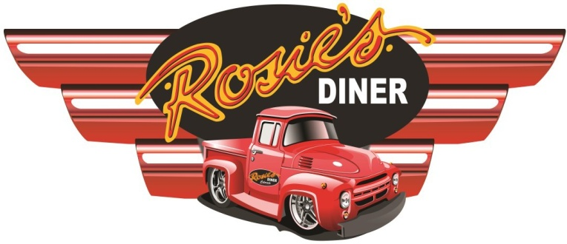
3925 Interpark Dr A
Colorado Springs, Co 80907
(719) 471-0777

4709 Chromium Dr,
Colorado Springs, CO 80918
(719) 428-8649
5950 Omaha Blvd, Brandon Short ASE Cert Mechanic (719) 653-7791
Colorado Springs, CO Marc Short General Sales Manager (719) 434--2184
Colorado Sports 2935 N Prospect St
Colorado Springs, CO 80907
(719) 553-5770
411 Hwy 105, Monument, Co 80132
(719) 232-3287
Hopfe Automotive LLC
570 E Chester Ave
Woodland Park, CO 80863 (719) 687-3313

