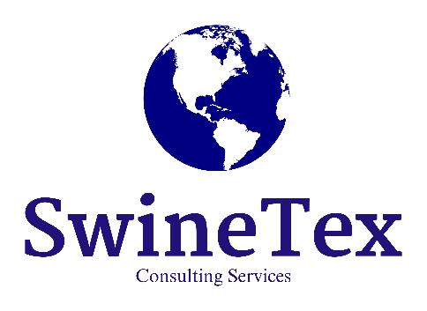
SwineTex Consulting Services, LLC is partnering with our friends at C&R Ag Products, LLC to make available a product that may be helpful to US pork producers in this time of crisis. Boost™ CompostXcel™ is a product originally designed as a manure lagoon/pit additive and is proven effective in several applications in the swine industry. The developers have since discovered it is also useful as an additive to composting systems for dead animal disposal.
Boost™ CompostXcel™ has undergone preliminary research in poultry composting and small experiments in cattle and pigs. SwineTex has been working with C&R Ag Products to shed light on the potential applications in the swine industry. Because of the tragic situation producers find themselves in during these trying times, we’ve decided to fast track this product and make it available to pork producers who plan to use composting as a part of their strategy for the disposal of euthanized animals.
We believe, based on the preliminary research, that this product can significantly reduce the amount of time to compost dead animals. Boost™ CompostXcel™ is a proprietary blend of bacteria that when applied to animal carcasses mixed with organic material, can complete composting in approximately 1/3 of the time normally required.
SwineTex has negotiated a discounted rate for this product and thanks to our colleagues at C&R Ag Products, we’re making this negotiated rate available to any US livestock or poultry producer for at least the next 90 days. Please contact SwineTex Consultant Todd Thurman (contact information below) for more information and details on amount of required product, proper use of the product, pricing and any other questions.
Todd Thurman
SwineTex Consulting Services, LLC
Phone: (682) 888-4287
Email: todd.thurman@swinetex.com

Disclosure: SwineTex Consulting Services, LLC has a 100% transparency policy with respect to product and service endorsements and recommendations. We commit to disclosing to clients any financial arrangement related to third party products or services relevant to our consulting or training services including commissions, affiliate bonuses, finder’s fees or any other compensation or other potential conflicts of interest. As a general rule, SwineTex hasn’t/doesn’t represent third party products but is making an exception in this case due to the exigent nature of the current circumstances in our industry. SwineTex and its representatives will serve as facilitators for any potential transactions, but those transactions will be between the purchaser and C&R Ag Products. SwineTex may receive a small commission on sales of Boost™ CompostXcel™ or related products from C&R Ag Products and may be reimbursed for some incidental expenses incurred.

