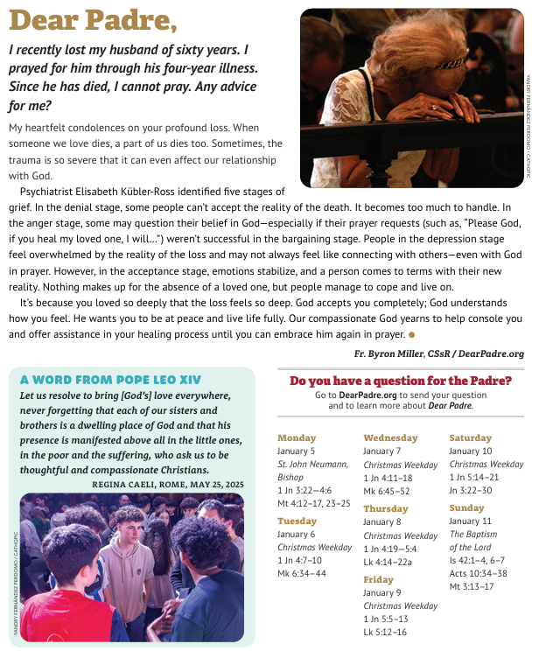

St. Agnes •St. Boniface •St. John the Evangelist
Rev. Michael Pampara Pastor email: pamparasdb@gmail.com
Father Michael Cell 308-660-5730
P O Box 309, Stapleton, NE 69163, email: abjcatholics@gmail.com
Parish Office 308-636-2421; Secretary, Kristie Walz Cell 308-636-8399
Website: www.abjcatholic.org - Facebook Page: St Agnes, St Boniface & St John the Evangelist
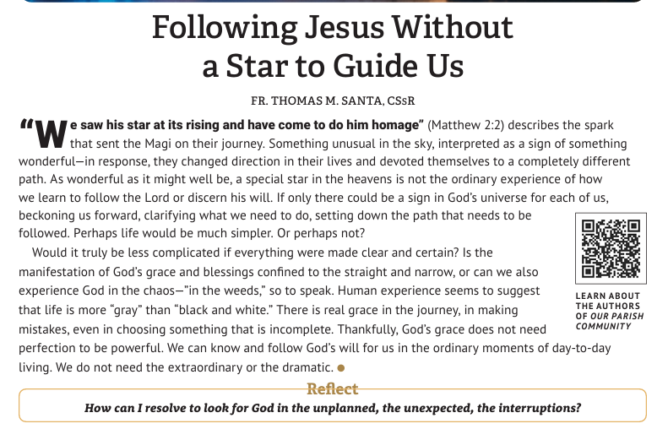

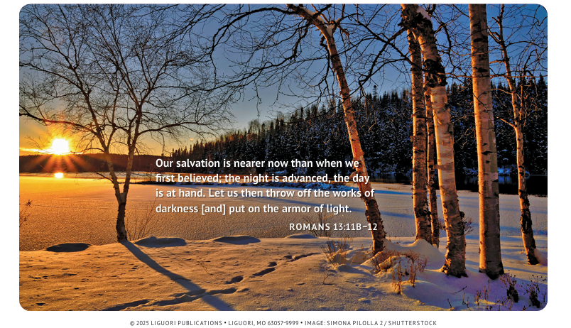



Date: Jan 10-11 | St Agnes | St Boniface | St John’s
Time | Sunday 8:00 AM | Saturday 6:00 PM | Sunday 8:00 AM
Hospitality | Conrad & Aleta P. | Steve & Kristen B. | Toby & Lisa K.
Lector | Aleta A. | Carla K. | Jon W.
Server |  | Olivia D. & Ellie P. | Tate B. & Cotter J.
EMHC | Conrad & Aleta P. | Seth & Tristan P. | Steve & Cindy F.
Communion to  shut ins or Music |  | Steve B. | Music: Jenny J.

Ministry Schedule

The Epiphany of the Lord (A) January 4 , 2026
The visit of the Magi occurs directly before the story of the Holy Family’s flight into Egypt. Matthew’s Gospel tells a version of Jesus’ birth that is different than the one in Luke. Of the actual birth of Jesus, Matthew tells us little more than, “When Jesus was born in Bethlehem of Judea, in the days of King Herod . . . ” The story of the census is found only in Luke’s Gospel, but we hear about the visit of the Magi only in Matthew’s Gospel.
We know little about the Magi. They come from the East and journey to Bethlehem, following an astrological sign, so we believe them to be astrologers. We assume that there were three Magi based upon the naming of their three gifts. The Gospel does not say how many Magi paid homage to Jesus. In Matthew’s Gospel, they represent the Gentiles’ search for a savior. Because the Magi represent the entire world, they also represent our search for Jesus.
We have come to consider the gifts they bring as a foreshadowing of Jesus’ role in salvation. We believe the meaning of the gifts to be Christological. Gold is presented as representative of Jesus’ kingship. Frankincense is a symbol of his divinity because priests burned the substance in the Temple. Myrrh, which was used to prepare the dead for burial, is offered in anticipation of Jesus’ death.
The word Epiphany means “manifestation” or “showing forth.” Historically several moments in Christ’s early life and ministry have been celebrated as “epiphanies,” including his birth in Bethlehem, the visit of the Magi, his baptism by John, and his first miracle at Cana.


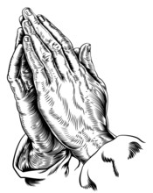

Cade Owens Jan 5th
Judy Meredith Jan 6th
Jim Hickey Jan 9th
Lawerence Duponcheel Jan 9th
Carla Kimball Jan 11th



Saint John Neumann (1811-1860)

“Merciful Father, you have given me all that I have in this world, even life itself. In all my daily needs, help me to remember the needs of others, too.”

St. John’s Our Gifts to God & Church December 25 & 28 2025
Total Collection: $3525.09
January 1, 2026
Total Collection: $102.00

Diocesan Appeal
Dollar Goal $2800 of $5179 with 9 of 15 Donors

CCD Wed, Jan 7th
PreK to 5th 3:40 PM
6th -12th Supper 6:30 Dailey
Class Begins 7:00 PM

Parish Council Meeting Jan 4 at 5 PM

St. Mary’s Parish Meeting at Oconto Jan 5th at 5 PM

St. Boniface Our Gifts to God & Church December 25 & 28 2025
Total Collection: $9875.25
January 1, 2026
Total Collection: $475.00

Diocesan Appeal
Dollar Goal $5900 of $7452 with 13 of 17 Donors

CCD Wed. Jan 7th
PreK to 2nd 4-5 PM
Supper 6:10
Class 6:30 to 7:30 PM

Parish Council Meeting Jan 8 at 6:00 PM

St. Agnes Our Gifts to God & Church December 25 & 28 2025 Total Collection: $4891.00
January 1, 2026
Total Collection: $84.75

Diocesan Appeal
Dollar Goal the GOAL is MET!!!

Thrift Store
Open Jan 9 9AM to 4PM

CCD Wed Jan 7th
Elementary 3:40 PM
High School 7:30 PM Meal Kiyoshi

Parish Council Meeting Jan 7 6:00 PM

Fr Michael will be going on India Jan 11 to Feb 12 to see his family.
Please remember him in your prayers.
Mass Schedule & Intentions
For the week of Jan 5, 2025
Mon. | Jan. | 05 |  |  | No Mass
Tues. | Jan. | 06 | 7:00 AM | SJ | Nancy Murphy
Wed. | Jan. | 07 | 5:30 PM | SA | JR Leech †
Thurs. | Jan. | 08 | 5:30 PM | SB | Tricia Young
Fri. | Jan. | 09 | 8:30 AM | SJ | Traci Lee
Sat. | Jan. | 10 | 6:00 PM | SB | Conrad & Theresa Wildhagen †
Sun. | Jan.. | 11 | 8:00 AM | SJ | Vernon Brosius †
Sun. | Jan.. | 11 | 9:30 AM | SA | People of the Parish

