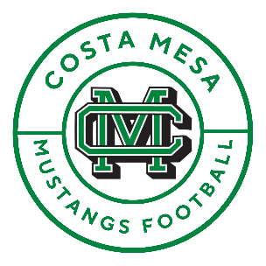

Dear Business Owner and Community Supporter,

The Costa Mesa High School Football Family invites you to invest in our program. We need community partners like you to join us in our mission to focus on developing the “whole” player as we strive to impact young people’s character, academics, and athletic development in a team atmosphere. With your support we can strengthen and build on Costa Mesa Football’s traditions and future success.

As a sponsor of Costa Mesa Football, you will positively impact our program, players’ lives, and our community. In return, we will invest in you through various methods at our athletic events and across our social media platforms.

We offer three levels of sponsorship opportunities that make it possible for any size of business or an individual supporter to help us achieve our goals. Your generosity will go towards equipment, uniforms, facilities, services, team-building meals, and other resources necessary to maintain and build the Costa Mesa Football program.

We are recognized as a 501(c)3 non-profit organization; therefore, your donation is fully tax-deductible. If you have any questions or need additional information, please contact the Costa Mesa Football Boosters at [**costamesafootballboosters@gmail.com**](mailto:costamesafootballboosters@gmail.com). We look forward to having you be a part of our program.



Gold Level Supporter $1500.00 (or more) Donation

* Large banner to be displayed on field sideline
* Featured sponsor on CostaMesaFootball.com including link to your existing website
* Exposure on team’s social medias and 2 targeted platform ads per month of the season
* TD banner
* Signed team football and CM Football team helmet
* Two VIP list passes for all home games



Silver Level Supporter $1000.00 Donation

* Banner to be displayed inside stadium
* Featured sponsor on CostaMesaFootball.com including link to your existing website
* Exposure on team’s social medias and 1 targeted platform ad per month of the season
* TD banner
* Signed team football
* One VIP list pass for all home games

Program Level Supporter $300.00 Donation

* 1/4 sized advertisement in the season’s football programs



Bronze Level Supporter $750.00 Donation

* Banner to be displayed inside stadium
* Featured sponsor on CostaMesaFootball.com including link to your existing website
* Exposure on team’s social medias
* Two targeted social media platform ads
* Two tickets to a home game of your choice

[**costamesafootball.com**](https://costamesafootball.com/)

**@CMHS-Football**

Donations may be made via check (made payable to Costa Mesa Football Boosters) or VENMO at: @CMHS-Football [Tax ID: 80-0815024]

Business Name and Address: ____________________________________________________________­­­­___________

Website________________________________ FB_______________________ IG ________________________

Contact Name, Phone & Email: __________________________________________________________________

Please fill out the above information and email to [costamesafootballboosters@gmail.com](mailto:costamesafootballboosters@gmail.com) or

mail with your check donation to: 3101 Yellowstone Dr., Costa Mesa, CA 92626