1 box of 24 ct crayons (Crayola brand)  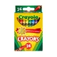 | 1 box of 12ct color pencils (Crayola brand)  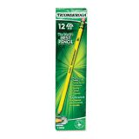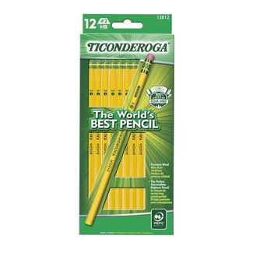
1 box of 10 ct thin markers (Crayola brand)  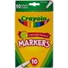 | 1 12 ct color pencils (Crayola brand)  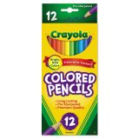
2 glue sticks  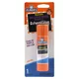 | 2 red checking pencils (any brand)  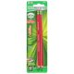
2 blue pens/ 2 black pens (3rd graders only)  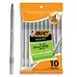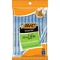 | 1 5 subject wide-ruled notebook (3rd grade only)  any brand 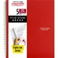
1 1 subject spiral notebooks (wide ruled) any brand  1 red | 1 supply box  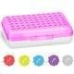
1 steno pad (1st grade only) any brand  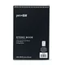 | 1 homework lesson planner (2nd and 3rd grade)  Available for purchase on Amazon or may be purchased through the school for $6.00  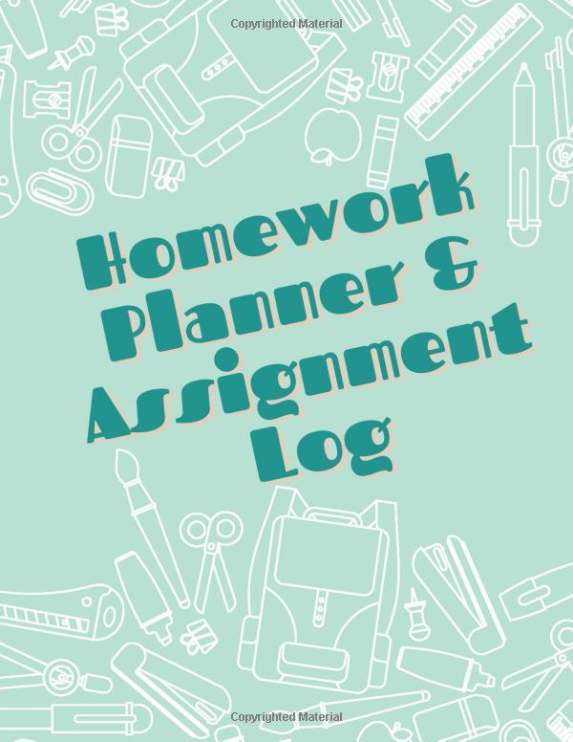
1 blue, 1 red, 1 green folders with brads (5 Star Mead brand)  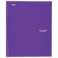 | 1 pair of Fiskar scissors  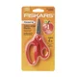
3 boxes of tissue | 1 12 count package of toilet paper
4 Clorox wipes | 1 box of sandwich bags
2 box of sandwich bags | 1-3 pack of baby wipes (1st and 2nd grade only)
1backpack/1 lunch box (no characters) | 6 rolls of paper towels
1 toiletry bag with the following items  Deodorant/ wipes / hand sanitizer/ feminine products  body spray (optional) | 1 small bag for P. E. items (3rd grade only )  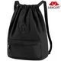
- 12 oz hand sanitizer

 Please purchase specified brands. *******Supplies may need replenished during the year*

