King’s Christian Academy Supply List K-4/K-5
2 boxes of jumbo crayons 8 count (Crayola brand)  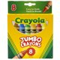 | 1 boxes of markers (Crayola brand)  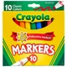
8 Jumbo Pencils (Ticonderoga brand)  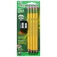 | 1-12ct boxes of pencils (Ticonderoga brand)  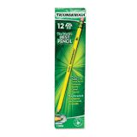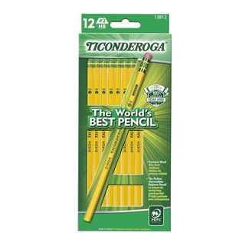
3 giant glue sticks  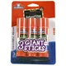 | 1 supply box  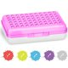
*Folders should be the Five Star Mead Folders*  1 blue folders with brads  1 purple folders with brads  1 green folders with brads  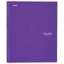 | 6 rolls of paper towels
3 boxes of tissue | 1 12 count package toilet paper
1 12 count package toilet paper | 4 Clorox wipes
2 box of sandwich bags | 1 box of gallon size bags
1 backpack/ 1 lunch box – no characters | 1 small pillow and blanket (must be able to fit in their cubby.) no characters
1 extra change of clothes  Boys- Shirt Girls- Dress  Pants/Shorts Under shorts  Underwear Underwear  Socks Socks | 5 packages of baby wipes
Storage Zip loc Bag  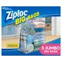 | 1-12 oz hand sanitizer

****Please purchase specific brands when indicated*** Supplies may need to be replenished during the year**

