2 12 ct boxes of pencils (Ticonderoga brand)  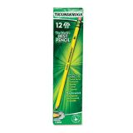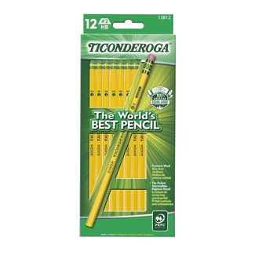 | 1 package of red pens/blue pens/black pens  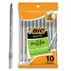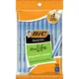
1 5 subject notebooks (college ruled)  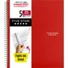 | 1ruler /1 protractor/ 1compass  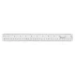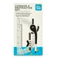
1 red, 1 green, 1 blue folder with brads  (5 Star Mead brand)  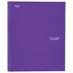 | 1 supply pouch for binder  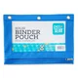
1 red, 1 blue, 1 green, 1 yellow 1 subject Spiral Notebooks ( colleged rule) | 1 academic planner available on Amazon  Elan Publishing Company Student Academic Organizer - 8.5" x 11" Weekly View; Dated for 2023-2024 Academic Year  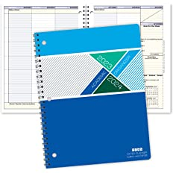  (may be purchased through school for $12.00)
2 packages of index cards  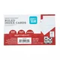 | 1 pair of student Fiskar scissors (7 in.)  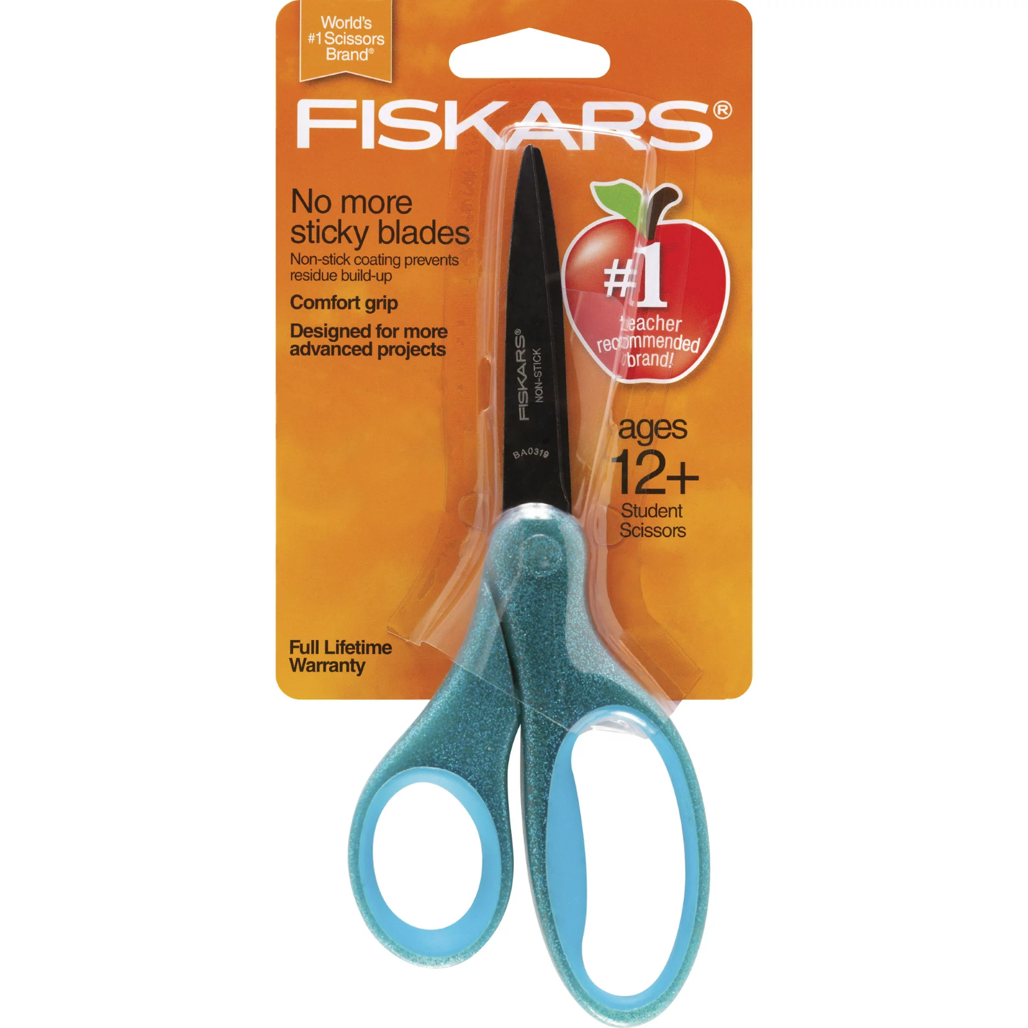
1 composition notebook  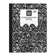 | 1 package of highlighters with assorted colors  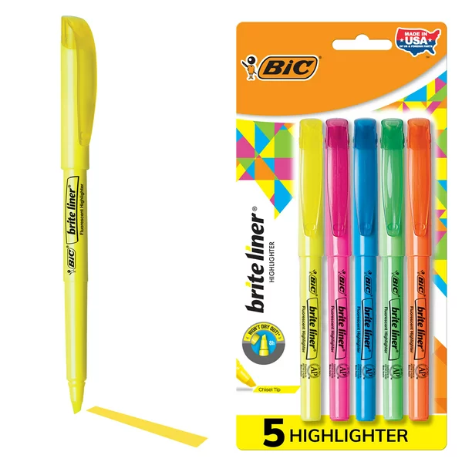
1backpack/1 lunch box (no characters) | 6 rolls of paper towels  4 boxes of tissue  4 Clorox wipes  1 pack of 12 toilet paper rolls  1-12 oz hand sanitizer
1 small bag for P. E. items  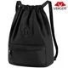 | 1 toiletry bag with the following items  Deodorant/ wipes / hand sanitizer/ feminine products  body spray (optional)

