Service access

This document is about how  we make it easy for you to  use our services | 
It is written in a way that is easy  to read | 
Our services are for people with  disabilities and their families | 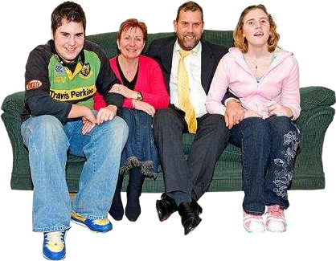
Everyone gets support that suits them | 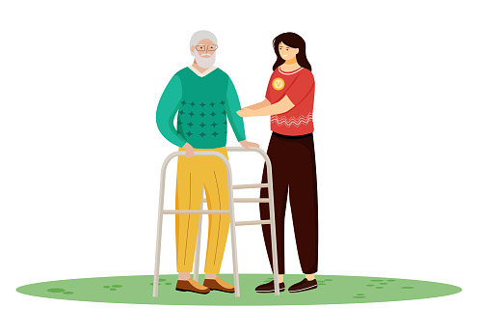
We support the rights of people  with disabilities | 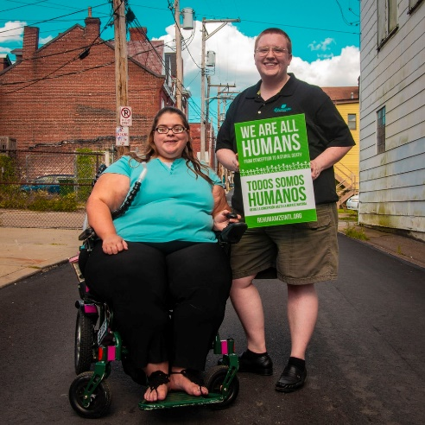
We treat everyone as equals | 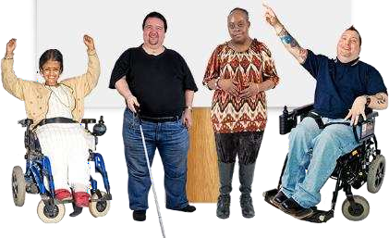
We know that people come from  different cultures and speak  different languages | 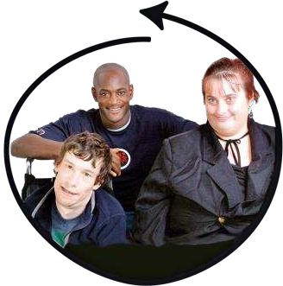
We make a Service Agreement  that says what you agree to do  and what we agree to do when  you use our services | 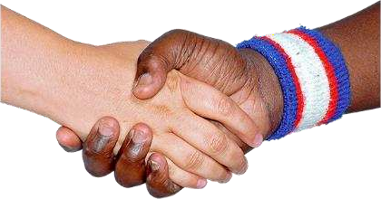
We plan your support with you  and your family if you want them  included. | 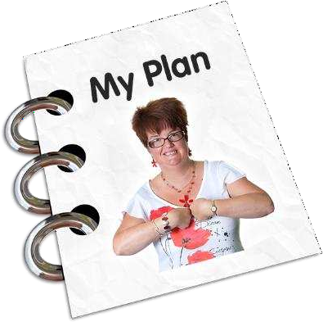
You will get your own plan and it  will be checked often | 
You can change your plan if you  are not happy with it | 
We will help you get the most out  Of your funding from the NDIS  and other places | 
We help you find other service  providers for things we cannot  help you with | 
We give you information you  need if you choose to stop getting  services from us | 