Complaints

A complaint is when you are not  happy with what we do | 
What you tell us is private | 
We will try to sort out your  problem as quickly as we can | 
We are on your side | 
If you do not like the way we  manage your complaint you can  talk to the NDIS Complaints  Commission. Call 1800 035 544 | 
When you make a complaint it  costs you nothing. | 
You do not have to give your  name when you make a  complaint. | 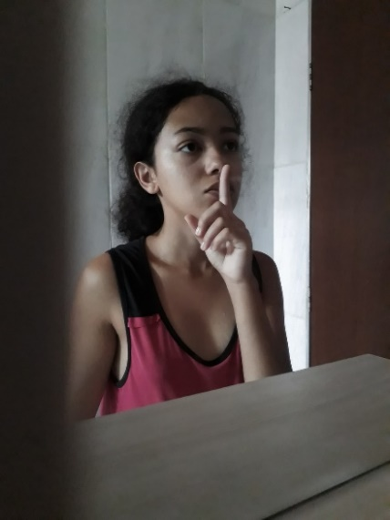
If your complaint is serious, we  may help you go to the police  and report to the NDIS. | 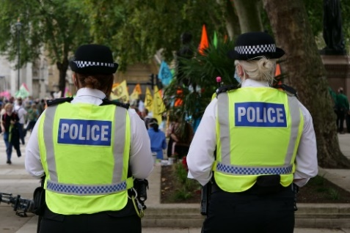
If you are a child and your  complaint is serious we may  report to the Child Protection  Hotline | 
We will send you a letter saying  we have received your complaint | 
We will talk to you | 
We will find out what you want | 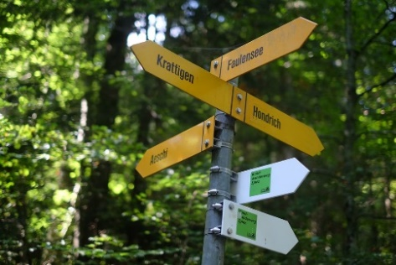
We will write to you when we  have solved the complaint. | 
If you need help to make a  complaint you can use an  advocate. | 
We want to know if things are  not working well so we can work  better for you and other people. | 

