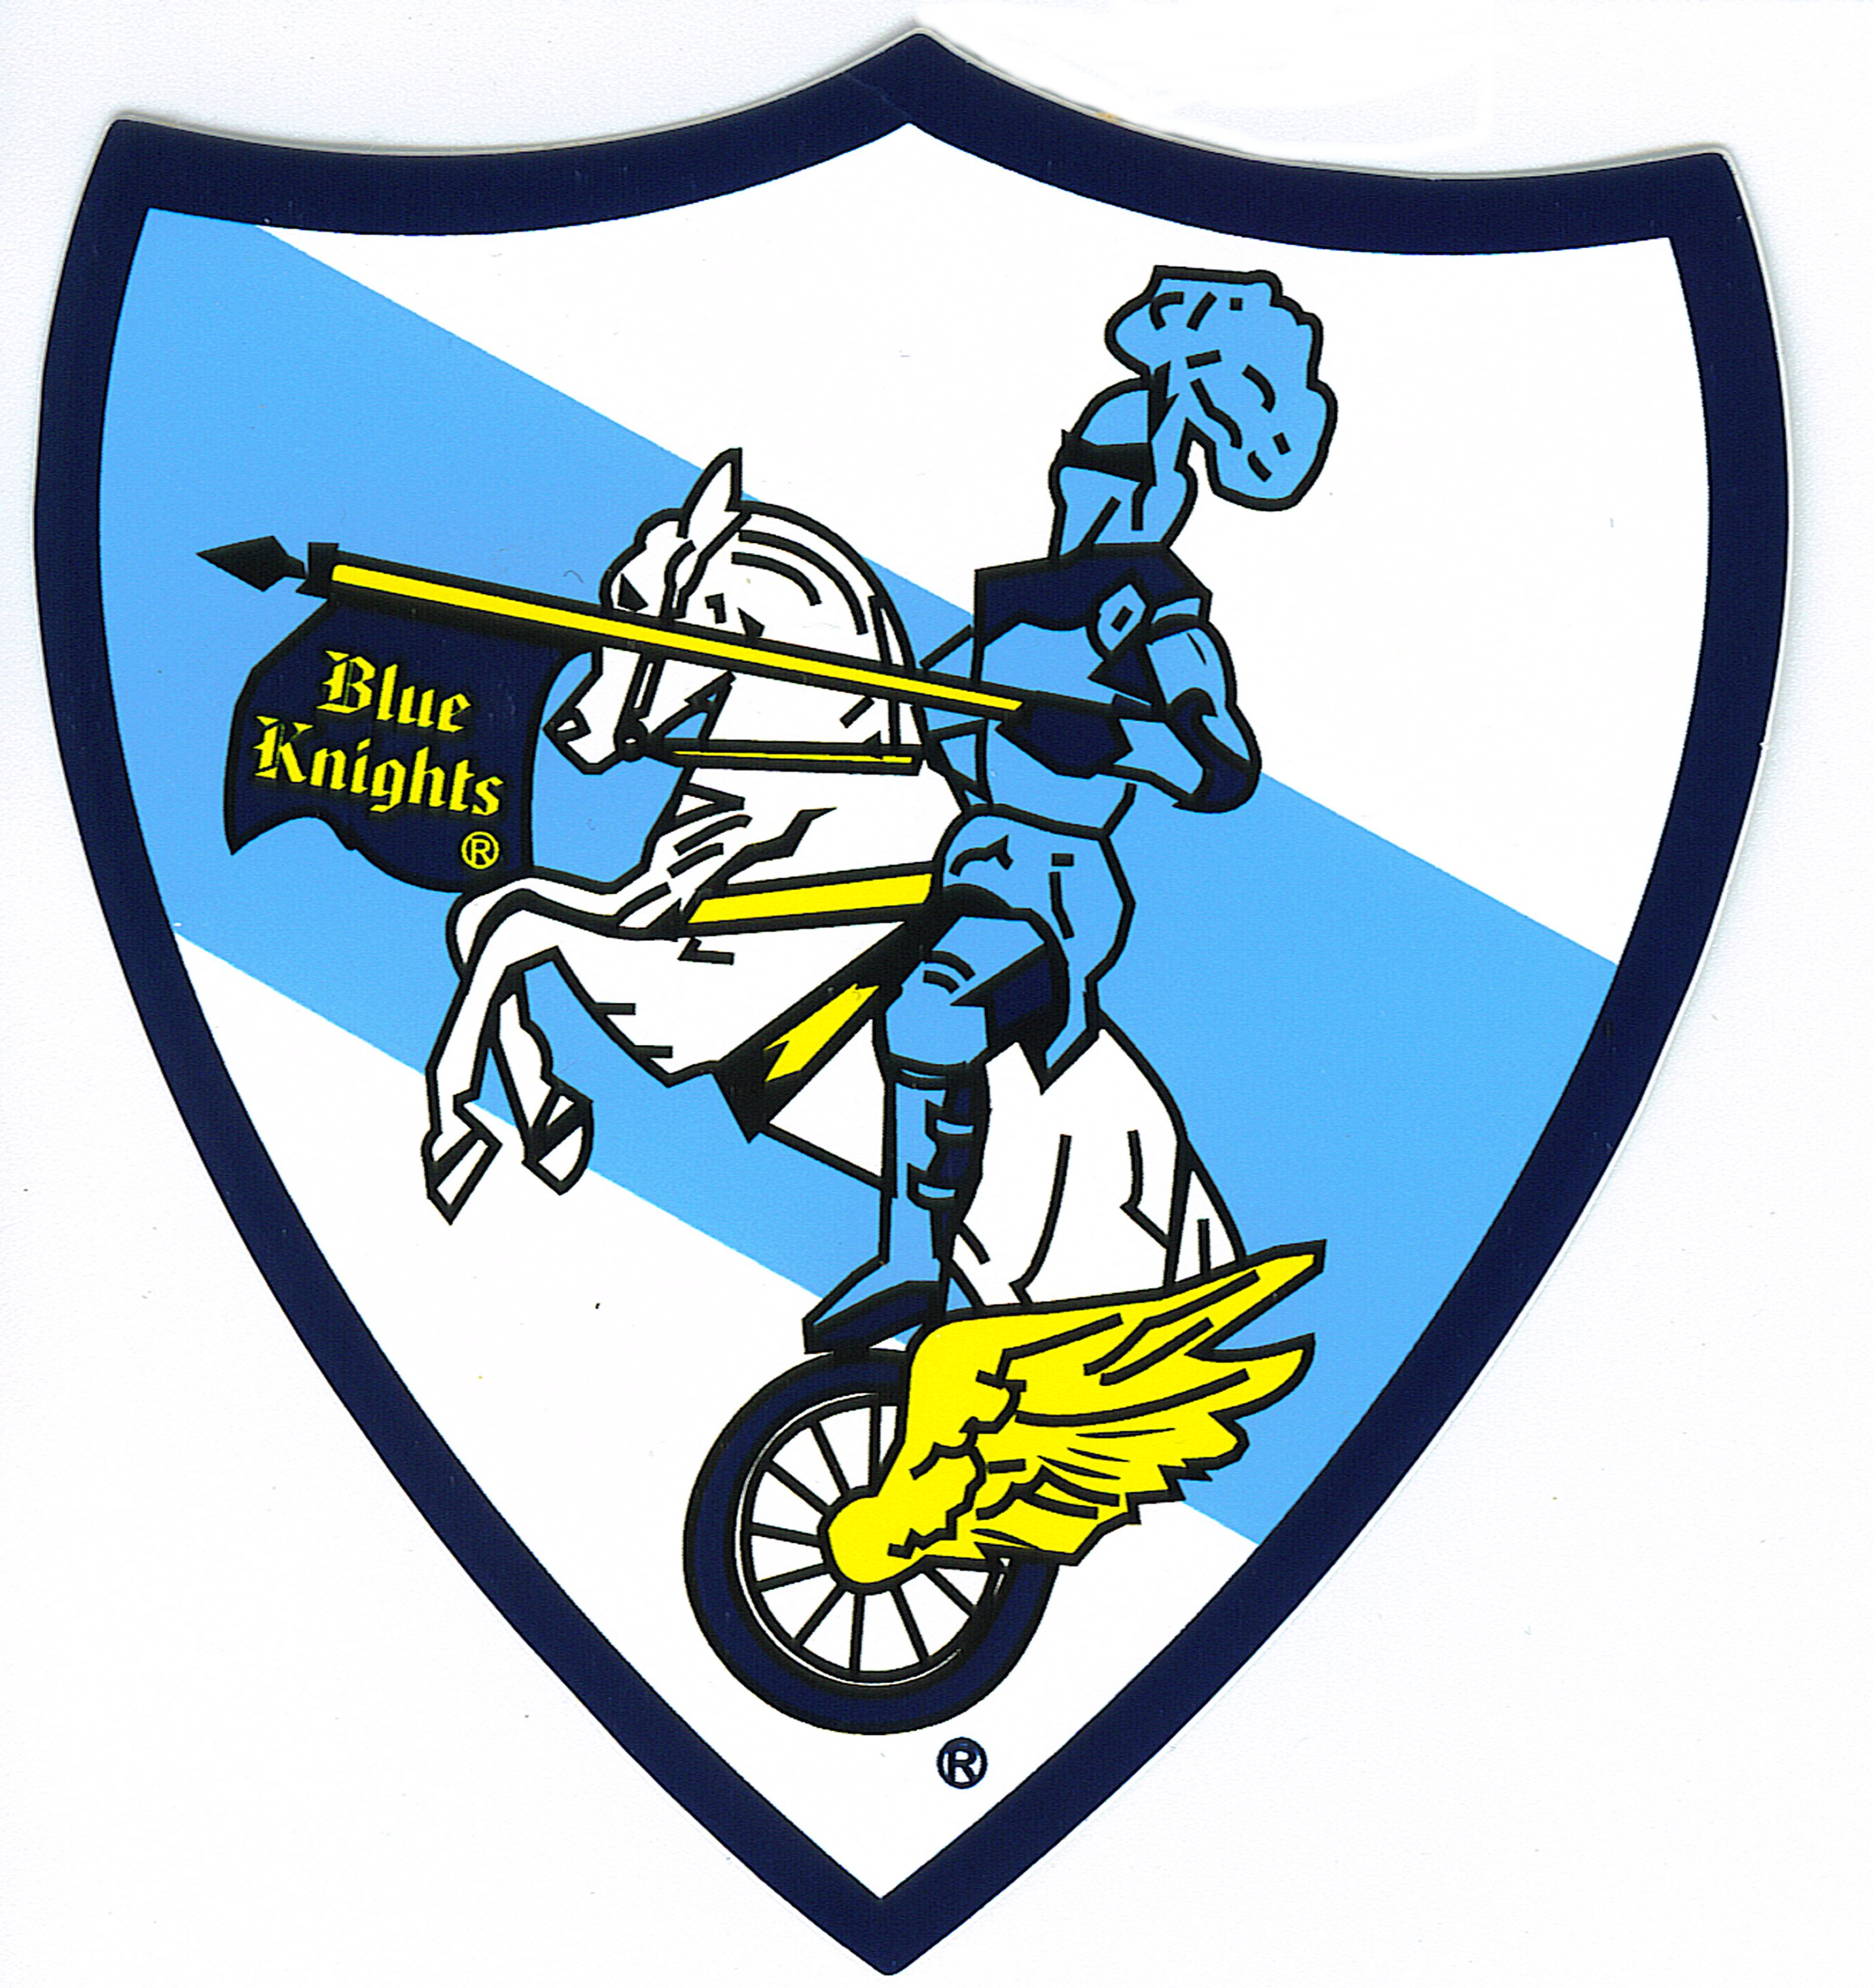
BLUE KNIGHT LAW ENFORCEMENT MOTORCYCLE CLUB
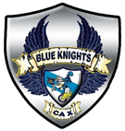
2022 SOUTHWEST CONFERENCE
APRIL 27 – MAY 1
EL CENTRO, CALIFORNIA
Best Western Comfort Inn Main Stay Suites
2352 S. 4th Street 2354 S. 4th Street 2356 S. 4th Street
El Centro, CA El Centro, CA El Centro, CA
(760) 337-8677 (760) 335-3502 (760) 970-4183

Hotel Reservations: mention Blue Knights for rates
No online reservations available

MEMBER NAME: ______________________________________________
GUEST NAME: ________________________________________________
MAILING ADDRESS: ____________________________________________
CONTACT PHONE NUMBER: ____________________________________
EMAIL ADDRESS: _____________________________________________
BK STATE-PROV/CHAPTER: _______________ BK MEMBER#__________

Member registration $100.00 after January 1, 2022 ($125.00)

Member Shirt: size: ( ) Med ( ) Large ( ) XL ( ) 2XL. ( ) 3XL
Guest Shirt: $25.00 size: ( ) Med ( ) Large ( ) XL ( ) 2XL ( ) 3XL

Member Banquet Included Choice: ( ) Chicken ( ) Beef

Guest Banquet Dinner: $60.00 ( ) Chicken ( ) Beef

CONFERENCE REGISTRATION: PayPal at: BlueKnightsCA-X.org
Email or mail registration and payment to: bk_ca_x@yahoo.com Total _________
For further info contact P.O. Box 646
J. Pacheco 760 540-9313 El Centro, CA 92243

