Berkshire County #1 Highway Superintendent’s Association, Inc.
Announces its 15th Annual Charity Golf Tournament

Hello to All Our Valued Vendor Members, The Berkshire County #1 Highway Superintendent’s Association Inc. is hosting its 15th annual charity golf tournament on Friday, June 7, 2024, at the Bas Ridge Golf Course in Hinsdale, MA. This year’s recipient will be: The One Call Away Foundation
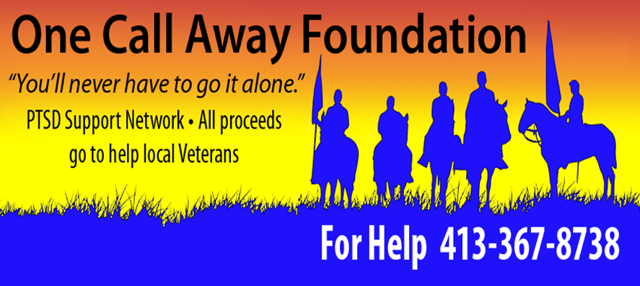

We have 18 holes available for sponsorship by or vendors at $150.00 per hole. Signs are being made to identify each vendor using their company (LOGO) and are positioned at each tee. The sale of these signs and all contributions that are made will go directly to the One Call Away Foundation. All vendors contributing to the charity pool will be acknowledged during the awards presentation.

See second page for sponsor forms

Sponsor Forms

Yes, I would like to sponsor one of the 18 holes @ $150.00
$ 150.00 Please include a copy of your company’s LOGO for the sign
Contributions can also be made to the Charities in care of the association. $___________
Yes I would like to sponsor a player or a team @ $100.00 per person $__________
We are also seeking sponsors to help defray the cost of Breakfast and Cookout $___________________
If you would like to sponsor one of these signs please call me A.S.A.P. they do go quickly, at 413-446-1937 or email me at : berkcountyhwyassoc@yahoo.com
Make check payable to: Berkshire County #1 Highway Superintendent’s Association, Inc. and mail to Gerald Coppola, 934 West Housatonic St., Pittsfield, MA 01201. More info about the actual tournament itself will be sent you in the near future.
Thank You,
Gerald Coppola, Committee Chair

