February 9th, 2020

Hello Bill:
I am Larry’s friend, and your products healed me faster than any product I had from the Doctor. I was thrilled to see the results so quickly.
I burned my leg on Weds, Jan 29th – went to the Doctor on Friday, Jan. 31st to get some products. Larry showed up with your spray – and we ordered the hand and body lotion. Started treatment on Friday, 31st with Vita Products. I will keep using the lotion and see how it changes the redness.
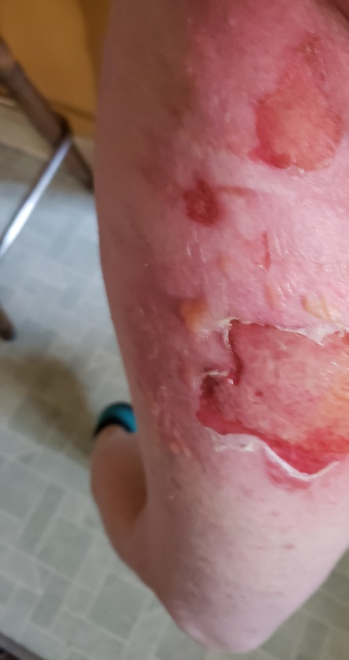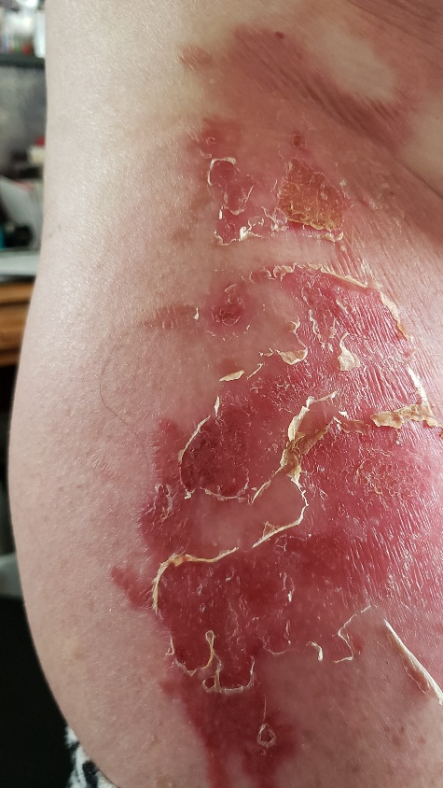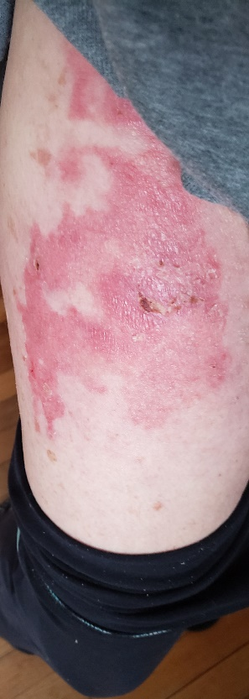
Friday, January 31st one-week later Feb 9th
Thank you Bill! Sandra Murray in Denver.

