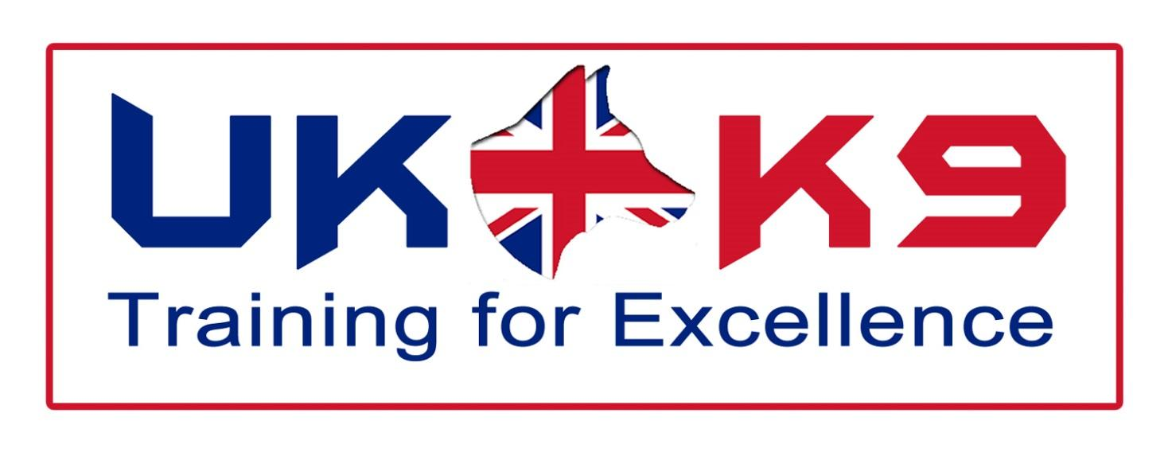

COMPANY NUMBER: 09318323

CAPABILITY STATEMENT

Introduction
UK-K9 Training for Excellence is at the forefront of delivering training to search & rescue dogs and their handlers, to the world’s emergency services. Our vision is to ensure that each K9-unit is trained to the highest standard, in all aspects of search & rescue, to create a fully operational and self-reliant team. As such we provide our clients with tailor made training and consultancy services.
Our instructors and staff have a wealth of experience, dating our first training back to 1986, when attending the aftermath of El Salvador earthquake. Since then our instructors, dog handlers and dogs have been utilised in search & rescue worldwide (see our instructor biographies for further information)
We pride ourselves in ensuring that the training and consultancy is the highest of quality, partnering ourselves with several universities has allowed us to provide current and elite training (see individual areas for further information).
These universities also provide a forensic consultancy on our behalf, combining all aspects that relate to disaster of a global scale. (For more details of this see forensic services)

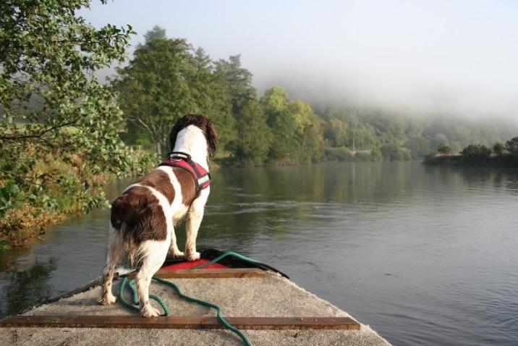

Training
The list below illustrates the areas in which UK-K9 Training for Excellence offers consultancy and training services:
- Cadaver/Human Remains Detection
- Water Search
- Urban Search & Rescue (USAR)
- Mountain Rescue
- Disaster Search & Rescue
- Drugs Detection
- Explosives Detection
- General Purpose Police Dogs
- Specialist Combat Tracker Dogs
- Passive and Proactive Detection
- Suicide Bomber Detection Dogs
- Helicopter Familiarisation
- Fast Rappelling/Abseiling from Helicopters.

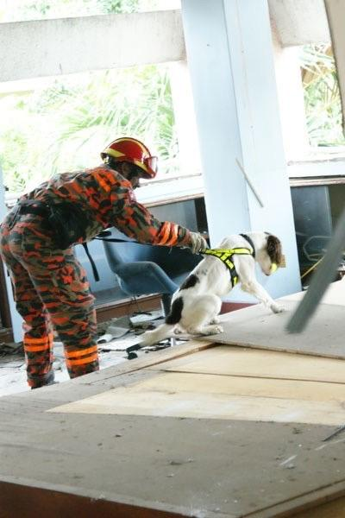
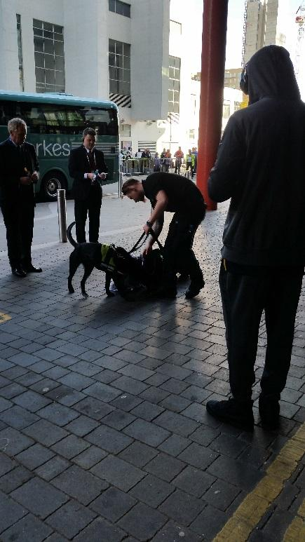

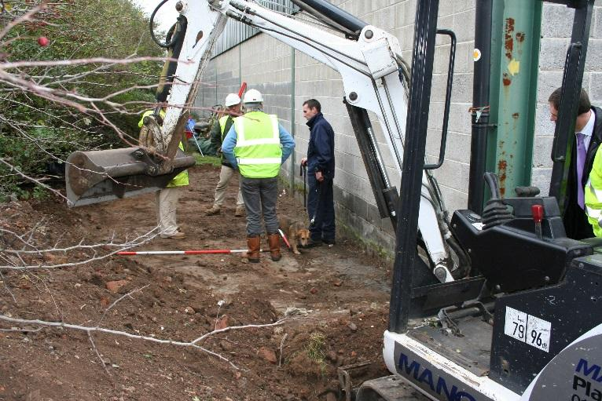

Other Training includes:

- Search Planning & Management
- Navigation
- Technical Rope Rescue
- Swift Water Rescue
- Powerboat Handling
Services Available
Cadaver/human remains Detection Dogs | - Dogs are trained to ignore other food types and will only give an alert on the scent of pig (used in training) or human remains.  - The training of these dogs has been in conjunction with the leading research team at the University of Leicester. The research looks to improve the accuracy and effectiveness by investigating the individual chemicals associated with cadaver material.
Water cadaver/human remains detection Dogs | - Combined with highly qualified water search personnel these dogs are able to search large areas of water, both lakes and rivers, helping to reduce the search area for other search personnel and making it more safe and time effective.
Mountain Rescue & Lowland Search Dogs | - Dogs trained to locate the missing person by homing in on the airborne human scent emanating from the missing person.  - Mountain rescue dogs able to search large areas of mountainous terrain, in all weathers, day and night with a high degree of accuracy.
Urban Search & Rescue (USAR) Dogs | - Dogs able to quickly and effectively locate survivors trapped in collapsed building debris and indicate on a location.  - Enables rescuers to focus their resources and efforts on these specific areas and save more lives.

Fire Investigation Dogs | - Dog used to search through the debris and damage of a fire scene to locate any remaining traces of ignitable liquids present.  - Dogs capable of recognising all of the readily available ignitable liquids, for example petrol, diesel, paraffin, barbeque lighter fuel, camping fuel, cigarette lighter fuel, white spirit, cellulose thinners and acetone.
Tracking & Trailing/Discrimination Dogs | - Dog trained to scent discriminate and able to pick up and follow a trail laid by a person when a scent article is available to the handler.  - Dog & Handler come into their own when the person is missing in a highly populated area where the need for scent discrimination is of paramount importance.
Patrol Arm True (PAT) Dogs | - Dogs capable of patrolling the perimeter of a site for up to 16 hours a day 7 days a week.  - Capacity to hear and smell intruders in hiding or lying in wait for the Security team from up to 200 metres or further in favourable conditions away it is almost impossible to ambush a trained Patrol Arm True dog team.
Tracker Dogs | - Dog trained to find the scent laid by an intruder from the point of entry to the source (the intruder).  - Dog trained to detect this scent after it was laid over 3 hours before it was discovered.  - Can cover distances ranging from 50 metres to up to 5 miles.
Arms Explosive Search Dogs (AES) | - Dogs can detect trace elements of the explosives even after they have been removed from a scene. With the capacity to find PE4, C4 Semtex, TNT, Cordtex, ANS, ANFO, PE7 and DM12
Vehicle Search Dogs | - Dog will eliminate this and continue to search for the presence of Explosives over and over again with only one focus, to find its reward.  - Has the ability to search Articulated lorries, small cars, planes, trains and boats.
Search Planning & Management | - Offer various courses that teach the principles of effective management of searching for lost persons and locating persons of interest.  - Emphasis is placed on open country search the principles are applicable to much wider fields of endeavour including urban, rural, mountain, and other search environments.
Helicopter Operations | - Helicopter familiarisation, Safety & Awareness  - Winching  - Abseiling/Rappelling
Swift water Rescue & Powerboat Handling | - Swift Water First Responder  - Swift Water Rescue Technician  - RYA Powerboat Level 1  - RYA Powerboat Level 2  - RYA Advanced Power Boat
Forensic Consultancy | - Experienced scenes of crime officers  - Forensic geophysical equipment (ground penetrating radar)  - Mass grave excavation (performed by trained and renowned forensic archaeologists and anthropologists)  - Mortuary management  - Deceased Victim Identification (DVI)

For further details please refer to our full brochure or contact us:

David Jones Tel: 07918 618001
Email: dave@uk-k9training.co.uk

