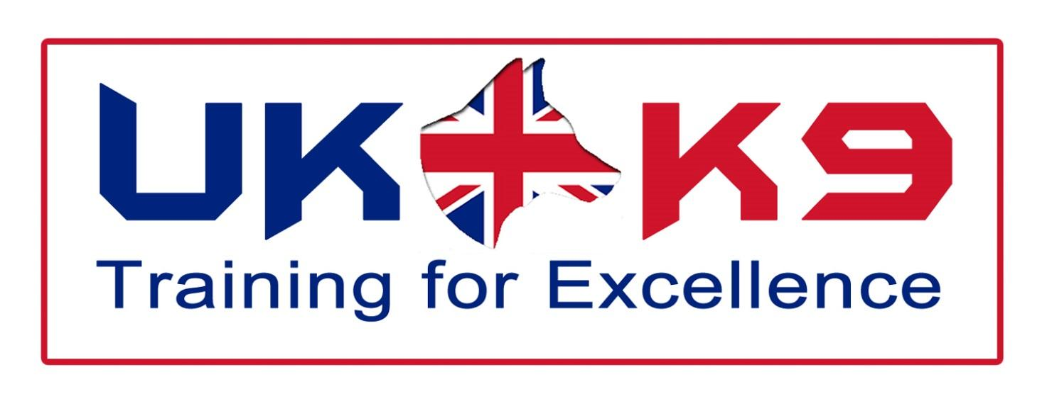

COMPANY NUMBER: 09318323

CAPABILITY STATEMENT

Contents

1 Introduction 3
2 Training 4
3 Services Available 5
3.1 Cadaver/human remains Detection 5
3.2 Water cadaver/human remains detection 5
3.3 Mountain Rescue & Lowland Search 6
3.4 Urban Search & Rescue (USAR) 6
3.5 Fire Investigation 7
3.6 Tracking & Trailing/Discriminating 8
3.7 Patrol Arm True (PAT) Dog 8
3.8 Tracker Dog 8
3.9 Arms Explosive Search Dog (AES) 9
3.9.1 Vehicle Search Dogs 9
3.10 Search Planning & Management 10
3.11 Helicopter Operations 10
3.11.1 Helicopter familiarisation, Safety & Awareness 10
3.11.2 Winching 10
3.11.3 Abseiling/Rappelling 11
3.12 Swift Water Rescue & Powerboat Handling 11
4 Forensic consultancy 12
5 Team Biographies 12

Introduction
UK-K9 Training for Excellence is at the forefront of delivering training to search & rescue dogs and their handlers, to the world’s emergency services. Our vision is to ensure that each K9-unit is trained to the highest standard, in all aspects of search & rescue, to create a fully operational and self-reliant team. As such we provide our clients with tailor made training and consultancy services.
Our instructors and staff have a wealth of experience, dating our first training back to 1986, when attending the aftermath of the El Salvador earthquake. Since then our instructors, dog handlers and dogs have been utilised in search & rescue worldwide (see our instructor biographies for further information)
We pride ourselves in ensuring that the training and consultancy is the highest of quality, partnering ourselves with several universities has allowed us to provide current and elite training (see individual areas for further information).
These universities also provide a forensic consultancy on our behalf, combining all aspects that relate to disasters of a global scale. (For more details of this see forensic services)

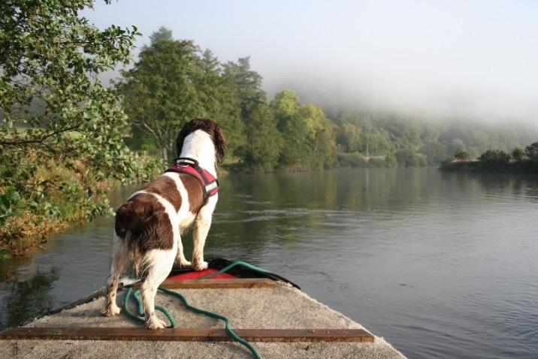

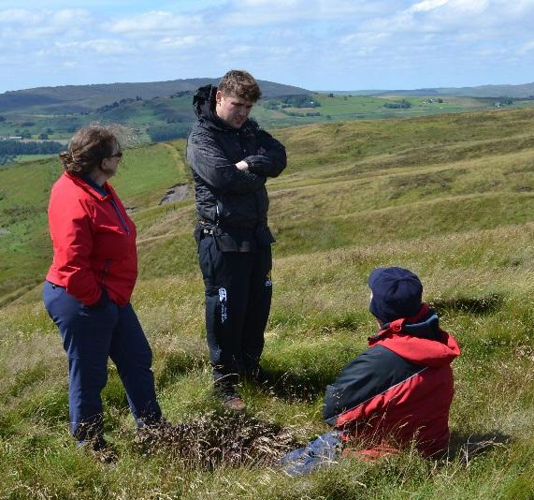

Training

UK-K9 Training for Excellence instructs using a three level modular system; level 1 aims to provide an awareness of search and rescue, level 2 is an operationally capable level and finally, level 3 is to an instructor level. Our instructors are approved NASDU (National Association of Security Dog Users) trainers, providing NASDU accreditation to each delegate/trainee when they complete the 150 hours of guided learning

The list below illustrates the areas in which UK-K9 Training for Excellence offers consultancy and training services:
- Cadaver/Human Remains Detection
- Water Search
- Urban Search & Rescue (USAR)
- Mountain Rescue
- Disaster Search & Rescue
- Drugs Detection
- Explosives Detection
- General Purpose Police Dogs
- Specialist Combat Tracker Dogs
- Passive and Proactive Detection
- Suicide Bomber Detection Dogs
- Helicopter Familiarisation
- Fast Rappelling/Abseiling from Helicopters.

Other Training includes:

- Search Planning & Management
- Navigation
- Technical Rope Rescue
- Swift Water Rescue
- Powerboat Handling

Services Available

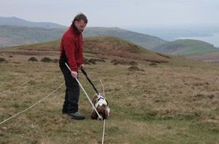
Cadaver/human remains Detection

Cadaver detection dogs have been widely used around the world. Their inherent search for food has made them the ideal tool to assist law enforcement officers in the search for human remains. They have been used for a variety of scenarios, from scenes of crime to mass disasters. The advantages of cadaver dogs are their ability to cover large areas, for example aircraft crash /mass graves, and to detect remains underground.

Modern day cadaver detection dogs have been trained to work alongside other search techniques such as ground penetrating radar (provided to us by Forensics Connect in partnership with the University of Leicester). By working to a strict protocol they are able to work together with these other techniques thus giving the investigator a greater understanding of the search.

Dedicated cadaver detection dogs are trained to ignore other food types and will only give an alert on the scent of pig (used in training) or human remains. Their specialised training reduces the amount of “false positive” indications and enables them to search large areas relatively quickly when compared to other search techniques.

The training of these dogs has been in conjunction with the leading research team at the University of Leicester. They are renowned for their forensic research, having developed the method for DNA analysis which is now used globally. The research looks to improve the accuracy and effectiveness by investigating the individual chemicals associated with cadaver material.

Water cadaver/human remains detection
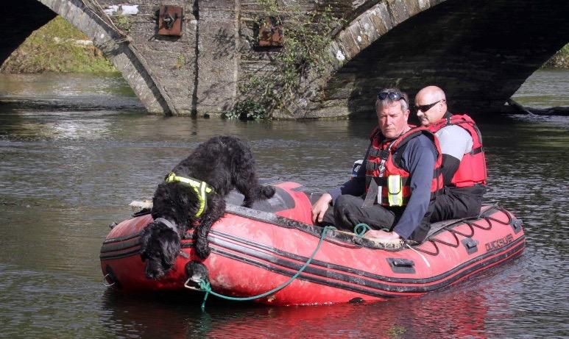
The training of cadaver detection dogs to search for submerged human remains is relatively new to the UK. However, with natural disasters occurring more frequently around the world, their usage is becoming ever more prevalent.

Combined with highly qualified water search personnel these dogs are able to search large areas of water, both lakes and rivers, helping to reduce the search area for other search personnel and making it more safe and time effective.

Mountain Rescue & Lowland Search

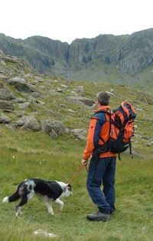
Mountain rescue teams advocate the use of highly trained search dogs and handlers in the search for lost, overdue, and injured walkers or climbers whose location is unknown.

The dogs are trained to locate the missing person by homing in on the airborne human scent emanating from the missing person. The dog and handler are trained to cover large areas of mountainous terrain, with the dog free ranging from the handler, searching for the scent carried on the wind. When this happens the dog will follow the scent to its source and then return to the handler and give an audible indication and then will lead the handler back to the missing person.

Mountain rescue dogs are able to search large areas of mountainous terrain, in all weathers, day and night with a high degree of accuracy. Even if the casualty is not located in the searched area the dog is still a vital asset as the search managers are now able to exclude the searched area with some degree of certainty and move their efforts and resources elsewhere. It has been stated that 1 search dog and handler team equates to approximately 20 trained search personnel in bad weather and at night this number can be increased.

The training of lowland search dogs is similar in its parts to that of a mountain rescue search dog however the handler possesses different skills. However, both the dog and handler must be adaptable and able to search in more populated environments, with a greater amount of distractions. It has been proved that dogs adapt well to searching in urban and rural environments and constitute an integral role in any lowland search and rescue team.

Urban Search & Rescue (USAR)
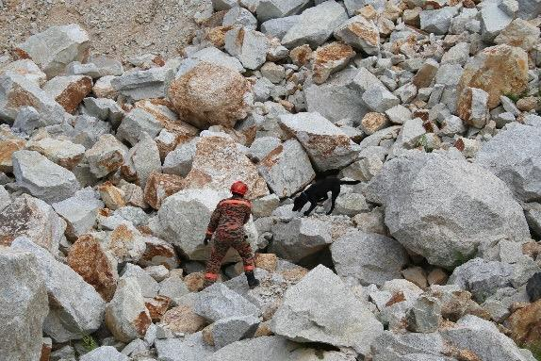
The use of USAR dogs is crucial in a post-disaster, collapsed building environment. Time is a critical factor in the preservation of life in such instances. USAR dogs are able to quickly and effectively locate survivors trapped in collapsed building debris and indicate on a location. This enables rescuers to focus their resources and efforts on these specific areas and save more lives. A USAR dog is a unique, life-saving tool whose speed and accuracy cannot be met by any other means.

Fire Investigation
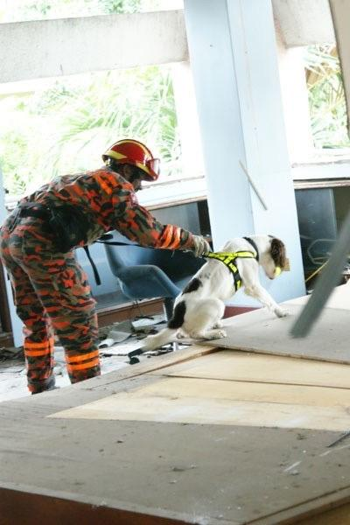
A fire investigation dog is used to search through the debris and damage of a fire scene to locate any remaining traces of ignitable liquids present.

The use of fire investigation dogs is now widely accepted as a major benefit to the fire investigator, in locating traces of ignitable liquids remaining at any fire scene under investigation. A fire investigation dog is used to search through the debris and damage of a fire scene to locate any remaining traces of ignitable liquids present. It remains the task of the fire investigator to determine the relevance of any finds by the dog. The dogs should be capable of recognising all of the readily available ignitable liquids, for example petrol, diesel, paraffin, barbeque lighter fuel, camping fuel, cigarette lighter fuel, white spirit, cellulose thinners and acetone. Once the dogs have acquainted skills to identify these materials it is highly likely that it will react to any other similar substances it encounters.

A fire investigation dog can cover a large area in a very short space of time with a degree of accuracy that is unlikely to be replicated by any other means. The dog must be capable of operating in the hostile environment found at the majority of post incident fires. A fire investigation dog should be capable of identifying substances in very minute quantities. One of the major advantages that the Fire Investigation dogs have over scientific apparatus is the ability to discriminate between two substances for hydrocarbons as opposed to their naturally occurring counterpart.

Tracking & Trailing/Discriminating
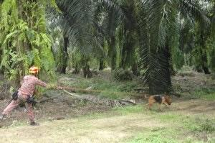
Tracking - A person walking away from location will leave a track which consists of rafts of human scent that are too heavy to remain airborne and will fall on or near to the footfall of the person laying the track. This combined with the scent of damaged grass and other vegetation can be followed by a dog and handler for quite a considerable distance depending on the prevailing weather conditions. Dogs trained for this discipline can be of use to law enforcement and search & rescue.
Trailing/Discriminating - Dogs trained to scent discriminate are able to pick up and follow a trail laid by a person when a scent article is available to the handler. These dogs again are of great use to search & rescue and law enforcement. Dogs and handlers with this training come into their own when the person is missing in a highly populated area where the need for scent discrimination is of paramount importance.

Patrol Arm True (PAT) Dog
Patrol Arm True Dogs are capable of patrolling the perimeter of a site for up to 16 hours a day 7 days a week. With the capacity to hear and smell intruders in hiding or lying in wait for the Security team from up to 200 metres or further in favourable conditions away it is almost impossible to ambush a trained Patrol Arm True dog team. The PAT Dogs pick up and indication methods allow the Security team to offer a level of assurance to the client that the perimeter will be extremely difficult to breach and with the reputation the canines provide, deter any would be intruder before attempting a breach.

Tracker Dog
Should there be an intrusion onto the site the Security team have the option of utilising the pick-up and indication capabilities of the PAT dog or calling upon a trained tracker dog. The tracker dog is trained to find the scent laid by an intruder from the point of entry to the source (the intruder). The dog is trained to detect this scent after it was laid over 3 hours before it was discovered. The length of the distance the dog is able to track is unprecedented with distances ranging from 50 metres to up to 5 miles. The dog is trained to track the intruder over varying surfaces including grass, hard standing, and the rugged surface the Middle East offers including hard compacted sand. Upon discovering the intruder, the Security team can again call upon the PAT dog to detain the suspect offering a level of safety for the security officers should the intruder be armed.

Arms Explosive Search Dog (AES)
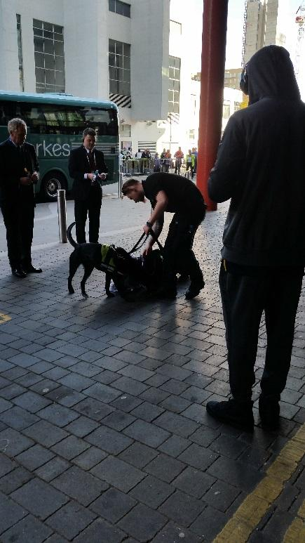
A fully trained Arms and Explosive Search team are an invaluable resource. The team are capable of locating an Improvised explosive device in any area containing an explosive sample from as little as 5 grams. The dog’s olfactory system can detect trace elements of the explosives even after they have been removed from a scene. With the capacity to find PE4, C4 Semtex, TNT, Cordtex, ANS, ANFO, PE7 and DM12 as a standard trained dog NCTC have the ability and knowledge to add explosive scents to the dogs training that have been flagged in a specific operational environment. An AES dog is also trained to search and detect explosives on all vehicle platforms including aircraft and due to the size and temperament they can be transported easily on rotary aircraft to provide a fast assurance to security teams operating remotely. All of the AES dogs have undergone a rigorous training package of 2 months with a highly qualified trainer. With Operational search experience in almost all Middle Eastern conflicts our trainers are able to imprint on the dogs the high standards required to operate successfully and easily identify dogs without the capability to do such a high demanding role. This experience drives down the rejection rates of dogs that simply do not have the drive to Search when mobilised to a warmer climate which in turn reduces the cost to the client.

The University of Leicester has also investigated improving the detection of explosives, again looking at the individual chemicals that the dogs are detecting to establish a more accurate method of detecting,

Vehicle Search Dogs

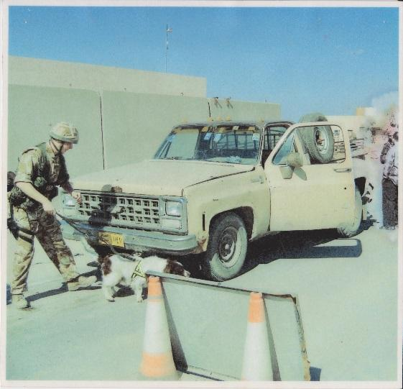
NCTC can assist the protection of compounds, buildings, and facilities with high traffic rate by the provision of Vehicle search dogs. Vehicle Search (VS) dogs have the same capability in the detection of explosives as an AES dog with the exception that it is solely trained to search Vehicles. With the ability to search over a hundred vehicles a day the VS dog is unique in the fact that searching vehicles time and time again will, in the case of security officers, become monotonous and create complacency. A trained VS dog will eliminate this and continue to search for the presence of Explosives over and over again with only one focus, to find its reward. The ability to search Articulated lorries, small cars, planes, trains and boats the VS dog reduces the training costs of security teams and speeds up the search procedures exponentially allowing regeneration projects to stay on time in a safe and consistent manner.

Search Planning & Management

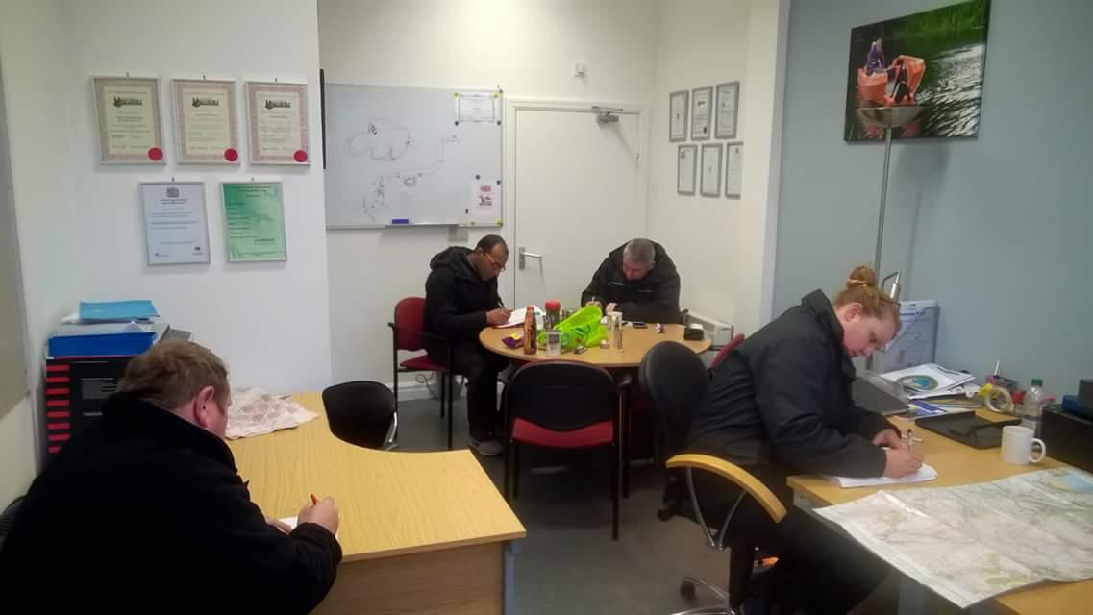
As it is imperative that all searches are managed effectively, UK-K9 Training for Excellence offers various courses that teach the principles of effective management of searching for lost persons and locating persons of interest. Whilst the emphasis is placed on open country search the principles are applicable to much wider fields of endeavour including urban, rural, mountain, and other search environments.

Considerable success has been achieved with this program in a number of countries throughout the world. The course enables the finding of missing persons in less time, with fewer resources and in a better state of health. In short, the program teaches a well-tested search management and planning process that endeavours to achieve “success fast” - the principle goal of all searches.

Helicopter Operations

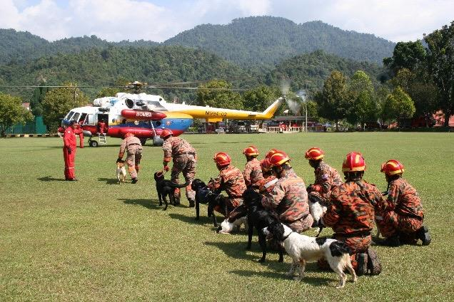
UK-K9 Training for Excellence also offers various training courses for those that rely on helicopters for use in professional circumstances. The courses are designed to increase safety, in and around the aircraft, increase interoperability between air and ground units and to develop standard operating procedures. Examples of courses include:

Helicopter familiarisation, Safety & Awareness
This course is designed to introduce professionals to best operating and safe working procedures whilst working with helicopters. The course consists of both indoor theory study and practical sessions with safety increased both in and around the aircraft.

Winching
UK-K9 Training for Excellence can provide its client’s with a winching course which aims to train people on how to winch to and from a helicopter in the safest and most effective way possible. The course aims to teach this in various weather conditions, day and night at various heights, with and without K9.

Abseiling/Rappelling
In some instances, it is not possible to use a winch as a means of extracting or inserting personnel. To resolve this UK-K9 Training for Excellence offers an abseiling or rappelling course designed to train delegates on how to abseil/rappel from a helicopter. As per the abseiling course, delegates will gain experience rappelling from various heights, in various conditions, day and night and with and without K9.

Swift Water Rescue & Powerboat Handling
When operating as a water search team it is imperative that all personnel are trained to high standards in all-encompassing areas. For this reason, UK-K9 Training for Excellence offers courses in areas such as swift water rescue and powerboat handling.
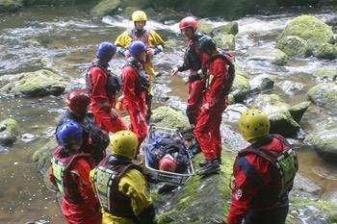
UK-K9 Training for Excellence offer the capability to gain accredited qualification through courses such as:

Swift Water First Responder
Swift Water Rescue Technician

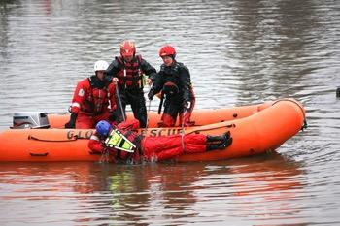
UK-K9 Training for Excellence offer boat handling courses accredited by the RYA including:

RYA Powerboat Level 1
RYA Powerboat Level 2
RYA Advanced Powerboat

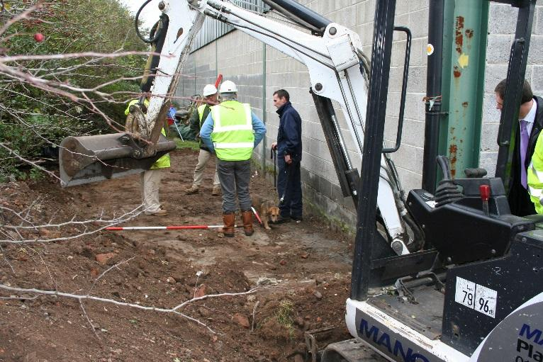
Forensic consultancy
We offer a range of forensic consultancy work, including:
- Experienced scenes of crime officers
- Forensic geophysical equipment
(ground penetrating radar)
- Mass grave excavation (performed by
trained and renowned forensic
archaeologists and anthropologists)
- Deceased Victim Identification (DVI)
Contact Us

For further details please contact:

David Jones Tel: 07918 618001
Email: dave@uk-k9training.co.uk

