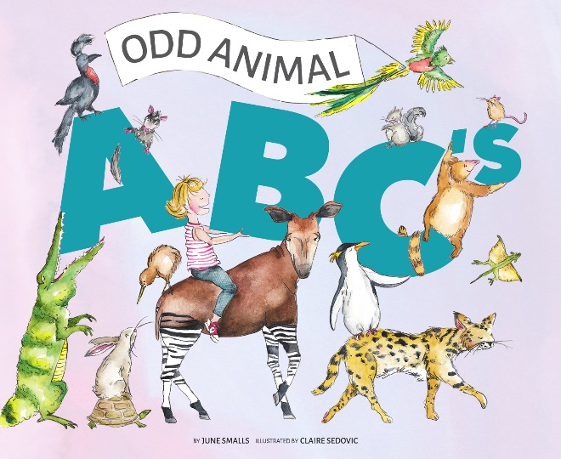

Aye-Aye [ahy-ahy]
Blue Footed Booby [bloo foo t-id boo-bee]
Civet [siv-it]
Draco Lizard [drey-koh]
Echidna (ih-KID-na)
Fossa [foo-sa]
Genet [jen-it]
Human [hyoo-muh n]
Ibis [ahy-bis]
Jerboa [jer-boh-uh]
Kiwi [kee-wee]
Kudu [koo-doo]
Leaf Tailed Gecko [gek-oh]
Maned Wolf [meyn ed]
Numbat [nuhm-bat]
Okapi [oh-kah-pee]
Pink Fairy Armadillo [ahr-muh-dil-oh]
Quetzal [ket-sahl]
Quoll [kwol]
Rock Hyrax [hahy-raks]
Serval [sur-vuh l]
Tree Kangaroo [kang-guh-roo]
Umbrella Bird [uhm-brel-uh burd]
Viscacha [vi-skah-chuh]
Wombat [wom-bat]
Xenops [zeh-nohps]
Yeti Crab [yet-ee krab]
Zebra Duiker [zee-bruh dye-ker]

