Scratch Introductory Level Lesson Six
Lesson Overview
Topic |  | Scratch  Intro. |  | Design Content  Content | Animals  Color  Stop Script |  | Design Plan
 |  |  |  |  |  |  | I believe everyone heard the story of the race between Hare and Tortoise. In this lesson, you will design a coding game about a race of two animals
Age |  | 8＋
Name |  | A game of Tom and Jerry
Activity  Goals |  | Learning Goals |  |  |  | Emotion Goals |  | Skill Goals
 |  | 1.Learn random block  2.Learn touching color block  3.Learn Stop Script block |  |  |  | 1.Increase students ‘endurance  2.Develop the ability of renovation  3.Increase interesting in coding |  | 1.Understand the rule to run two Sprites at the same time  2.Understand the concept of moving speed.  3.Konw to Stop Script
Classroom Segments
ICETeaching Method | Intro  (10min) |  | Lead-in questions:  1.Who is the winner in the story of The race between Hare and Tortoise?  2.Have you ever attend sports meet?  3.What’s your ranking on your last sports meet?  4. Design a sports meet,  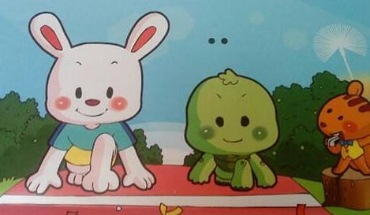
 | Create  （55min） |  | 1.Open Scratch Desktop Software  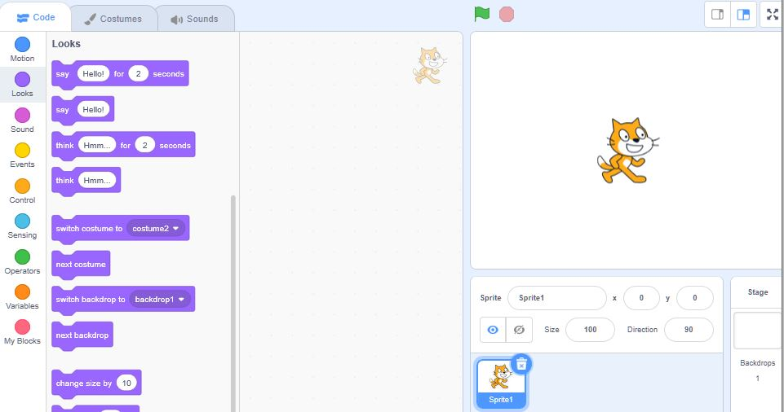  2.Select Backdrop and drop a red line on it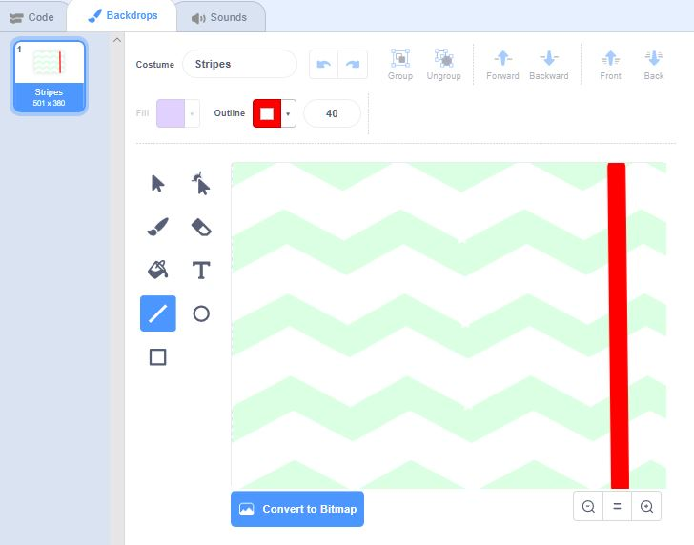  3. Choose Sprite Rabbit and Horse  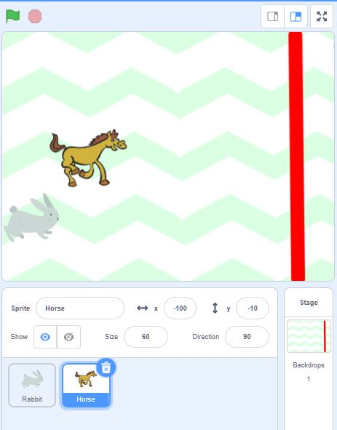  4.Determine the start point of two Sprites  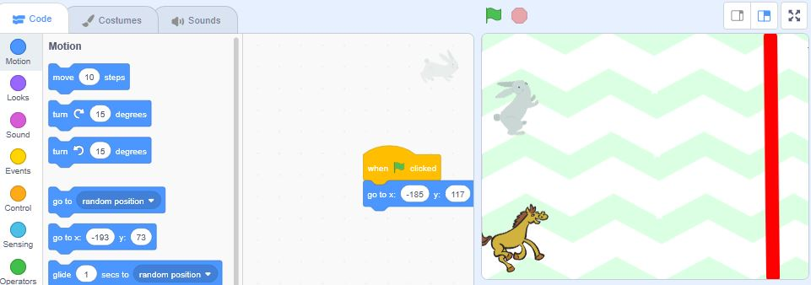  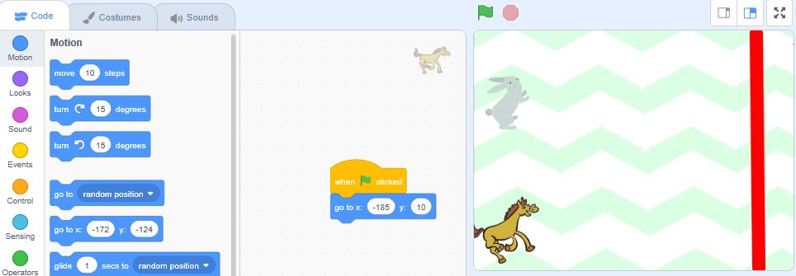  5.Select Pick Random block and add it into Move motion module  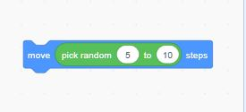  6.Set the Starting Direction of the Sprite  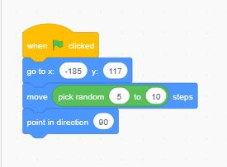  7.Select Touching color block from “Sensing”module, choose ending line red color from color choise fuuction.  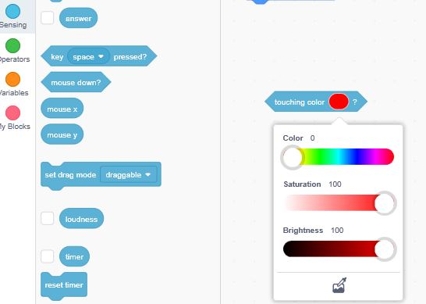  8.Select if… then block from “Control”Module and add the touching color block into If…then  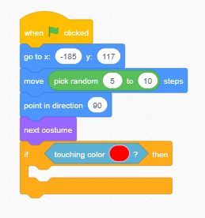  9.Select Stop all block from “Control”Module then insert it into If…then block and add repeat block  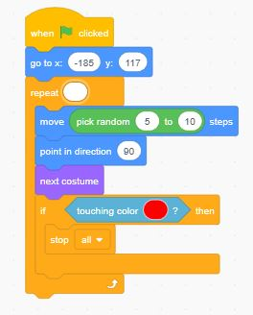  10.Follow the above step to duplicate the coding to another Sprite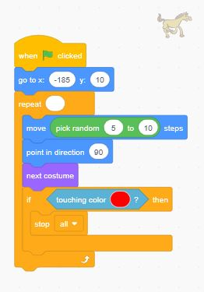
 | Thinking  Time  （5min） |  | 1.How does the speed run randomly?  2.When one Sprite touch the ending line, how to stop all Sprites?  3.How to decide the color?
 | Explore  (10 min) |  | Add one more Sprite to make three animal complete.
 | Share

