Nevada Equine Council Member meeting agenda | 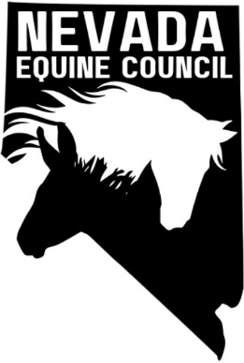

Location: | South Valleys Library - Diamond Room, 15650A Wedge Pkwy Reno, NV 89511
Remote Info: | TBD
Date: | April 1, 2025
Time: | 6:30 PM
The purpose of this notice/agenda is to inform you of the date, time, place and action items of the upcoming scheduled member meeting of the Nevada Equine Council (NVEC). The agenda for the current meeting is available on the website. Draft minutes of this meeting will be available within 30 days after the meeting date.

meeting details

Roll call

Approval of Member Meeting minutes

NA

Treasurers report

committee reports

Membership Committee

Legislative/Land Use Planning/Environmental Committee

member hot topics

The Board has the authority to limit the time for individual comments. Please limit your comments to 3 minutes.

meeting/events schedule

NV Equine Council Member Upcoming Meeting and Locations
Date | Locations
May 6, Jun 3, Jul 1, Aug 5, Sep 2 | South Valleys Library – Diamond Room, 15650A Wedge Pkwy Reno, NV 89511
No meeting in December

New upcoming Events

Adjournment

