Nevada Equine Council Meeting Minutes | 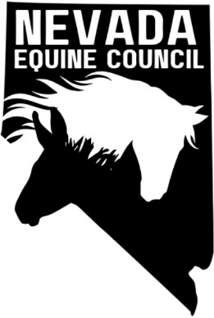

Location: | Raley's 108 - Reno Gather A Meeting Room, 18144 Wedge Parkway, Reno, NV 89511
Date: | September 3
Time: | 6:00 PM

meeting details

Roll call

Sam, Heather, Kathy, Deanna

Approval of minutes

August 2024 minutes approved; Kathy motioned to approve, Sam seconded

Treasurers report
NA

old business and Action Items

NV Equine Council setup

Reviewed and commented on drafted by-laws

Review completed, final version of by-laws to be distributed for approval at next meeting

All other items tabled to future meetings

committee reports

NA

new business and Action Items
NA

Conclusion
Meeting adjourned

