Nevada Equine Council Board Meeting Minutes | 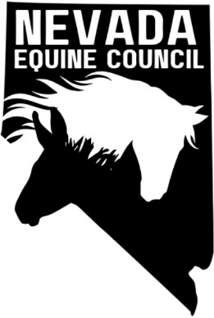

Location: | South Valleys Library - Diamond Room, 15650A Wedge Pkwy Reno, NV 89511
Remote Info: | Zoom Meeting
Date: | June 10, 2025
Time: | 6:11 to 7:00
Minutes, together with other important NVEC information are posted on the website at nvequinecouncil.org.

meeting details

Roll call

Heather, Sam, Deanna, Sam, Giovanni

Approval of minutes
May 2025 minutes. Heather motioned to approve, Kathy seconded. Minutes approved.

Treasurers report
Previous balance $289.42. June balance $389.42.

old business and Action Items

Board member recruitment.

Nonprofit Management Liability Policy

IRS form to obtain nonprofit status. Fee $600.

Identify Sponsors/Partners

Feed/Hay suppliers

American Horse Council (https://horsecouncil.org/).

Veterinarians

Farriers

Nevada Rangeland Resource Commission https://nevadarangelands.org/

NDOR – add NV Trail Finder to website (completed)

Newsletter. Tabled until additional members are available.

High Desert Horseman (HDH) – on agenda for July 10 meeting to give presentation on NVEC and try to recruit members

No movement on possible CERT clinic for emergency equine evacuation clinic.

AHC membership due July. Deanna will pay ($365) for 2025-2026.

committee reports

Membership Committee

Legislative/Land Use Planning/Environmental Committee

Carson City Master Plan. Removed specific users so now includes equestrians.

SB303

new business and Action Items

Collective Action for the Greater Good panel event on May 27th.

Monthly meetings moved to second Tuesday of the month. November meeting will be November 18.

Membership incentives. Look at swag (hat, T-shirt, stickers, water bottles), discounts, insurance on horse ($1M excess liability), window decal, member directory. Look at other councils perks. FFA, 4-H, Farm Bureau, Truck Dealers, S&W tractor.

Calendar and meeting/events

NV Equine Council Board Meeting Schedule and Locations for 2025
Dates | Locations
New dates – second Tuesday of the month: Jun 10, Jul 8, Aug 12, Sep 9, Oct 14 and Nov 18 | South Valleys Library – Diamond Room, 15650A Wedge Pkwy Reno, NV 89511
No meeting in December

New upcoming events

Nevada Agriculture Fair (previously known as the Silver & Sage Fair) will be held at the Douglas County Fairgrounds July 18 to 20 https://www.nvagfair.com/

Adjournment

