Nevada Equine Council Board Meeting Minutes | 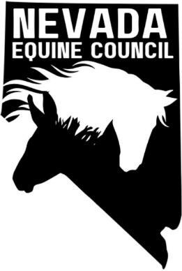

Location: | South Valleys Library - Diamond Room, 15650A Wedge Pkwy Reno, NV 89511
Remote Info: | Zoom Meeting
Date: | May 6, 2025
Time: | 6:00 PM

meeting details

Roll call
Samantha, Heather, Kathy, Deanna
Giovanni Diaz (NV FAA), Bailey and Tony from Back Country Horsemen (remote).

Approval of minutes
April 2025 minutes; Heather motioned to approve, Samantha seconded, minutes approved.

Treasurers report
Report on shared drive. Funds pending in next few days.

old business and Action Items

New membership - Welcome Giovanni! Thank you for donation and interest in becoming board member.

Board member recruitment

Discussed requirements for board members. In addition to member in good standing (i.e., paid membership for current year), person must attend at least 3 meetings (board and/or general membership) to be eligible to be board member. To be added to P&P.

Nonprofit Management Liability Policy

IRS form to obtain nonprofit status. Fee $600.

Identify Sponsors/Partners

Feed/Hay suppliers

American Horse Council (https://horsecouncil.org/).

Veterinarians

Farriers

Nevada Rangeland Resource Commission https://nevadarangelands.org/

NDOR – add NV Trail Finder to website

TMT working group update

Deanna attended TMT Working Group meeting April 17, 2025. Not much regarding equestrians. But of note, NASTR provided $5K grant to TMT

Newsletter. Would be nice to have but tabled until additional members are available.

committee reports

Membership Committee – See attached regarding membership

Legislative/Land Use Planning/Environmental Committee

new business and Action Items

Kathy and Deanna to attend Collective Action for the Greater Good panel event on May 27th.

Deanna attended High Desert Horseman (HDH) President’s BBQ and Game Day April 19, 2025

Spoke with Laura Ammons from Carson Valley Trails. They are promoting “Go Slow and Say Hello” safety program. Brochure downloaded (on Google shared drive) and suggest we add to our webpage. She provided contact information for Eric Wambach for possible CERT clinic for emergency equine evacuation clinic. Deanna working on follow up.

Deanna to also attend HDH meeting on May 8 and will promote NVEC membership/support from HDH.

Back Country Horsemen (BCH) members Bailey Dikes and Tony attended meeting.

Working on signs at trailheads. Event planned for Washoe Lake State Park in 2026 (Jennifer) BCH meeting May 21 at Mimi’s Café on May 21 @7:00 pm. Heather will work with BCH.

Calendar and meeting/events

NV Equine Council Board Meeting Schedule and Locations for 2025
Dates | Locations
Apr 1, May 6, Jun 3, Jul 1, Aug 5, Sep 2, Oct 7 | South Valleys Library – Diamond Room, 15650A Wedge Pkwy Reno, NV 89511
Nov4 | TBD. No meeting in December

New upcoming events

National Pony Express Association (NPEA) National Convention 2025 will be held in Elko, NV. Sept 5 & 6. The convention is open to all to attend. Registration form is on website https://nationalponyexp

Nevada Reined Cow and Cutting Horse Association, Winnemucca Events April 15 to 20 and June 10 to 15. (www.NRCCHA.com)

Chappell Ranch. Ranch Camp. April 21 to 25 and April 28 to May 2. Gardnerville. (www.chappellranchllc.com)
    - Nevada QHA (nvqha.com): AQHA Silver State Circuit and Gamblers Choice, VRH Show, Winnemucca, July 23-27, 2025

Adjournment

Nevada Equine Council Membership Committee report | 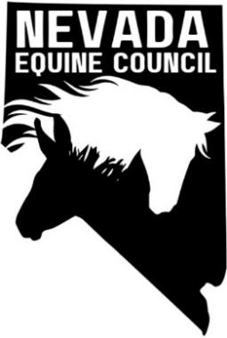

Report Date: May 6, 2025
Submitted By: Deanna Newcomb
Committee Members: Deanna Newcomb, Heather Manzo
Meeting Date(s): None
Motion(s) to be brought to NVEC Board:
No motions coming forward at this time
Committee’s Action Items: No action items at this time
Discussion Items:
- Submitted online requests for donation/support to CAL Ranch and Tractor Supply Company on March 29, 2025.
- Reached out to Jordan at Guided Trail Rides in Gardnerville (Facebook). New business and not ready to get involved yet but will reach out in the future.

NVEC information added to NDOR Eastern Sierra Trails Coalition quarterly newsletter. Introduction plus asking for general and board members (used text from FB post). Also provided flyer and May meeting info.

May 5 - Introductory emails sent to Nevada Quarter Horse Association (NQHA), Chappell Ranch in Gardnerville, Nevada Reined Cow & Cutting Horse Association (NRCCHA), Roper Buildings (Elko and Reno/Western NV contacts), River Bottom Ranch in Carson City, and Equest Training Center in Washoe Valley.
Next Steps:
- Kathy to contact Hoof Beats and Corrals in Fallon and Big R in Fallon.
- Deanna to continue to reach out to organizations. Also S&W Tractor in Carson City

