Nevada Equine Council Board Meeting minutes | 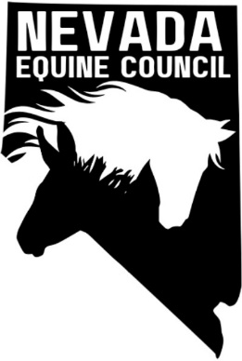

Location: | South Valleys Library - Diamond Room, 15650A Wedge Pkwy Reno, NV 89511
Date: | April 1, 2025
Time: | 6:07 PM – 7:08 PM
Minutes, together with other important NVEC information are posted on the website at nvequinecouncil.org.)

meeting details

Roll call

Kathy, Deanna, Samantha, Heather.

Approval of minutes

March 2025 minutes. Kathy motioned to approve, Samantha seconded. Minutes approved.

Treasurers report
No change from March however funds are on website waiting for transfer. DbarM and one family membership completed.

old business and Action Items

New membership. New membership form generated and website updated.

Board member recruitment. Kathy contacted James Galos on LinkdIn; works for New York Life Insurance. Giovanni Diaz for legal advice and support $$$. Can they help us with Nonprofit Management Liability Policy. Also, Kathy has Lawyer at her church that she will contact also.

Nonprofit Management Liability Policy tabled until May 2025 (need IRS nonprofit first).

IRS form to obtain nonprofit status. Fee $600. To be addressed when funds are available.

Identify Sponsors/Partners

Vendors/Feed/Hay suppliers

American Horse Council (https://horsecouncil.org/).

Veterinarians

Farriers

Nevada Rangeland Resource Commission https://nevadarangelands.org/

Committee establishment and member recruitment for standing committees:

Membership Committee – Deanna/Heather

Legislative/Land Use Planning/Environmental Committee - Kathy

Newsletter. Would be nice to have but tabled until additional members are available.

committee reports

NA

new business and Action Items

Kathy has been in contact with Allegra Printing in Reno about making some items for Team Yriarte for events and was told that they have a program called The footPRINT Fund. They select up to 10 local non-profits to sponsor their printing needs (including specialty items like branded pop-ups, table covers, etc) up to $1000. We just need to fill out a simple application. They were very encouraging when Kathy told them what NVEC are doing and where we are at. Here is the link to the details including what they offer: https://www.allegramarketingprint.com/locations/reno-nv/the-footprint-fund

Deadline to apply is in June. Kathy will complete application. We can also re-apply each year with no limitations!

Suggested we contact RR and other rodeos for booth/promotions.

Add website metrics to Board Meeting

Website Metrics | Site Visitors | Conversations | Social Views | Performance Score
Year to Date | 1056 | 7 | 517 | 57
Last 30 Days | 187 | 1 | 34

Calendar and meeting/events

NV Equine Council Board Meeting Schedule and Locations for 2025
Dates | Locations
Apr 1, May 6, Jun 3, Jul 1, Aug 5, Sep 2 | South Valleys Library – Diamond Room, 15650A Wedge Pkwy Reno, NV 89511
Oct 7, Nov4 | TBD. No meeting in December

New upcoming events

National Pony Express Association (NPEA) National Convention 2025 will be held in Elko, NV. Sept 5 & 6. The convention is open to all to attend. Registration form is on website https://nationalponyexp

Adjournment
Meeting adjourned

