Nevada Equine Council Meeting minutes | 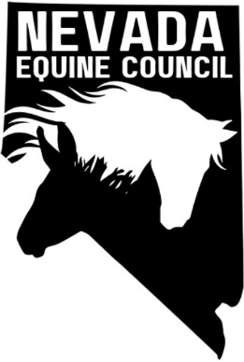

Location: | Raley's 108 - Reno Gather A Meeting Room, 18144 Wedge Parkway, Reno, NV 89511
Date: | October 1
Time: | 6:00 PM

meeting details

Roll call

Heather, Kathy, Deanna, Sam

Approval of minutes

September 2024 minutes, Heather motioned to approve, Kathy seconded

Treasurers report
Not applicable

old business and Action Items

Final review and approval of by-laws – final review completed, final draft to be sent for approval

Discussed “Dynamic Nonprofit Board Development lecture presented by Cheri S Hill of Sage International, Inc. July 24, 2024

Discussed BLM NV Recreation Summit Summary (09 July 2024) Sam to provide more info when results are available. Possibly by end of year.

NV Equine Council setup

Board member recruitment

Non-profit category - Heather looked into other states; decision was made to go with 501(c)(6) at this time with addition of (c)(3) at a later date

Draft Articles of Incorporation – Deanna to do

Draft NVEC flyer for distribution – Deanna to do

Apply for NV Business License after completion of Item 3

Identify Sponsors/Partners

Feed/Hay suppliers

American Horse Council (https://horsecouncil.org/).

Veterinarians

Farriers

Nevada Rangeland Resource Commission https://nevadarangelands.org/

Sam - list of Southern NV contacts (Eastern also?)

Addition of any future action items for southern NV (particularly Vegas area)

Facebook page – this has been completed

committee reports

NA

new business and Action Items

Meeting adjourned

