Nevada Equine Council Board Meeting agenda/notice | 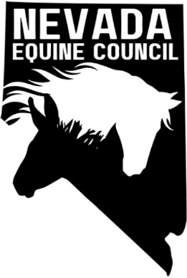

Location: | South Valleys Library - Diamond Room, 15650A Wedge Pkwy Reno, NV 89511
Remote Info: | Join Zoom Meeting  https://us05web.zoom.us/j/85136573464?pwd=xAEJlnmRiTFbTaKkocZiuQHUo7Bwkh.1
Date: | July 8, 2025
Time: | 6:00 PM (board check in at 5:45)
The purpose of this notice/agenda is to inform you of the date, time, place and action items of the upcoming scheduled meeting of the Nevada Equine Council (NVEC) Board.

meeting details

Roll call

Approval of minutes
June 2025 minutes

Treasurers report
Previous balance $389.42. July balance $__________.

Fees coming due

Microsoft 365 email (1 year) Due 24-Jun-25 $95.88

Website+Marketing Basics (1 year) Due 8-Jul-25 $203.88

AHC Membership Due 31-Jul-2025 $365.00

old business and Action Items

Board member recruitment.

Nonprofit Management Liability Policy

IRS form to obtain nonprofit status. Fee $600.

Identify Sponsors/Partners

Feed/Hay suppliers

American Horse Council (https://horsecouncil.org/).

Veterinarians

Farriers

Nevada Rangeland Resource Commission https://nevadarangelands.org/

Newsletter. Tabled until additional members are available.

High Desert Horseman (HDH) – on agenda for July 10 meeting to give presentation on NVEC and try to recruit members

No movement on possible CERT clinic for emergency equine evacuation clinic.

committee reports

Membership Committee

Legislative/Land Use Planning/Environmental Committee

website metrics

Website Metrics | Site Visitors | Conversations | Social Views | Performance Score
Year to Date
Last 30 Days

new business and Action Items

Economic Benefits (and More) of Horse Trails in the American Economy, Webinar, July 17, 2025, 10:00 AM PDT

Horse rescue issue in Storey County.

Calendar and meetings/events

NV Equine Council Board Meeting Schedule and Locations for 2025
Dates | Locations
New dates – second Tuesday of the month: Jul 8, Aug 12, Sep 9, Oct 14 and Nov 18 | South Valleys Library – Diamond Room, 15650A Wedge Pkwy Reno, NV 89511
No meeting in December

New upcoming events

Horse Owner Preparedness Meeting

NRHA Star Spangled Slide

Adjournment

