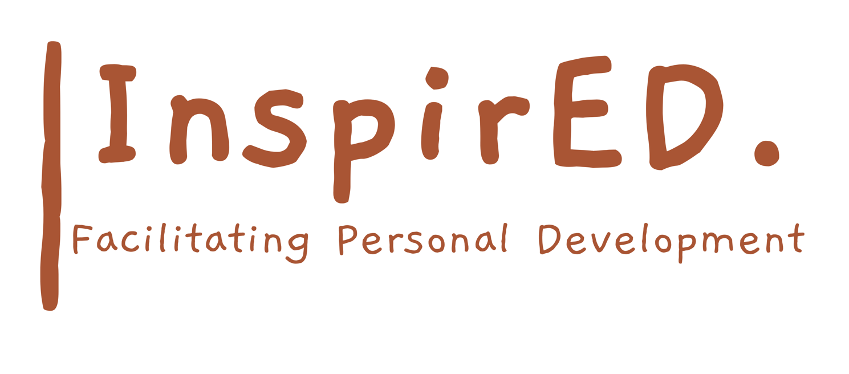

Staff Code of Conduct Policy

Date of issue: September 2024

Date for renewal: September 2026

CODE OF CONDUCT

# OVERVIEW

At InspirED we require that all of our employees conduct themselves according to the highest standards of ethics, integrity, and behaviour when dealing with students, colleagues and other stakeholders. This includes, but is not necessarily limited to, adherence to all other policies relevant to set roles.

This Code establishes the standards of behaviour that must be met by all employees. Where these standards are not met, appropriate disciplinary action will be taken. In cases where the breach involves serious misconduct, this may result in dismissal. In cases where a breach of the policy involves a breach of any law, then the relevant government authorities or the police may be notiﬁed.

# OPERATION

The purpose of this policy is to make it clear what the Company expects from employees, and employees are required to be familiar with and comply with the terms of this policy at all times. Failure to do so may result in disciplinary action, including potentially termination of employment.

In so far as this policy imposes any obligations on the Company, those obligations are not contractual and do not give rise to any contractual rights. To the extent that this policy describes beneﬁts and entitlements for employees, they are discretionary in nature and are also not intended to be contractual. They set the terms and conditions of employment that are intended to be contractual out in an employee’s written employment contract.

The Company may unilaterally introduce, vary, remove or replace this policy at any time.

# STANDARDS OF CONDUCT

The standards expected of employees include:

Compliance with all Company and workplace policies, procedures, rules, regulations and contracts; Compliance with all laws;

Compliance with all reasonable and lawful instructions given by or on behalf of the Company;

Devotion of the employee’s entire time, attention and skill during normal working hours and at other times as reasonably necessary for the employee to perform their duties;

To be honest and fair in dealings with our students, colleagues, external stakeholders and anyone else who might be interacted with during the working day including the public.

To be faithful and diligent, and actively pursue the Company’s best interests at all times, whilst contributing to the vision of the company.

To work in a safe and compliant manner, and to observe all workplace health and safety rules and responsibilities outlined in the health and safety policy;

Refraining from any discriminatory, bullying or harassing behaviour toward our students, colleagues, parents/carers or any other stakeholder,

To not make any statements to the media about the Company’s business, unless expressly authorised to do so by the Company and written permission is granted by the Director;

To not make any statements about the Company on social media, or any other public platform, that may harm the Company’s reputation;

To not, in connection with the employee’s employment, accept any ﬁnancial or other beneﬁt from any entity other than the Company – unless acceptance of such beneﬁt is in accordance with the Company’s other workplace policies or is otherwise disclosed to the Company and expressly permitted by the Company;

To not engage in any employment or provide any services to any person or entity other than the Company, except with the Company’s prior written/verbal consent;

To not engage in any employment or provide any services to a supplier or competitor of the Company, except with the Company’s prior written/verbal consent;

Immediately disclosing any potential, perceived or actual conﬂict of interest (whether direct or indirect) that may give rise to a conﬂict with the performance of the employee’s obligations to the Company, or the Company’s business, conﬁdential information or reputational interests. The Company may direct employees to take action to eliminate or reduce any such conﬂict, and employees must comply with such directions;

To not engage in conduct, whether during or after work hours, that in the opinion of the Company causes damage or potential damage to the Company’s property or reputation;

To not use, or come to work while aﬀected by use of prohibited drugs or alcohol;

To not discriminate on the basis of personal characteristics including (but not limited to) sex, race, disability, pregnancy, age, marital status or sexual orientation;

To dress in an appropriate manner and to ensure that appearance is presentable, clean, neat and tidy (including but not limited to wearing any uniform that is required of you by the Company).

To not use Company internet to access and/or download sexually explicit material or other oﬀensive material;

To not use Company email to send sexually explicit or suggestive material, or other oﬀensive or harassing material;

To maintain both during employment and after termination of employment with the Company, the conﬁdentiality of any conﬁdential information, records or other materials acquired during the course of employment;

At all times, behave in a way that upholds the Company’s core values and the integrity and good reputation of the Company;

Reporting any conduct of other workplace participants which is in breach of any of the above, or potentially in breach of any of the above, without delay.

# OTHER POLICIES

Employees are encouraged to read this policy in conjunction with other relevant Company policies, including Safeguarding, Health and Safety inc. first aid, Equality and diversity and Relational and behavior policy.