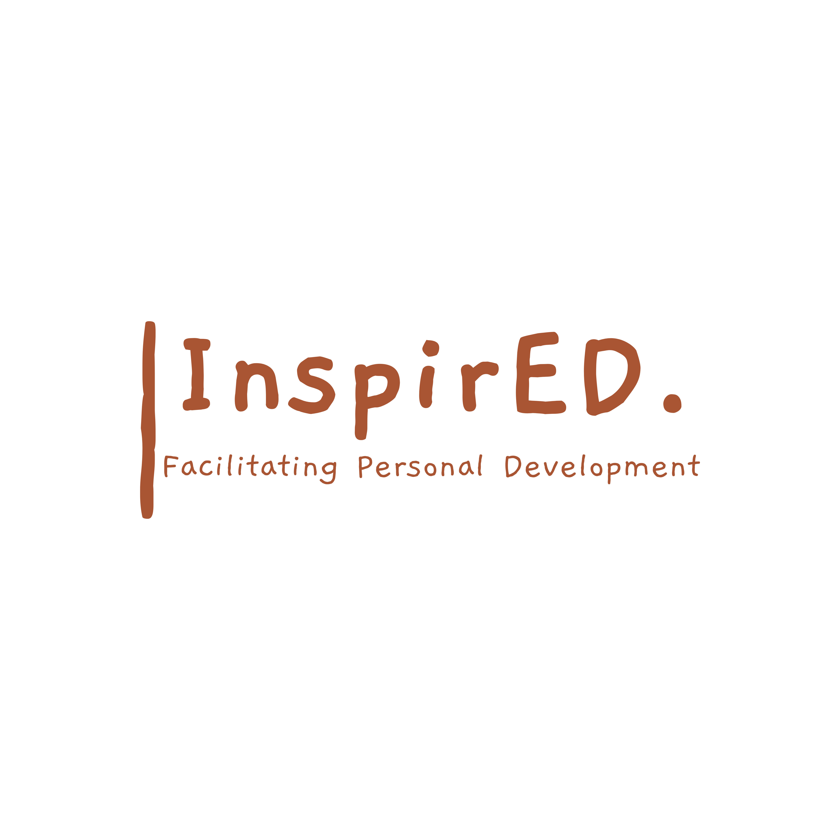

**Curriculum Policy**

Issue date: September 2024

Review date: September 2026

Author: Philip Parker

**Contents**

1. Curriculum aims 3

2. Roles and responsibilities 4

3. Organisation and planning 5

4. Inclusion 5

5. Monitoring arrangements 6

6. Future policies to support 6

# 

# 1. Curriculum aims

Our curriculum aims/intends to:

Insert the aims/intention of your curriculum here – for example, to:

* Provide a broad and balanced education for all pupils that’s coherently planned and sequenced towards cumulatively sufficient knowledge for skills and future learning and employment
* To engage students back into learning and give a sense of purpose
* Enable pupils to develop knowledge, understand concepts and acquire skills, and be able to choose and apply these in relevant situations
* Support pupils’ spiritual, moral, social and cultural development
* Support pupils’ physical development and responsibility for their own health, and enable them to be active
* Promote a positive attitude towards learning
* Ensure equal access to learning for all pupils, with high expectations for every pupil and appropriate levels of challenge and support
* Equip pupils with the knowledge and cultural capital they need to succeed in life
* Provide subject choices that support pupils’ learning and progression, and enable them to work towards achieving their goals
* Develop pupils’ independent learning skills and resilience, to equip them for further/higher education and employment.
* To enhance students character and allow them to grow as people
* To develop their understanding of the world around them and how to navigate that world effectively.

# 2. Roles and responsibilities

2.1 The governing board (pending assemblance)

The governing board will monitor the effectiveness of this policy and hold the headteacher to account for its implementation.

The governing board will also ensure that:

* A robust framework is in place for setting curriculum priorities and aspirational targets
* The school is complying with ISS and teaching a "broad and balanced curriculum" which includes English, maths, and enough teaching time is provided for pupils to cover the requirements of the curriculum plans
* Proper provision is made for pupils with different abilities and needs, including children with special educational needs (SEN)
* All courses provided for pupils below the age of 19 that lead to vocational qualifications from AQA or City and Guilds amongst other providers
* The school implements the relevant statutory assessment arrangements
* It participates actively in decision-making about the breadth and balance of the curriculum
* Pupils from year 10 onwards are provided with independent, impartial careers guidance, and that this is appropriately resourced

3.2 Headteacher/Director

The headteacher is responsible for ensuring that this policy is adhered to, and that:

* All required elements of the curriculum, and those subjects which the school chooses to offer, have aims and objectives which reflect the aims of the school and indicate how the needs of individual pupils will be met
* The amount of time provided for teaching the required elements of the curriculum is adequate and is reviewed by the governing board
* Where appropriate, the individual needs of some pupils are met by permanent or temporary disapplication from all or part of the National Curriculum
* They manage requests to withdraw children from curriculum subjects, where appropriate
* The school’s procedures for assessment meet all legal requirements
* The governing board (pending) is fully involved in decision-making processes that relate to the breadth and balance of the curriculum
* The governing board is advised on whole-school targets in order to make informed decisions
* Proper provision is in place for pupils with different abilities and needs, including children with SEN

3.3 Other staff

Other staff will ensure that the school curriculum is implemented in accordance with this policy.

# 4. Organisation and planning

* Curriculum is based around personal development and growth. Vocational pathways are chosen by students that will enhance personal well-being whilst preparing learners for the next step within education
* Learners who access this curriculum will have experienced a turbulent time within education and the curriculum is designed to allow accessibility for all students but also to be aspirational
* Subjects are designed to adhere to the ISS as well as offer enhanced cultural capital.
* The curriculum covers;
  + Relationships and sex education, and health education (secondary schools)
  + Spiritual, moral, social and cultural development
  + British values
  + Careers guidance

Please see curriculum overview for further details

* A long-term overview and medium-term planning is in place for all subjects and should be adhered to at all times unless otherwise agreed.
* The curriculum is delivered onsite and across the region to ensure students receive a quality offer.

# 5. Inclusion

Teachers set high expectations for all learners. They will use appropriate assessment to set ambitious targets and plan challenging work for all groups, including:

* More able pupils
* Pupils with low prior attainment
* Pupils from disadvantaged backgrounds
* Pupils with SEN
* Pupils with English as an additional language (EAL)

Teachers will plan lessons so that pupils with SEN and/or disabilities can study every National Curriculum subject, wherever possible, and ensure that there are no barriers to every pupil achieving.

Teachers will also take account of the needs of pupils whose first language is not English. Lessons will be planned so that teaching opportunities help pupils to develop their English, and to support pupils to take part in all subjects.

Further information can be found in our statement of equality information and objectives, and in our SEN policy and information report.

# 6. Monitoring arrangements

This will be reviewed and updated when a governing body is appointed and in place.

The director will QA curriculum implementation and impact until this point

# 7. Future policies to be put in place

This policy links to the following policies and procedures:

* Assessment policy
* Non-examination assessment policy
* SEN policy and information report
* Equality information and objectives