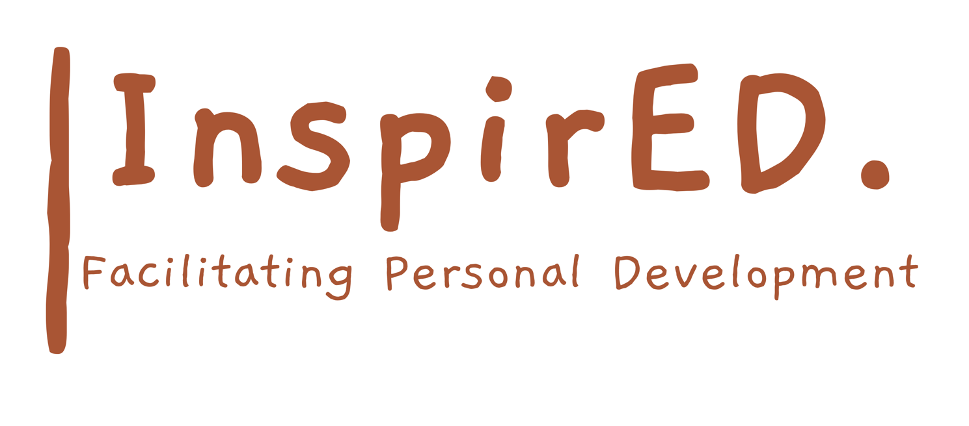

Plagiarism and Cheating Policy

Date of issue: September 2024
Date for renewal: September 2026
Author: Philip Parker

Rationale
InspirED PD wants to support students in creating original ideas and explore own capacity for learning. When a student use’s another person’s (peer or someone external to the school) thoughts or ideas, that student is not engaging in their learning. InspirED PD has adopted the following policy:
- Plagiarism and/or cheating is not allowed under any circumstances at any point within a learning journey
- The severity of any such action and other factors involved will impact the disciplinary response from InspirED PD
- The disciplinary actions may include, but be restricted to;
- A lesson on what plagiarism/cheating is to build awareness
- Discussion with parents or carers
- Meeting with the Director or other senior members of staff
- Automatic withdrawal of assessed work in question
- Removal from the class
- Re-sit of assessment in question

Plagiarism definition
Plagiarism consists of using ideas, thoughts, or words (phrases or sentences) that are someone else’ without given documented credit to that person.

