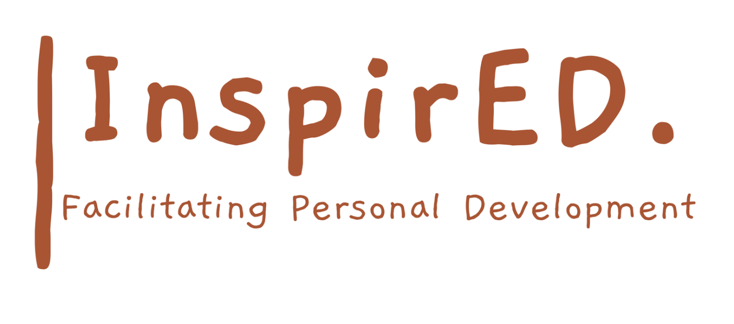

Policy on Distribution of Certificates

Date of issue: September 2024
Date for renewal: September 2026
Author: Philip Parker

Open Awards will issue certificates for learners who have successfully completed unit(s), within 20 working days of receipt of verified results.

All certificates will be forwarded to your Centre, via recorded delivery, for the attention of the Administration Contact.

This Centre will notify Open Awards within 5 working days of any identified problems with the certificates received. Once we have checked that all certificates are present and correct, we will confirm receipt within 10 working days via the Secure Portal.

InspirED PD will issue learner certificates within 10 working days of receipt from Open Awards. Unless it has been agreed otherwise, certificates will be issued directly to the employer/learner. Records of results/photocopies of certificates will be kept by the Quality Manager on a group database and/or in the personal files of the learners.

Certificates will then be posted/collected/delivered to the learner, who will acknowledge receipt of each certificate gained.

