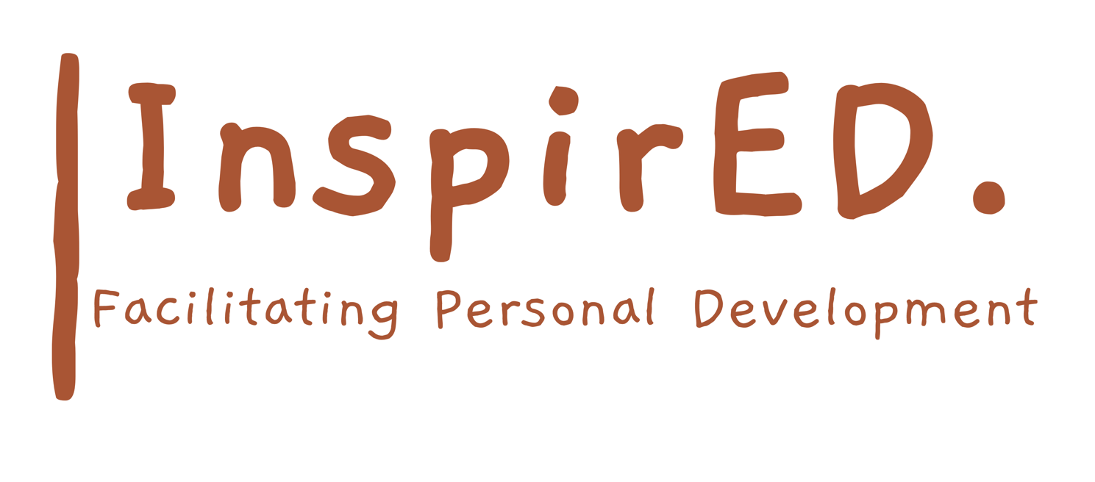

Recognising Prior Learning, Credit Transfer and Exemption Policy and Procedure

Date of issue: September 2024
Date for renewal: September 2026
Author: Philip Parker

Learners are able to use past achievement against units within the Regulated Qualification Framework (RQF) to achieve a Qualification. This enables learners to avoid duplication of learning and assessment through equivalences, exemptions, or credit transfer as follows:

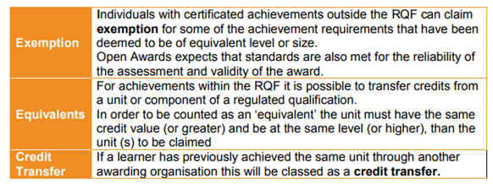

In all the above cases as the learner has already had their achievement recognised, and will have received a certificate to confirm this, their achievement towards this specific qualification will be shown as an exemption, equivalent or credit transfer and will not be allocated any credit achievement.

Recognition of Prior Learning (RPL) is a method of assessment that considers whether a learner can demonstrate that they can meet the assessment requirements for a unit through knowledge, understanding or skills they already possess and do not need to develop through a course of learning. Therefore, the learner is awarded the unit, so it will show as a unit achievement on the certificate.

PLEASE NOTE: For any learner who has previously achieved units that have been approved as Exemptions, Equivalents, Credit Transfer or will be achieved through RPL it is our responsibility to inform the Awarding Organisation at registration, through the use of the Learner Past Achievement Form which can be downloaded from the secure portal. The information about approved exemptions and equivalents can be found within the Qualification Guide where applicable.

When claiming for Exemptions/Equivalents and Credit Transfer requests, the learner will need to present the original certificate to the tutor, to show previous achievement. The tutor will need to take a copy of the certificate and sign and date to verify they have seen the original certificate. The copy of the certificate must be made available to the Internal Verifier, along with the Learner Past Achievement Form, as part of the verification process.

