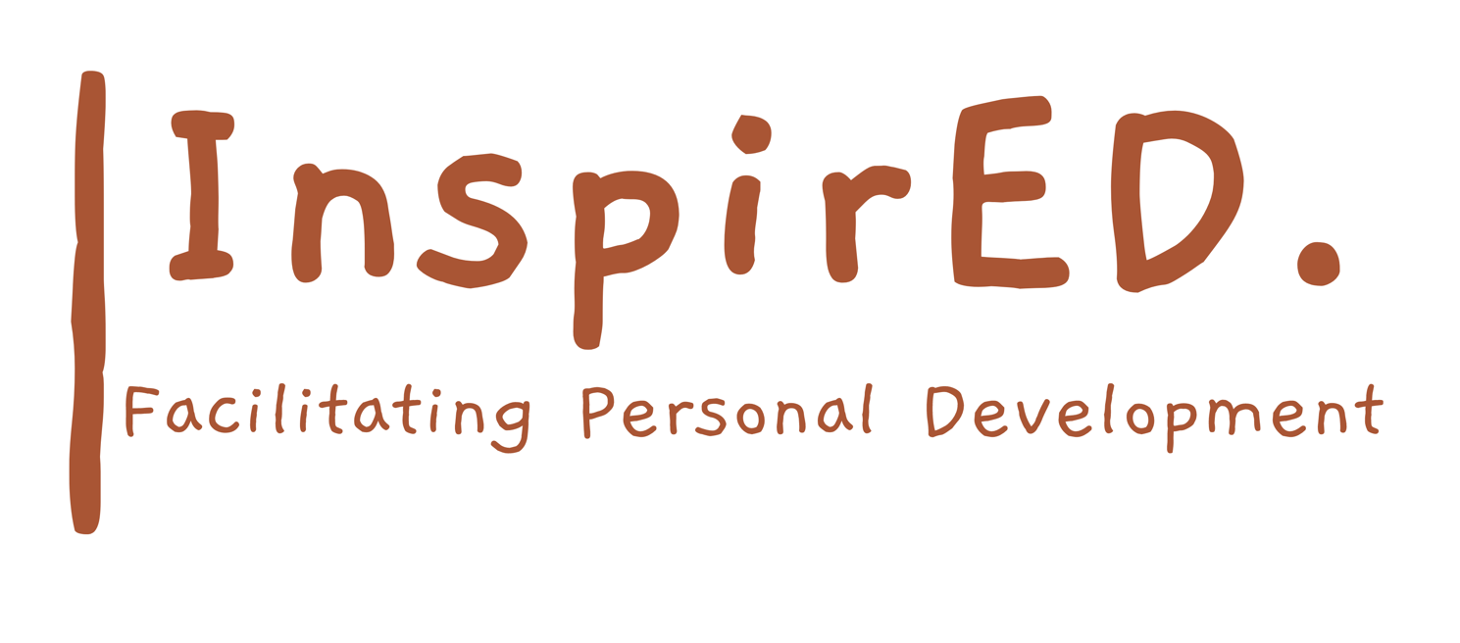

Relational Behaviour Policy

Date of issue: September 2024

Date for renewal: September 2026

3rd Edition

Author: Philip Parker

1. **Policy statement**

InspirED is committed to creating an environment where students feel safe to be able to access all learning opportunities afforded to them. Everyone is expected to maintain the highest standards of personal conduct, to accept responsibility for their behaviour and encourage others to do the same. Our relational behaviour policy guides staff to teach students self-discipline. It echoes our core values with a heavy emphasis on respectful behaviour, an informed approach to managing challenges and utilising effective interventions that support students as well as staff. Our ultimate aim is to ensure positive relationships between staff and students, with an understanding that staff make the ultimate decisions around behaviours that are acceptable in line with our core values/expectations.

1. **Aim of the policy**

* To create a culture of acceptance, support and growth where learning is valued and embraced.
* To ensure that all stakeholders and staff are treated fairly, shown respect and to promote positive relationships.
* Ensuring all students have what they need to be able to make good choices. To minimise the time and attention given to the poor conduct of students, to redirect them instead back towards their learning.
* To help students take control over their behaviour and be responsible for the consequences of it.
* To build a community which values kindness, care for one another, good manners, respectful language and empathy for all.
* To promote community cohesion through improved relationships and investment in each other
* To ensure that excellent behaviour is an expectation for all.

3**. Purpose of the policy**

To provide simple, practical procedures for staff and students that:

* Recognise and strive to meet our expectations
* Positively reinforce expectations being met
* Promote self-esteem and self-discipline
* Teach appropriate behaviour through positive interventions

**All staff**

1. Meet and greet students positively.
2. Refer to InspirED: Expectations (5 R’s)
3. Model positive behaviours and build relationships.
4. Plan lessons that engage, challenge and meet the needs of all students.
5. Use the B4L expectations to discuss points against the values
6. Award positive for any student going above and beyond our values.
7. Be calm and use the ‘language’ when going through the steps. Use layered interventions as preventative measures in order to try and avoid sanctions.
8. Follow up incidents of poor behaviour every time, **retain ownership** and engage in reflective dialogue with students.
9. Never ignore or walk past students who are behaving badly.
10. Monitor the awarding of positive behaviour points and positive phone calls, emails and any other mode of positive feedback to parents.

**Senior leaders**

Senior leaders are not expected to manage behaviour referrals in isolation, rather they are to stand alongside colleagues to support, guide, model and show a unified consistency to the students.

**Senior leaders will:**

* Celebrate staff and students whose effort goes above and beyond expectations
* Use behaviour data to target and assess school-wide behaviour policy and practice
* Regularly share good practice through observation and/or CPD
* Regularly review provision for students who are ‘hard to reach’ or failing to access learning
* Be a daily visible presence around the corridors and the site.
* Support staff in managing students with more complex or entrenched negative

presentations.

**Recognition and rewards**

At InspirED, we recognise and reward students who ‘go above and beyond’ in demonstrating our values in line with their current capacity. Although positive points, postcards, electronic, weekly and termly awards exist as standard, staff understand that a quiet word of personal praise can be as effective as a larger, more public, reward. The use of praise in developing a positive atmosphere in the classroom cannot be underestimated. It is the key to developing positive relationships, including with those students who are hardest to reach as we strive to instil intrinsically motivated leaners.

**School level**

1. Positive points on Compass
2. Electronic praise, postcards, “You are awesome/thank you for being kind” awards
3. Weekly keyworker awards for behaviour and attendance
4. Weekly contact with parents/carers (phone call or email)
5. Half termly rewards

**Classroom level**

1. Verbal praise
2. Positive points – including plenary to finish each lesson
3. Daily contact with parents/carers (phone call or email) from key worker

**Practical steps in managing and modifying poor behaviour at InspirED.**

**Layered Interventions**

Students are held responsible for their behaviour. All staff will deal with behaviour without delegating. Staff will use the InspirED layered interventions for dealing with inappropriate conduct. Steps should always be followed with care and consideration, taking individual needs into account where necessary. Staff will praise the behaviour they want to see. All students must be given the opportunity to make the right choice in between steps. Staff will use the ‘language of choice’ at every step. Every lesson allows for a fresh start. Although there are occasions when it is necessary to remove a student from learning, this should be avoided at all costs.  **Every minute a student is out of a lesson is one where they are not learning/connecting.**

**Redirection**

Gentle encouragement, a ‘nudge’ in the right direction, small act of kindness. Try and engage/redirect with positivity and tactically ignore negative conduct where possible.

**The reminder**

A reminder of the Values for students (5 R’s) delivered discreetly to the student. The teacher makes them aware of their behaviour referring to the values. The student then is given time to process and make positive choices.

**The caution**

1. Gentle approach, personal, non-threatening, side on, calm tone of voice, eye level or lower.
2. State the behaviour that was observed and which value is not being met.
3. Tell the student concisely and clearly why the behaviour is inappropriate, using language that is accessible to the student. Refer to previous good behaviour/learning as a model for the desired behaviour.
4. Walk away from the student; allow the student time to decide what to do next. If there are comments, as you walk away, make a note of them and follow up later.
5. Resist endless discussions around behaviour and instead, spend energy returning students to their learning.
6. If the student continues to make poor choices, the student is asked to speak to the teacher away from others, outside the room

* Boundaries are reset
* Student is asked to reflect on their next step. Again, they are reminded of their previous conduct/attitude/learning.
* Student is given a final opportunity to re-engage with the learning / follow instructions. The language of choice is used: ***“You can choose to do X and not show respect for learning or choose to do Y and be successful. I know you can make the right choice”.***

If a student has asked to leave the classroom to regulate and/or to defuse a situation, in general, three minutes will suffice. Students should always be supervised unless stated in individual RA.

If the step above is unsuccessful, or if a student refuses to engage in the conversation outside the classroom, then the student will be asked to go to leadership team, where they will spend the rest of the lesson (if more than 1 student in a group).

Staff will always deliver sanctions calmly and with care. It is in nobody’s interest to confront poor behaviour with anger. Please remember students will need our support to navigate the situation in an adaptive manner.

**The restorative conversation**

Restorative conversations at InspirED are a core part of repairing damage to trust between staff and students. Restorative conversations should reaffirm the ongoing commitment to building a trusting relationship.

Staff take responsibility for leading restorative conversations. Senior Leaders will support if requested and if possible.

Students may have their behaviour monitored by teachers to show progress towards agreed targets. At InspirED this may be done via a tutor/support member of staff.

**Conduct for excellent teaching and learning**

High quality behaviour for learning is underpinned by relationships, lesson planning and positive recognition.

T**Consistencies**

1. Meet and greet at the door/communal room.

2. Model positive behaviours and build relationships/check inner narrative.

3. Plan lessons that engage, challenge and meet the needs of all students.

4. A mechanism for positive recognition is used in each classroom throughout the lesson.

5. Refer to the values in all conversations about conduct.

6. Be calm and give time to make the right choice when going through the steps. Use layered interventions as preventative measures in order to try and avoid sanctions.

7. Follow up every time, **retain ownership** and engage in reflective dialogue with students.

8. Never ignore or walk past students who are behaving badly.