*Requirements for a display screen Equipment*

Date of issue: September 2024

Date for renewal: September 2026

Author: Philip Parker

**1. The Environment:**

* Adequate illumination with no reflection or glare on screen.
* No bright distracting lights in the users’ field of vision.
* Temperature and humidity to be comfortable.

**2. The Screen:**

* Should be adjustable in tilt, swivel and preferably height.
* Should have brightness and contrast adjustment.
* Characters should be stable (no flicker) and sharp.

**3. Desk:**

* Must be adequate in size to accommodate components of the workstation without clutter.
* Should have sufficient height to allow for unhindered knee space.
* Should have matt (non reflective) surface.

**4. Copy stand:**

* Should be provided and positioned at the same height and distance as screen.

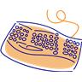**5. Keyboard /Mouse:**

* The Keyboard should have a flat profile.
* The keyboard should be adjustable, tilt and should have a non-reflective surface.
* The Mouse – when using the mouse, it should be kept close to the body and within easy reach so that it can be used with the wrist straight.
* 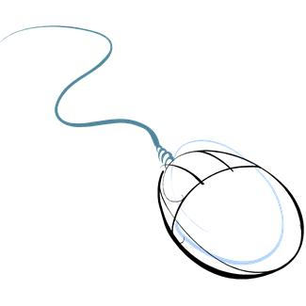Sit upright and close to the desk so that the arm used to operate the mouse is not stretched and kept in a locked position.
* Support the forearm on the desk with the elbow bent and do not grip the mouse too tightly.
* Rest your fingers lightly on the buttons and do not press them hard.
* People who are left-handed should consider using the appropriate software to convert the mouse for left hand use.

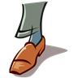

**6. Feet:**

* Should be flat on the ground or on a footrest.

**7. Head:**

* Should be balanced, with chin up and no strain on the neck muscles.

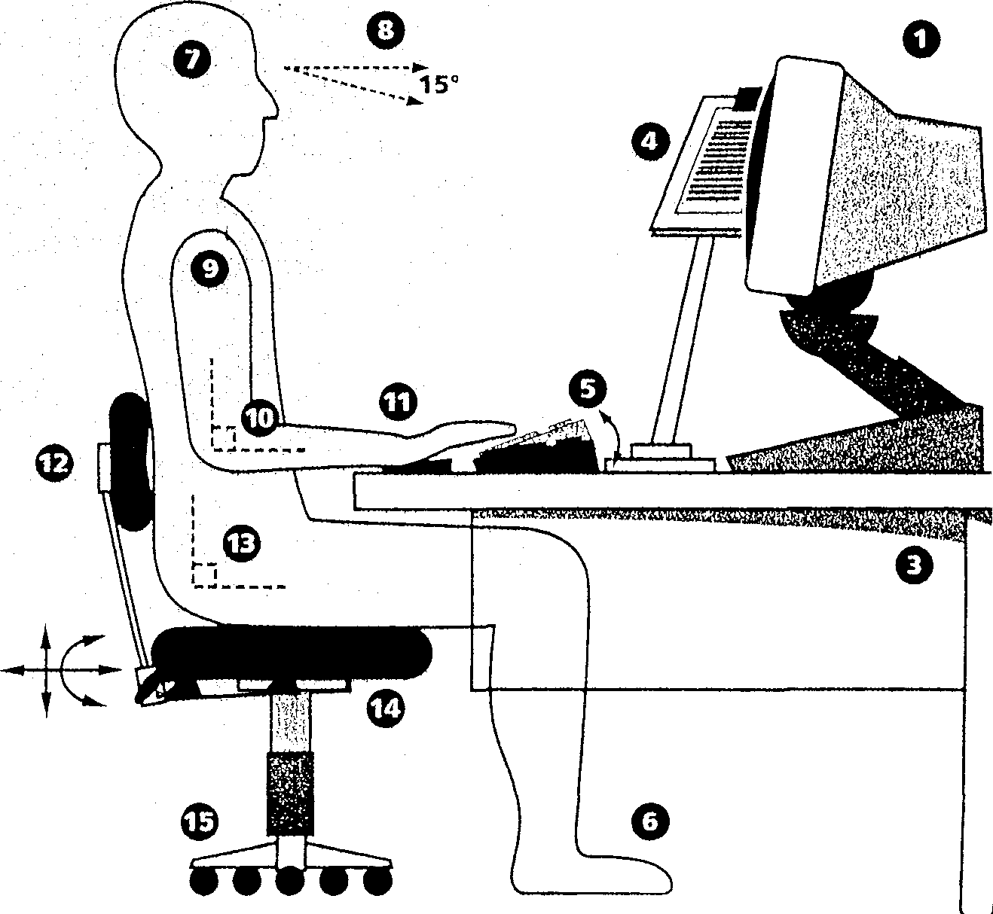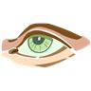**8. Eyes:**

* Should look down at the screen with an angle of about 15 degrees from the horizontal.
* Eyesight should be tested and corrected if necessary for the viewing distance of the screen and copy.

**9. Shoulders:**

* Should be in a comfortable position – relaxed and not hunched.

**10. The Upper Arm:**

* Should be positioned vertically with the elbow at right angles.

**11. The Wrist:**

* Should be straight when typing and supported during breaks.

**12. Chair Back:**

* Should be adjustable in height and tilt so that the curvature of the lower back is supported.
* 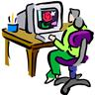Full length back rests can also provide support to the upper back and head.

**13. Sitting:**

* Sit well back in the chair so that the back rest supports the lower back.
* Pull the chair forward to find the right keyboard position – do not sit on the edge of the chair.
* The hip should be at right angles.

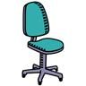**14. The Chair Seat:**

* Should be adjustable in height to find the correct position for the forearms.
* If this causes the feet to be off the floor - use a footrest.

**15. The Chair Base:**

* Should be stable – ideally with castors.