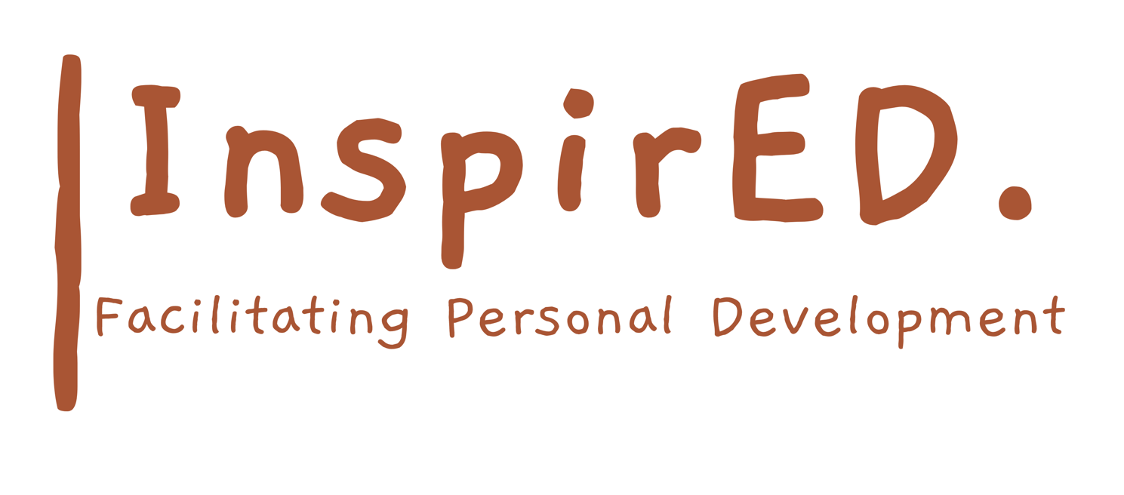

Drugs Policy

Date of issue: September 2024
Date for renewal: September 2026
Author: Philip Parker

Introduction
InspirED PD are responsible employers and we take our obligations to our employees very seriously. This is why we have set out this policy to help us ensure the health, safety and welfare of our employees and to help us comply with our legal duties. The use of non prescribed drugs is not only dangerous but also illegal under criminal law.

- Section 2(2)(e) of the Health and Safety at Work Act 1974 places a duty on employers
to provide a safe and healthy working environment.
- It is an offence to supply, produce, and offer to supply or produce controlled drugs.
- The Misuse of Drugs Act 1971 makes it an offence for the occupier of premises to permit knowingly the production or supply of any controlled drugs or allow the smoking of cannabis or opium on those premises.
- It is also an offence to aid or abet any of these offences.

Any reference in this Policy to a non-prescription drug refers only to controlled or illegal substance and does not refer to medicines, supplements and similar substances that are legally and commercially available in the United Kingdom.

Aims of the Policy
This policy aims to:
- Comply with the Company’s legal obligations to provide a safe and healthy working environment for all staff.
- Comply with all of the requirements imposed by law.
- Raise awareness of the dangers and penalties associated with the use of controlled drugs.
- Guarantee the right of all staff to work in an environment unaffected by controlled drugs.
- Provide support to staff whose lives are or who have been affected by the misuse of controlled drugs.

Health and Safety

Controlled substances often possess side effects that could not only adversely affect employee’s health but that of their colleagues at work as well as their performance. Employees should be aware that anyone under the influence of controlled drugs is a risk to everyone around them and should be alert to possible signs of drugs abuse. Such indicators commonly include:

- Sudden changes in behaviour;
- Confusion;
- Irritability;
- Fluctuations in mood and energy;
- Impairment of performance; and
- Increase in short term sickness absence.

Employees should report any concerns they may have about a colleague displaying any or all of these symptoms to a line manager or senior manager but should not under any circumstances approach the person displaying the symptoms or discuss their concerns with any other colleagues.

Prohibition

- No non – prescription drugs are allowed to be consumed in or brought onto company premises, land or vehicles at any time by any person irrespective of their status in, or business with, the Company.
- The prohibition of non – prescription drugs extends to all activities carried out by staff whilst they are at work. These activities include but are not restricted to driving on company business, when on call or standby duties or when on trips for company business, training or social events.

Disciplinary Action

A breach of these rules will be defined as gross misconduct and it is likely that the employee in question will face summary dismissal.

Principles

- If an employee is diagnosed as having a drug related problem the Company will treat it as a health matter. This does not however excuse the employee from any of the disciplinary matters that may fall within the scope of the Company disciplinary policy.

- All drug related issues will be dealt with in a constructive and sympathetic manner, and the person responsible for all such issues in the Company is Philip Parker, who will also provide any interested employees with the details of where to seek further information and help.

- All requests for help will be treated in the strictest confidence and all information gathered as a result will be held in accordance with the Data Protection Act 1998.

- Following effective treatment and in the absence of any disciplinary action the Company will endeavour to return an affected employee to the same role previously fulfilled by the employee [and where this is not possible to a suitable alternative].

- In the event that an employee following successful treatment for a drug related problem suffers a relapse the Company is under no obligation to make provision for any further treatment and the employee in question may face summary dismissal.

